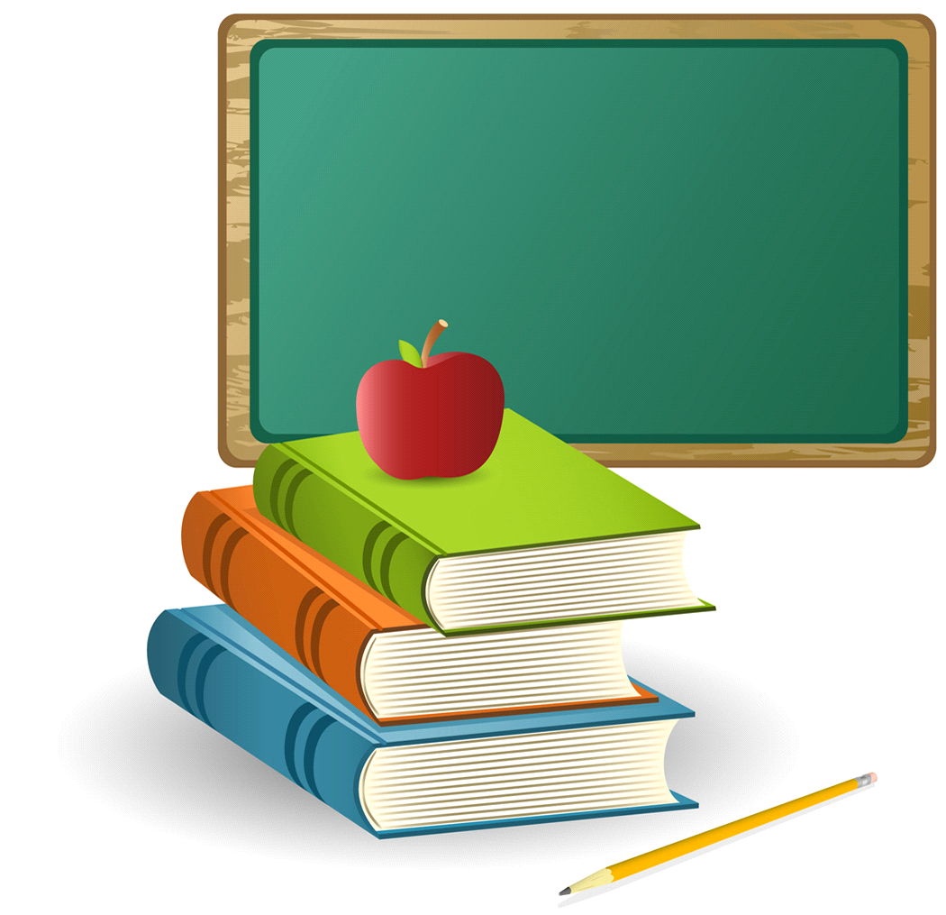Open House

**2018 - 2019** 

*Welcome to* ***KINDERGARTEN!***

**Kindergarten Special Events**

November 9th – Salute America Parade

February 15th – “Pastries with Parents”

April 4th – Evening Music Program

**Field Trips**

November 16th - The School of Theater at FSU

April 11th or 12th – The Challenger Learning Center

(dates subject to change)

**Class Parties**

October 31st – Fall Party/Book Character Dress-Up

December 20th – Winter Holidays Celebration

Week of May 28th – End of the Year Activities

**Kindergarten Curriculum**

**Reading** is taught using our *Wonders* reading program. The five components of reading: phonemic awareness, phonics, fluency, vocabulary, and comprehension are taught through direct instruction lessons, computer based lessons, small group instruction, and workstations. Reading skills are differentiated to meet the academic needs of each student through small group instruction and workstation activities.

**Phonemic Awareness** is a consciousness of the sounds in words. It includes the ability to hear rhymes, separate the sounds in words, and detect consonants and vowel sounds. Our program has a strong emphasis on developing children’s phonemic awareness, which prepares them for learning to read and write.

Reading to and with your child has an integral place in our program. We share with your child the joy of literature through many avenues. We use Big Books, songs, and poems for shared reading. Literature books and non-fiction books are read to the children to develop our theme studies. Independent reading allows the children to enjoy literature at their own pace and interest level and to develop a love for books. Kindergarten supports Hawks Rise reading goals by participating in school-wide **Reading Rallies.** Kindergarten has set a **Reading Rally** goal of at least 30 books ***read at home*** each nine-week period and a challenge Reading Rally goal of 40 books ***read at home.*** These may include take-home stories/books from the teacher, the *Wonders* decodable books, books from the county library, or your own personal books.

# Handwriting & Creative Writing

Hawks Rise kindergarten teachers use the *Handwriting Without Tears* writing curriculum. It is a hands-on approach to handwriting, providing consistency with child-friendly language and multisensory activities. Kindergarten children will write creatively about some of the themes we are studying and about their own personal experiences throughout the year. Spelling approximations are expected and encouraged. Students will learn opinion writing, explanatory/expository writing, and narrative writing.

**OVER**

**Math and Science**

Creating an environment where students can relate and understand math and science concepts as an integral part of life is the purpose of our program. Math is taught using the *Go Math* curriculum. This program incorporates the use of technology, hands-on activities, and workbook practice to teach and review the Florida standards for math.

**Social Studies**

Throughout the year your kindergartner will learn about the symbols of the United States, Government, Citizenship, Black History, Geography, Celebrations around the world.

**Centers/Work Stations**

Activities are chosen from subject areas to reinforce and enrich specific literacy developmental skills being covered in the curriculum. We have very busy classrooms with learning projects coordinated around our themes.

**Grading Policy**

Students’ content area and social skills progress will be assessed from activities, daily work and work habits, learning center accomplishments, special projects, classroom participation, and assessments. All curriculum areas will be assessed through the use of the Florida State Standards and subject area curriculum guide benchmarks and outcomes. Grades will be given beginning the second nine weeks in kindergarten and will be based on the following: 50% chapter and/or unit tests, 30% quizzes and 20% for classwork. Parents are required to attend one Report Card conference a year held at school.

**Classroom Donations**

Thank you very much for donating consumable items to the classroom. These items will be used in many ways to further our education program.

**Volunteers**

Classroom and home volunteers are a *very important* addition to each classroom’s accomplishments. **Thank you** for donating your valuable time to further our classroom goals.

If you have any questions or concerns, please feel free to call (487-4733). We are looking forward to a wonderful year!

j0344872

Thank you,

The Kindergarten Teachers