Fairview Middle School

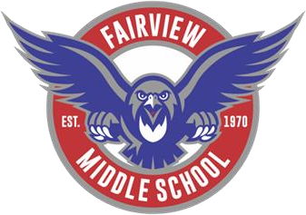

Summer Reading 2022

* **Step One:** Choose ONE book from the following grade level lists (make sure you choose from the list of the grade that you will be in during the next school year—August 2022).
* **Step Two:** After reading your selected book, choose and complete ONE of the project options.
* **Step Three:** Turn in your summer reading project on Wednesday, August 24.

# Book Options

6th Grade

1. *Ghost*—Jason Reynolds
2. *Becoming Muhammad Ali*—James Patterson and Kwame Alexander
3. *Restart*—Gordon Korman
4. *The Mysterious Benedict Society*—Trenton Stewart

7th Grade

1. *New Kid—*Jerry Craft
2. *Song for a Whale—*Lynne Kelly
3. *Inkling—*Kenneth Oppel
4. *The Unsung Hero of Birdsong, USA—*Brenda Woods

8th Grade

1. *The Last Voyage of Poe Blythe*—Ally Condie
2. *Deep Water*—Watt Key
3. *The Unteachables*—Gordon Korman
4. *Clean Getaway*—Nic Stone

# Project Options

1. **Book Trailer:** Your summer reading book has been made into a movie, and you are in charge of creating the trailer. You want to be as creative as possible. You also want your project to be visually appealing. Remember, you want views to watch the movie but not give the ending away! Use PowerPoint or iMovie to create a movie trailer for your book.

# Pay attention to the following details:

* + Introduces the main characters of the novel.
  + Outlines the basic plot of the book (WITHOUT GIVING AWAY THE ENDING!).
  + Describes the main conflicts of the novel.
  + Includes the setting in pictures and words.
  + Includes your name, the author’s name, and the title of the book.
  + Includes background music and special effects.

1. **Three Key Passages:** Select three passages that you feel help develop a major theme of the book, or show a major character’s development. Choose a passage from the approximate beginning, middle, and end sections of the novel. Include:

* Three Passages (a passage is just a short excerpt that you select—this could be a paragraph), with the page number. Label your passages: Beginning, Middle, End
* For each passage, explain why you chose it and how it develops your chosen theme or character. Each response should be at least one paragraph 6-8 sentences.
* All three passages should be about either a theme or character development. Choose one of these two topics!