**Kindergarten through 2nd Grade**

1. Listen to your favorite song. Find the steady beat and demonstrate it somewhere on your body or by walking/marching/tiptoeing/galloping etc. to the beat. BEAT is pulse, heartbeat of the music.
2. Teach someone else at home a song or poem we learned this year.
3. Sing a song while walking to the beat. Stop and clap the rhythm of the song. Repeat. Rhythm will include both long & short sounds.
4. Sing a lullaby to a younger brother/sister or to a stuffed animal. If you can’t remember a song, make one up.
5. Create sound effects to go with a story (such as rain sounds, action sounds, sounds for particular characters, etc.). Perform them with the story for everyone at home.
6. Listen to a song without any words and draw a picture of what the music makes you think of or feel.
7. Use all of your voices today (speaking, singing,whispering, & shouting) singing a song you know.
8. Sing an action song you have learned this year and perform it for someone in your family.
9. Make a list of ice cream flavors and create your own song using sol-mi. Sing your ice cream song for a family member or to a stuffed animal.
10. Write down animals that make loud sounds and animals that make quiet sounds.

**3rd through 5th grades**

1. Create a hand-clapping game and teach it to someone else at home.
2. Make up a body percussion pattern for a song you like.
3. Find two wooden objects (pencils, sticks, wooden spoons, etc) and play a rhythm pattern on a box, bucket or the floor. Teach it to someone else.
4. While watching a movie or TV, listen and see what music (if any) is playing underneath what’s going on. Write down or talk about how the music helps to tell the story.
5. With another family member, create two rhythm patterns and play them together, using body percussion or found objects.
6. Pick 3-5 items in your house. Write the name of each item on a piece of paper* and determine the rhythm of the words, and make a pattern using them. (Hint: “bar-bie doll” has three sounds, *ti-ti -ta****or***  *Du-de Du* is the pattern.) *\*if it’s a nice day use chalk outside instead!*
7. Sing your favorite song for someone in your home. You can also sing the song to a family member who lives somewhere else using a cell phone or over a video chat.
8. Use a familiar tune (like “Happy Birthday”, “ABC song”, “Mary Had a Little Lamb”, etc.) to make up a jingle for a pet food commercial.
9. Interview someone in your family about their favorite song.
10. Grill out theme! Hamburger is *ta-ti-ti* **or** *Du Du-de*, and Hot Dog is *ta-ta* **or** *Du Du*. Create a diagram of other foods that have the same rhythm pattern.

**Online Enrichment Ideas/ Options:**

1. Check out these Music Channels on YouTube: ***(Suggested for K-2)***
   1. [https://www.youtube.com/user/TheLearningStation/video](https://www.youtube.com/user/TheLearningStation/videos)s- to get you moving
   2. <https://www.youtube.com/user/HarryKindergarten/videos>
   3. <https://www.youtube.com/user/JackHartmann/videos>
   4. <https://www.youtube.com/user/GoNoodleGames/playlists>
   5. John Feierabend folksong books: <https://bit.ly/2UG22HW>
2. Listen to the story “ The Remarkable Farkle McBride” by John Lithgow- As the story is being read, look at the instruments of the Orchestra & listen to their sounds. Decide what family they belong to: strings, brass, woodwind or percussion. <https://youtu.be/oM5pmq5nr1Q>
3. *George Meets the Orchestra, A Introduction to the Orchestra for Children* - It is presented by the Sydney Opera House. George is a little boy who is meeting the Sydney Youth Orchestra. He wants to learn an instrument, but which one? <https://bit.ly/3asrkQn>
4. Check out these Music Channels on YouTube: ***(Suggested for 3rd-5th)***
   1. **Musical Minds:**<https://bit.ly/2xDynXV>
   2. **GoNoodle:** <https://www.youtube.com/user/GoNoodleGames/playlists>
   3. **Quaver Music Song Videos:** <https://www.youtube.com/user/quavermusic/playlists>
5. Young Person’s Guide to the Orchestra interactive game: <https://bit.ly/3dvHqLf>
6. Free - Quaver Music Online: Play these fun games as review-- Instru. Crane Game/ Tempo- Beat Bounce/ Note & Rest Grab/ Beat or No Beat ----Select a QuaverBook to read: Francis Scott Key & listen to The Star Spangled Banner/ Beethoven & listen to Moonlight Sonata/ Sousa & listen to his Marches/ Rock & select the rock band instr.----Recorder: Play songs using notes B,A,G.as review
   1. Go to: [https://www.quavermusic.com/](https://www.quavermusic.com/info/)
   2. Click  in the upper right hand corner
   3. Then type in **HOME20**  in this box 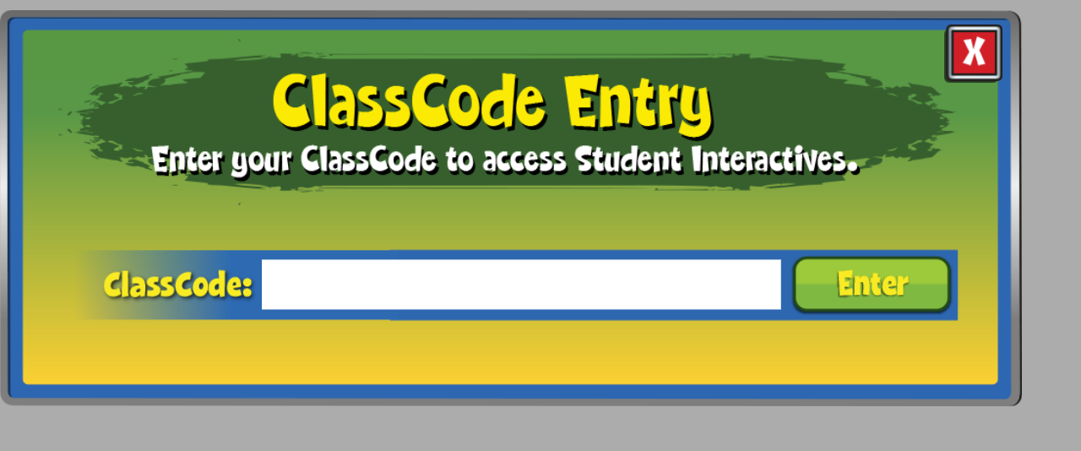

7. A rhythm game and dance site in Spanish for kids and parents. <https://bit.ly/33SB97O>

8. Barefoot Books, Animated Singalong Books - <https://www.barefootbooks.com/kids/animated-videos/>