Name: _____________________________ Date:__________________ Class Pd:____

Classification (2.6) Quiz RETAKE

Match the people with their contribution to our current classification system.

1. Proposed 5 Kingdoms: Monera, Protists, Plantae, Fungi, and Animalia
2. classified life into two Groups: Plants and Animals
3. Named the two Plantae and Animalia groups Kingdoms
4. ____ Carolus Linnaeus
5. ____ Robert H. Whitacker
6. ____ Aristotle
7. What happened to the kingdom Monera in the 1990s?
   1. Scientists decided to keep it a Kingdom
   2. Scientists decided to split it into two Kingdoms: : Bacteria and Archaea
   3. Scientists decided to make it a Domain
   4. Scientists decided to split it into two Domains: Bacteria and Archaea
8. Which group holds more species, a Domain or a Kingdom?
   1. Domain
   2. Kingdom
   3. Both are the same

Why? _______________________________________________________________________

1. Which group holds more species, an order or a class?
   1. An order
   2. A class
   3. Both are the same

Why? _______________________________________________________________________

1. Which group hold more species, a phylum or a family?
   1. A phylum
   2. A family
   3. Both are the same

Why? _______________________________________________________________________

1. Which group holds more species, a Genus or a Species?
   1. Genus
   2. Species
   3. Both are the same

Why? _______________________________________________________________________

1. In which domain are humans classified in? ________________________
2. List the 3 domains.

________________________ ___________________________ __________________________

1. In which Kingdom are humans classified? _____________________________
2. In a complete sentence, describe 2 reasons that scientific names are used.

_________________________________________________________________________________________________________________________________________________________________________________________________________________________________________________________________________________

1. What is a dichotomous key?
   1. A family tree
   2. A system to determine the names of organisms
   3. A system to determine the heritage of organisms
2. How are organisms given a scientific name?
   1. Using the genus and species
   2. Using its’ species name
   3. Using its kingdom name
   4. Using its domain and kingdom name
3. Use the below dichotomous key to classify the two organisms below, they all belong to the Genus Cobbus.

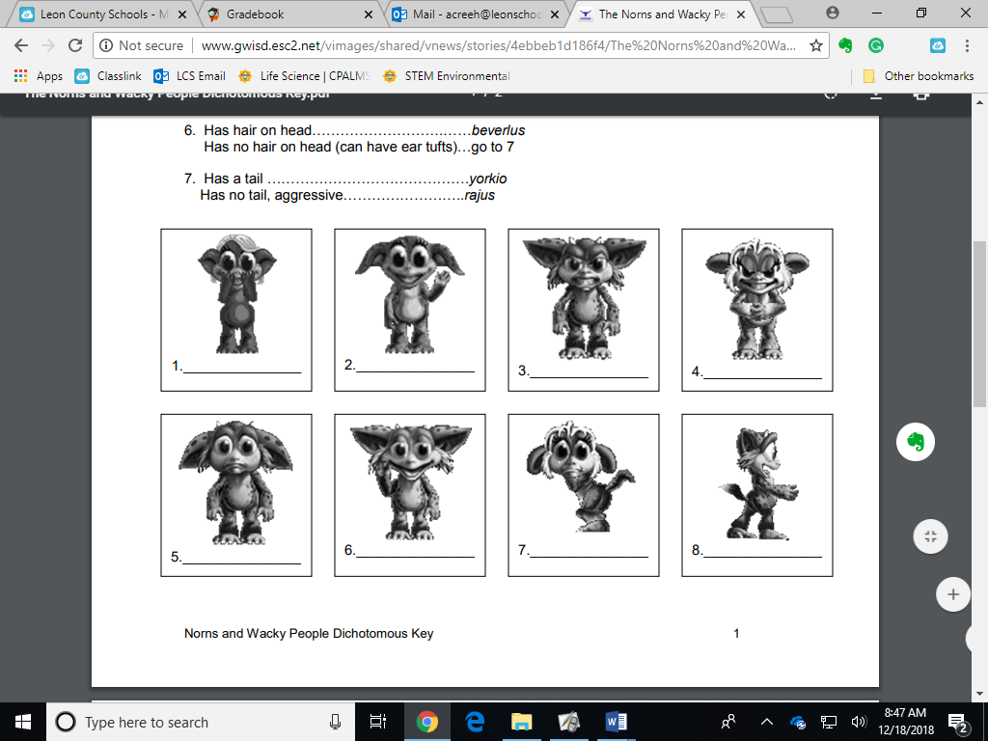

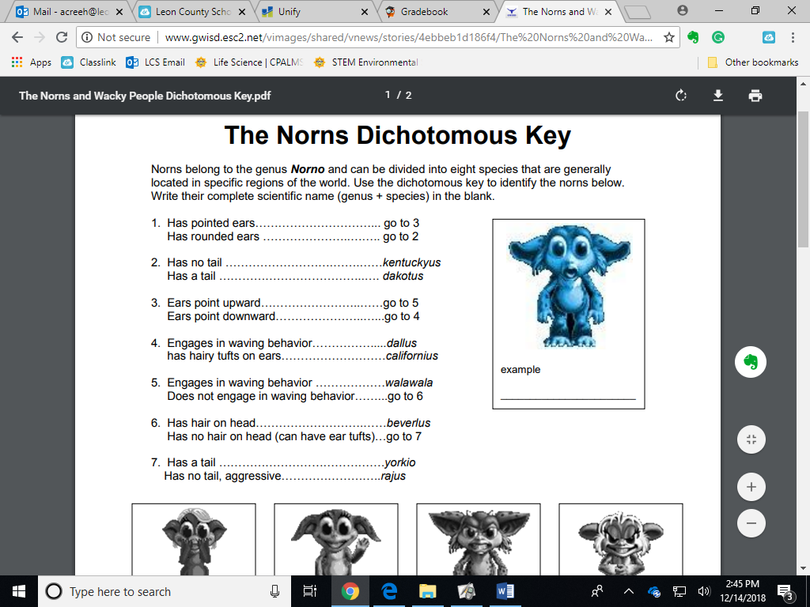

1. Extra credit:

Name the levels of organization in order from largest group to smallest group.