**Read the paragraph below about Central America, and then answer the questions after the paragraph. You can answer the questions in English.**

**¿Dónde empieza Centroamérica?**

[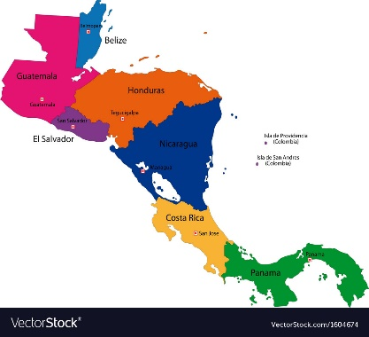](https://www.google.com/url?sa=i&url=https%3A%2F%2Fwww.vectorstock.com%2Froyalty-free-vector%2Fcentral-america-map-vector-1604674&psig=AOvVaw2oVhgyB0aOiWoicLsQZOjM&ust=1588676983226000&source=images&cd=vfe&ved=0CAIQjRxqFwoTCMiE_JGJmukCFQAAAAAdAAAAABAI)**Guatemala está en América Central (*Central America*). Este país (*this country*) y Belice marcan la transición entre Norteamérica y Centroamérica (*mark the transition between North America and Central America*).**

Central America

1. Besides Guatemala and Belize, what countries make up Central America? Write their names.