**2009 Revised AP World DBQ- Response to Imperialism**

1.Using the documents and your knowledge of world history, analyze at least two African responses to European imperialism during the last nineteenth and early twentieth centuries.

**Document 1**

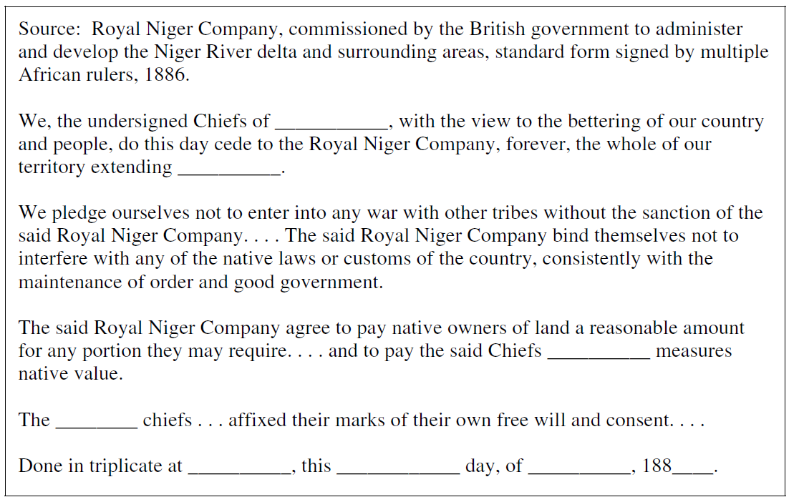

**Document 2**

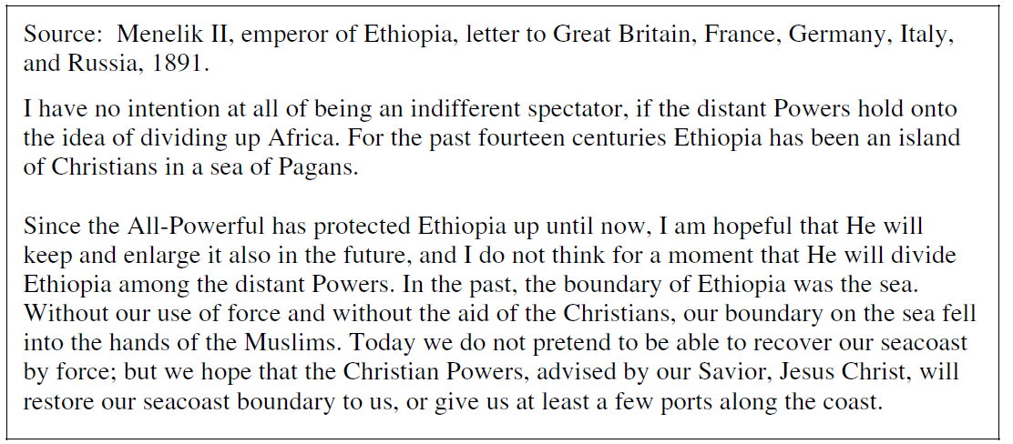

**Document 3**

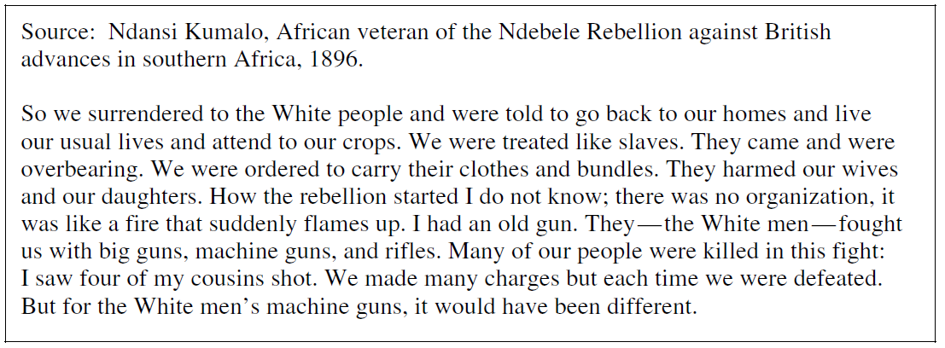

**Document 4**

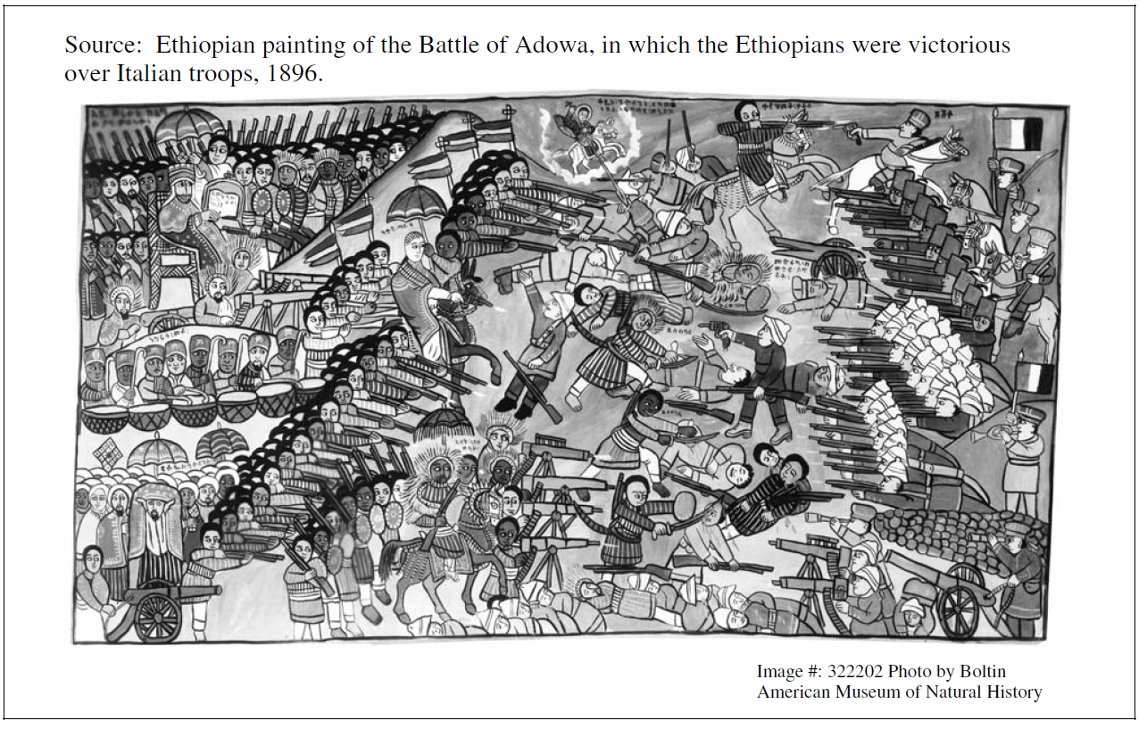

**Document 5**

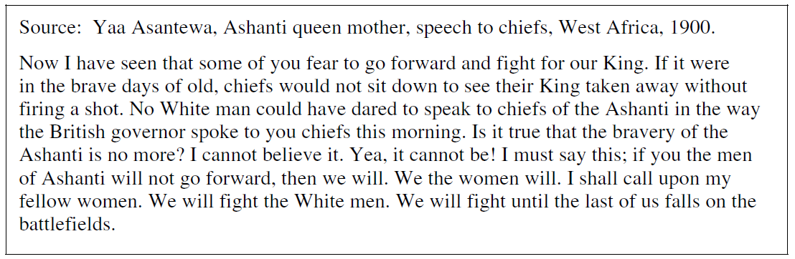

**Document 6**

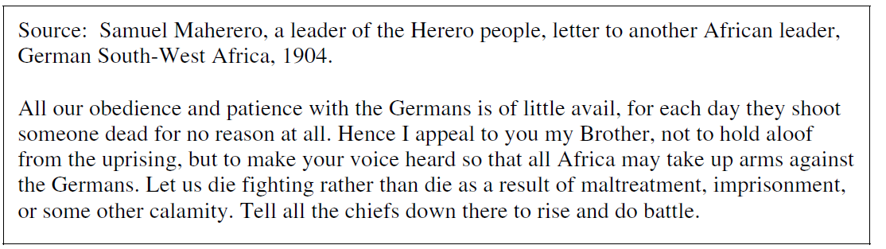

**Document 7**

