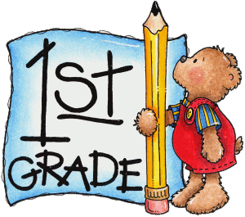

**Week 7 Quiz**

Directions: Complete and submit for your weekly quiz and participation grade. This can be done by taking a picture and sending it via Remind, Teams or teacher’s email. (Please refer to videos and Week 7 packet.)

**ELA- Read and answer the following questions.**

**Curt and Herbie in Space**

“You can tell by looking at the sky,” says Herbie. “The sun is small.” “No,” says Curt. “The sun is large. It only looks small because it is so far away!” The boys cannot agree. Their teacher makes a plan to help them. “I will take our class up in my spaceship,” she says. “Great! Then we can see how big the sun is!” says Curt. The travelers hop into the spaceship. First, the teacher makes the spaceship go up high. Then she whirls it around. “Whoa!” cries Herbie. “What is that?” “Venus!” says Curt. “It’s a planet that travels close to the sun.” The spaceship hurls through space. Then the kids see another planet. “That is Mercury!” Herbie blurts out. “Its path passes close to the sun, too!” “You are right!” yells Herbie. “The sun is really huge now!” “Please take us back to the suburbs,” urges Curt. “I want to tell my family about this exciting trip!” The teacher turns her spaceship to the left, and they head back to school.

1.Curt says that the sun looks small because it is so_______.

a) bright

b) near by

c) far away

2.Why does the teacher take the class up in her spaceship?

a) She wants the boys to see the size of the sun.

b) She wants the boys to have an exciting class trip.

c) She wants to show the boys what a spaceship looks like.

3.Why does the teacher make the spaceship go up so high?

a) She is in a hurry to leave the school.

b) She needs to keep the children quiet.

c) She wants to get close to the planets.

**Math-Read and answer the questions.**

1. A square has ______ sides and _______ vertices.
2. A circle has ______ sides and _______ vertices.
3. Which shape shows halves? Circle or square

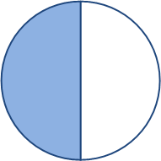

|  |  |
| --- | --- |
|  |  |

1. Which shape shows fourths? Square or rectangle

|  |  |  |  |
| --- | --- | --- | --- |
|  |  |  |  |

|  |  |  |  |
| --- | --- | --- | --- |
|  |  |  |  |

**Science- Read and complete**

How are frogs and toads different?

**Social Studies**

Who was George Washington?