**Ch. 13 Urban Patterns**

**Key Issue 2 Where Are People Distributed in Urban Areas?**

**Rubenstein, p.466-477**

1. The distribution of people in urban areas is NOT _________________________.

**I. MODELS OF URBAN STRUCTURE**

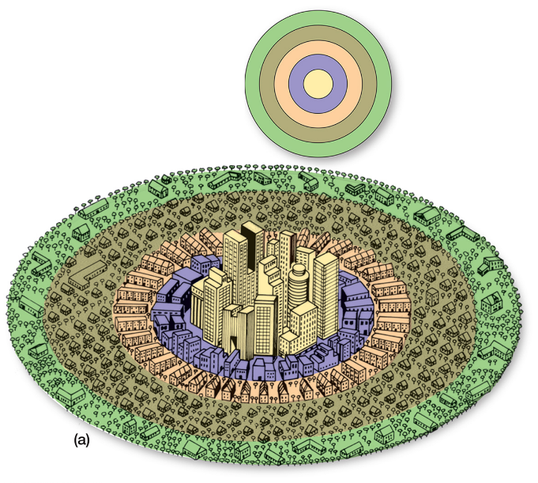

2. Label and describe the **concentric zone model** developed by E.W. Burgess in 1923.

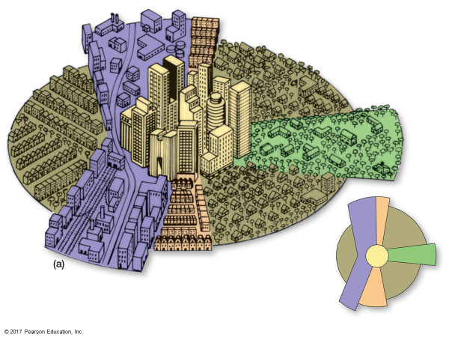3. Label and describe the **sector model** developed by Homer Hoyt in 1939.

4. Label and describe the **multiple-nuclei model** developed by Harris & Ullman in 1945.

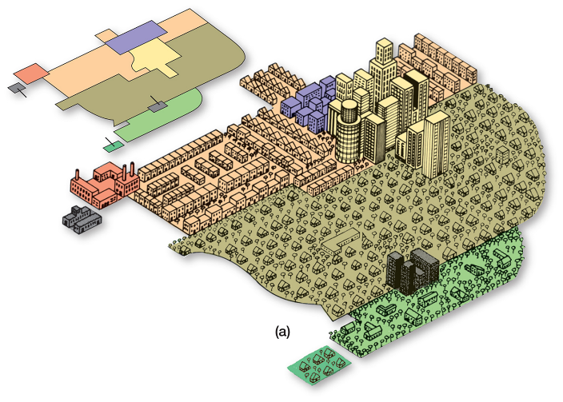

**edge city** –

**II. APPLYING THE MODELS IN NORTH AMERICA**

5. The 3 models are used to show what two phenomena?

6. Define **social area analysis**:

7. Skim the social analysis section referring to the three models and read the last sentence on p.468.

What is the main point(s) of this section?

8. What are some limitations/criticisms of the three models?

**III. APPLYING THE MODELS IN EUROPE**

9. What are some characteristics of European cities that set them apart from American cities?

10. Using the three models, identify similarities and differences between American and European cities.

Concentric zone model –

Sector model –

Multiple nuclei model –

**IV. PRE-MODERN CITIES I DEVELOPING COUNTRIES**

11. For most of recorded history, the world’s largest cities have been in _____________, despite the fact

that until recently, most Asians have lived in _____________________. (Make sure you grasp how this is possible.)

12. Describe three ways in which European colonizers shaped cities in their colonies.

**V. APPLYING THE MODELS IN DEVELOPING COUNTRIES**

13. Describe each of the three models as applied to LDCs. Note similarities or differences from the

models as applied to American and European cities.

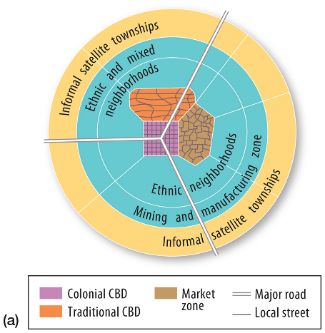 Concentric Zone Model –

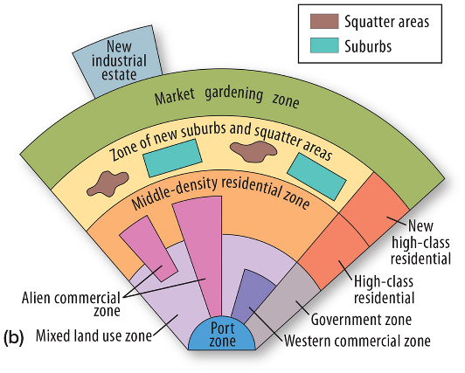

Multiple Nuclei Model –

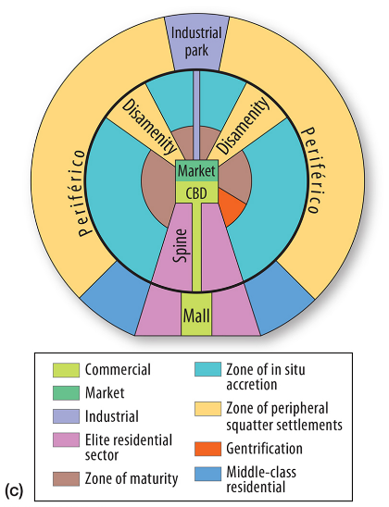

Sector Model –

**VI. CHANGING URBAN STRUCTURE OF MEXICO CITY**

14. Like many Latin American Cities, Mexico City has passed through what three phases of development?

15. Which of the models apply(ies) to Mexico City? Justify your answer.