Dr. Sullivan’s classroom procedures

1. ENTERING THE CLASSROOM
2. Entering the classroom- You will enter the classroom QUIETLY!! That means NO NOISE!!

If you are making noise, you will go BACK OUT and ENTER AGAIN, QUIETLY!!

1. Do not bring food or drinks to class. You may bring water or a drink that has a screw top. (Any food/drink item must be left on the shelf by the door.)
2. Take out your Spanish folder/notebook and a writing implement.
3. Sharpen your pencil if needed before bell rings.
4. Look at the board where assignments are written and begin working on bell work if there is one.
5. **GETTING TEACHER’S ATTENTION IN CLASS**
6. Raising your hand - When you want to raise your hand for something, here’s what it will look like:

To answer a question- Hand raised, no calling out, wait for the teacher to call on you!



1. **HALL PASSES**
2. Hall passes- You will be given 4 hall/tardy passes for the per semester. Any passes you do not use, you will turn those in at the end of the year for extra credit.
3. **CELL PHONES**
4. As soon as the bell rings to start class, all phones must go AWAY.
5. There will be times when you will be allowed to use your phones at the end of class, normally.

Cell phone usage at the end of class **will** **depend upon class behavior however.**

1. If you are caught texting in class, I will confiscate your phone and a parent may pick it up at the end of the day. I will hand you a Ziploc bag, and a small card, you will fill out the card with your name and the period number, place both the phone and card in the Ziploc bag and hand it to me.
2. Failure to turn over your phone when I ask for it will result in an automatic 3-day suspension, as per the Student Handbook (Agenda book).
3. There is a cellphone charging station at the front of the room. This is the **ONLY** place in the room that you may charge your phone. ☺
4. **RECYCLING**
5. There is a big green bin in the front of the room. Please recycle all paper and plastic. 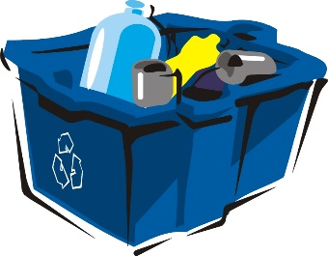
6. Do NOT crumple your paper!!! Keep it flat and recycle it!!

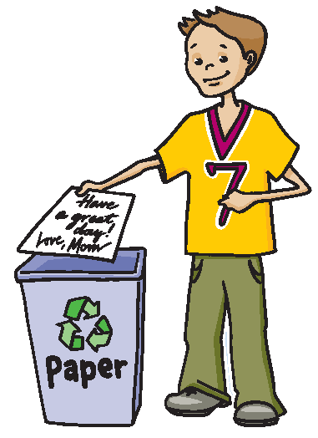

1. **If you throw the balled up paper (or anything else!!) across the room, you will receive an automatic ½ hr. lunchtime detention**.
2. **DISMISSAL BELL**

The bell to dismiss class does NOT mean for you to get up immediately but rather it is the sign for me that class is over. I am the one to dismiss class. That is to say, do NOT start packing up your stuff before I give the signal. You must stay in your seat until I dismiss the class. No gathering around the door!

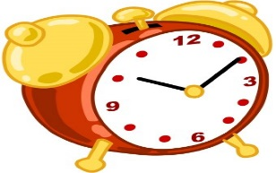

1. **ARGUING WITH THE REF**
2. ) When you have a disagreement with me about a disciplinary measure I have taken (such as asking you to switch seats) you may NOT argue with me during class time. To signal that you would like to speak to me about the issue, indicate this by showing me a “T” sign, for time out. I will then acknowledge you and I will speak with you at the END of class (not at that moment).

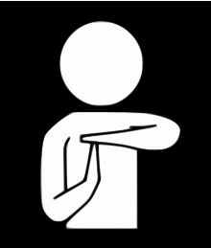

1. ) If you choose to continue arguing, the consequence will be double, 1 for the original infraction and 1 for arguing with me and taking up class time.
2. If you are the type of student that insists on jumping into the fray when I am dealing with another student, you will come to see me AFTER SCHOOL on FRIDAYS. I call these folks “Student lawyers”.

**I WILL MEET WITH STUDENT LAWYERS ON FRIDAYS AT 3 PM**

1. **SILENCE DURING ANNOUNCEMENTS**- **Positively NO talking during announcements**!! As soon as you hear the beep for announcements ALL talking must cease immediately!!!
2. **COMING TO ATTENTION** – I will raise my hand in the air when I want you to get quiet and listen to me. You will get quiet and raise your hand in response to indicate that you have seen my hand raised.



1. **FIRE DRILL**: As soon as you hear the fire alarm, stop what you are doing, stand up and QUIETLY file out of the door towards the exit that is facing Meridian Road. Please take ALL of your belongings with you. Turn right outside of the double doors and head to the parking lot at the McDougal house right next door. Stay together because I will be taking roll. Once roll is taken you may split off from the group.

**11.) Procedure for making up work**:

Check folders that will be placed on top of shelf as you walk in the door. Folders will be marked by day and level. Check the folder for the day(s) you missed and make up that work. You will have the day you come back plus the numbers of days missed to make up your work. **This applies to quizzes and tests as well.** Also, looking at Pin Point will let you know what assignment you missed. If you did not get the chance to finish the work we did in class, you must turn that work in the next day. You will NOT be given a reminder.

**If you have an unexcused absence for that day, I will check your work in, but I will not count it until you get your absence excused. This also applies to quizzes and tests.**

**12.)GUM**

I would prefer that you NOT chew gum in class. But if you must, I do not want to hear it (as in cracking your gum) or see it (as in blowing bubbles). Please dispose of your gum responsibly, i.e. do NOT stick it under your desk.

**13.)NO WRITING ON DESKS!!!-**

Please do NOT write on your desk, even if it is in pencil. If you come to class and there is writing on your desk, please let me know immediately so that I will not blame you. If you are caught writing on the desk, you will receive a ½ hr. lunchtime detention in my room and you will clean desks. ☺

**14.) IF YOU LOSE/MISPLACE/FORGET TO BRING IN A WORKSHEET-**

In the event that you lose/misplace/forget to bring your copy of a worksheet to class (especially when we are doing a 2-sided worksheet) you will be given another copy once I determine that I have enough copies for all the absentee students. The second time you forget your copy, you will be given another one with a 20% reduction in points. Each subsequent extra copy you receive will add an additional 10% reduction in points.

1st time- no reduction

2nd time- 20% reduction

3rd time- 30% reduction, etc.

**SO DON’T LOSE YOUR COPIES!!!**

**15. PARTICIPATION POINTS:**

Every day each student receives 10 points for full participation, which means responding in a respectful manner when called upon in class. Failure to participate will result in a loss of those 10 points. In addition, you may also lose points for the following:

1. Falling asleep in class- 5 point loss and you may NOT make up the work you missed in class OR use your cell phone at the end of class.
2. Doing other work in class- 5 point loss
3. Unexcused absence- 10 point loss