**Home Sweet Home**

**At the bottom of each picture, copy the Spanish word.**

**DORMITORIO VASO COCINA CASA**

[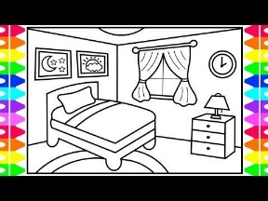](https://www.google.com/url?sa=i&url=https%3A%2F%2Fwww.pinterest.com%2Fpin%2F722194490220850256%2F&psig=AOvVaw1qTmoWo9bt_mf4WAsisBaO&ust=1588773760676000&source=images&cd=vfe&ved=0CAIQjRxqFwoTCOilueLxnOkCFQAAAAAdAAAAABAD)[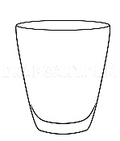](https://www.google.com/url?sa=i&url=https%3A%2F%2Fdragoart.com%2Ftut%2Fhow-to-draw-a-glass-3259&psig=AOvVaw37Ky9fp1atqGWkLaK1kWbn&ust=1588774294731000&source=images&cd=vfe&ved=0CAIQjRxqFwoTCODdmerznOkCFQAAAAAdAAAAABAD)[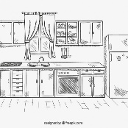](https://www.google.com/url?sa=i&url=https%3A%2F%2Fwww.freepik.com%2Ffree-vector%2Fhand-drawn-kitchen_765591.htm&psig=AOvVaw2k9ozKqJ2qZRJO-Kv0eAAn&ust=1588774435285000&source=images&cd=vfe&ved=0CAIQjRxqFwoTCIjZh6L0nOkCFQAAAAAdAAAAABAD)[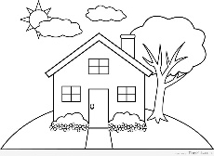](https://www.google.com/url?sa=i&url=http%3A%2F%2Fgetdrawings.com%2Fsimple-house-drawing-for-kids&psig=AOvVaw3jfkqaWAJzy-ux_4PHfONN&ust=1588774528168000&source=images&cd=vfe&ved=0CAIQjRxqFwoTCIDo9Mv0nOkCFQAAAAAdAAAAABAJ)

**____________ ____________ ____________ ____________**

**SALA BAÑO TOALLA CAMA**

[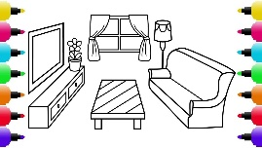](https://www.google.com/url?sa=i&url=https%3A%2F%2Fpaintingvalley.com%2Fliving-room-drawing&psig=AOvVaw21pgnGS2J1fCXjPzQTLtbh&ust=1588774669062000&source=images&cd=vfe&ved=0CAIQjRxqFwoTCKDYl4v1nOkCFQAAAAAdAAAAABAD)[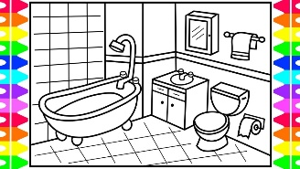](https://www.google.com/url?sa=i&url=https%3A%2F%2Fwww.youtube.com%2Fwatch%3Fv%3DHgRxajoxZbk&psig=AOvVaw36naqknypC729Hz301mltU&ust=1588774745418000&source=images&cd=vfe&ved=0CAIQjRxqFwoTCIjA-rP1nOkCFQAAAAAdAAAAABAD)[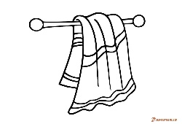](https://www.google.com/url?sa=i&url=http%3A%2F%2Fgetdrawings.com%2Fbeach-towel-drawing&psig=AOvVaw3-bmmv8ckLuhBqZ9qeqCBQ&ust=1588774893551000&source=images&cd=vfe&ved=0CAIQjRxqFwoTCOit5f71nOkCFQAAAAAdAAAAABAD)[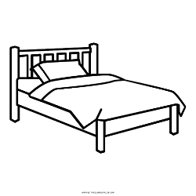](https://www.google.com/url?sa=i&url=http%3A%2F%2Fclipart-library.com%2Fclip-art%2Fbed-clipart-transparent-16.htm&psig=AOvVaw0Ng83oJ2Kw6Wg_hTjIo3zZ&ust=1588775019540000&source=images&cd=vfe&ved=0CAIQjRxqFwoTCLi60K_2nOkCFQAAAAAdAAAAABAD)

**____________ ____________ ____________ ____________**

**ESTUFA TELEVISIÓN LÁMPARA TELÉFONO**

[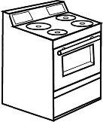](https://www.google.com/url?sa=i&url=https%3A%2F%2Fpaintingvalley.com%2Fstove-drawing&psig=AOvVaw282hRRYmoQqPz2QTDNwF1n&ust=1588775831397000&source=images&cd=vfe&ved=0CAIQjRxqFwoTCMCXm7L5nOkCFQAAAAAdAAAAABAD)[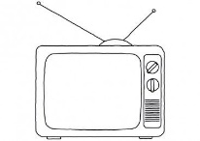](https://www.google.com/url?sa=i&url=https%3A%2F%2Fwww.pinterest.com%2Fpin%2F584342120372013927%2F&psig=AOvVaw1aN8xGvKEckCU1tyc7bPyL&ust=1588775941505000&source=images&cd=vfe&ved=0CAIQjRxqFwoTCJDa6Ob5nOkCFQAAAAAdAAAAABAD)[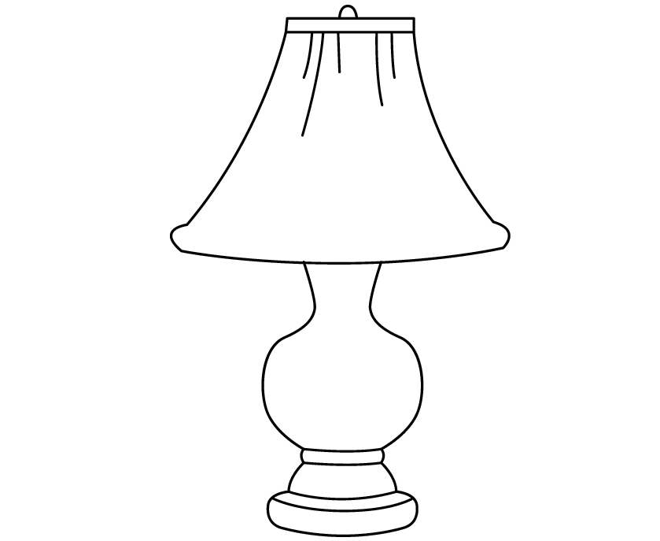](https://www.google.com/url?sa=i&url=https%3A%2F%2Fwww.pinterest.com.au%2Fpin%2F302304193714253625%2F&psig=AOvVaw0FL7Wt_75ruwtd157x-WOm&ust=1588775992269000&source=images&cd=vfe&ved=0CAIQjRxqFwoTCMinjP_5nOkCFQAAAAAdAAAAABAD)[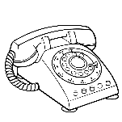](https://www.google.com/url?sa=i&url=https%3A%2F%2Fwebstockreview.net%2Fexplore%2Fclipart-telephone-draw%2F&psig=AOvVaw19iP4TAkkzrQnqNmhs0lxD&ust=1588776064761000&source=images&cd=vfe&ved=0CAIQjRxqFwoTCMDz0KH6nOkCFQAAAAAdAAAAABAD)

**____________ ____________ ____________ ____________**

**Write the Spanish word after each room or household item.**

1. bathroom ____________________________ 7. lamp ____________________________

2. towel ____________________________ 8. bed ____________________________

3. television ____________________________ 9. telephone ____________________________

4. bedroom ____________________________ 10. stove ____________________________

5. living room___________________________ 11. glass ____________________________

6. kitchen ____________________________ 12. house ____________________________