 Kindergarten Connection

February, 2025



Themes

Groundhog Day

Valentine’s Day

Presidents’ Day

Black History

Reading Skills

Phonics- qu,v,z,short a and short i review

Skills: blending and reading cvc words, sentence structure

Sight words: have, what

Grammar: Verbs and adjectives

Science

Unit 7- Force and Motion

Unit 4- Day and Night, Space

Social Studies

Black History Month, Presidents’ Day, Valentine’s Day

Math

Chpt.9 Put together and take apart numbers to 5

Chpt.10 Put together and take apart numbers to 10

Important Dates

2/4 100th Day of School

2/7 Nest Lunch and 1st Friday Treats

2/14 Valentine’s Day in Classrooms

2/17 Presidents’ Day-NO SCHOOL

2/20 PTO

Reminders:

* Please remember to send a labeled small snack and water bottle each day with your student.
* Please label all jackets, lunch boxes and snack bags

Thank you for your help!

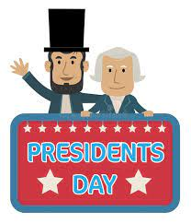The Kindergarten Team: Mrs. Campbell, Mrs.Deason, Mrs.Lindsey, Mrs.Ramos, Mrs.Randall, Mrs.Rockwood, Ms.Lindquist, Ms.Hammond

