**Phillips Curve**

The Phillips Curve is a graph that shows the inverse relationship between inflation and unemployment. It is a mirror image of the aggregate supply curves.

•Movement Along the Short-Run Phillips Curve: A Change in Aggregate Demand (Shifting the AD curve), causes a movement along the Short-Run Phillips Curve (SRPC).

•Shifting the Short-Run Phillips Curve- 4 scenarios *(you are most likely to see #1&2 on AP exam)*

1. A change in Aggregate Supply (Shifting the SRAS curve), causes a shift in the Short-Run Phillips Curve (SRPC).

Below are side-by-side graphs of the AS/AD model and Phillips Curve. It shows the movement that occurs on the Phillips graph when there is a shift in SRAS.

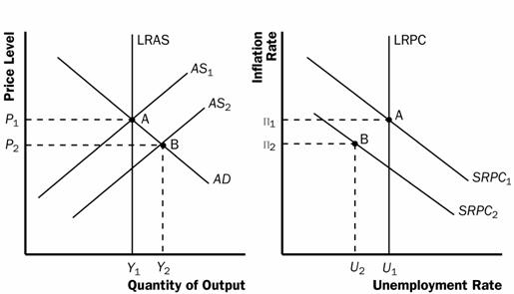

1. Expected Rate of Inflation is also a determinant and shifts the SRPC

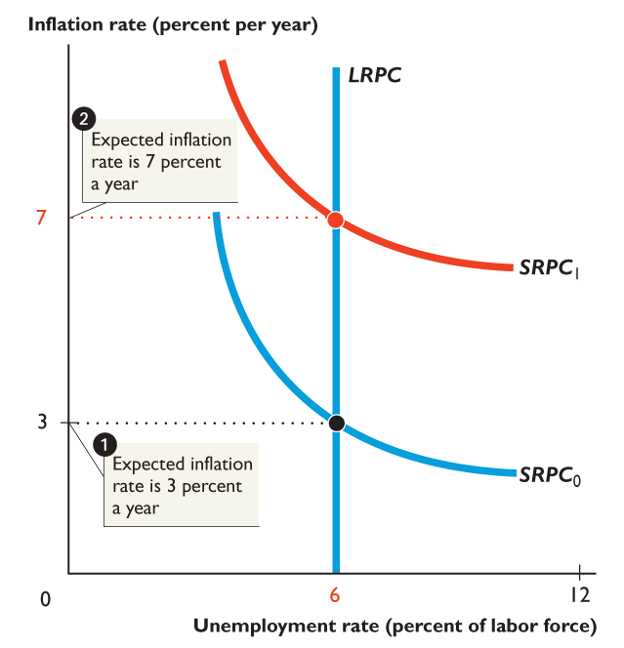

1. If the LRAS shifts the LRPC shifts and the SRPC must follow.

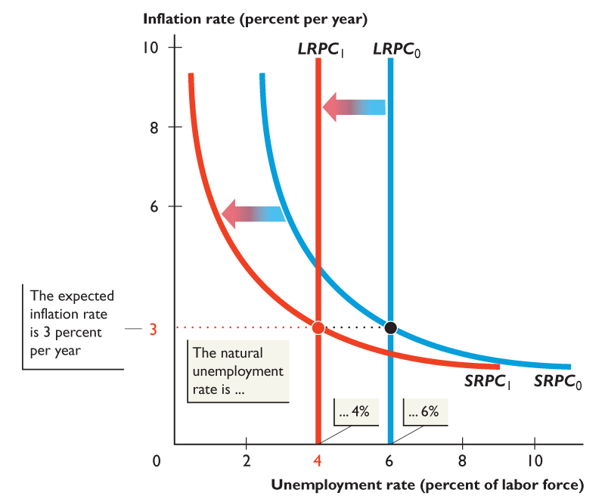

1. Natural Rate Hypothesis- is the proposition that when the inflation rate changes, the unemployment rate changes *temporarily* and eventually returns to the natural unemployment rate.
2. The inflation rate is 3 percent a year and the economy is at full employment, at **point *A***.
3. Then the inflation rate increases. In the short run, the increase in inflation brings a decrease in the unemployment rate — a movement along *SRPC*0 to **point *B***.
4. Eventually, the higher inflation rate is expected and the short-run Phillips curve shifts upward to *SRPC*1 to **point *C***. At the higher expected inflation rate, unemployment returns to the natural unemployment rate—the natural rate hypothesis

