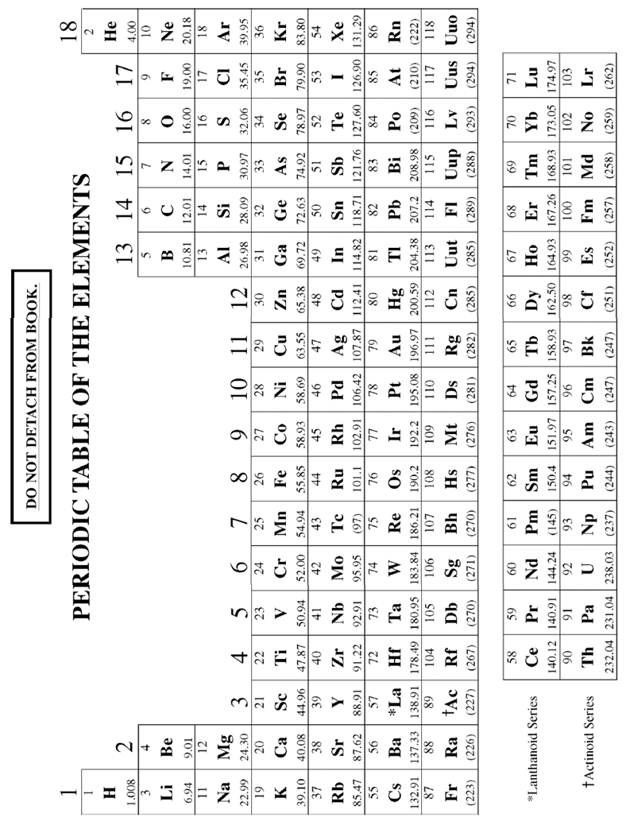

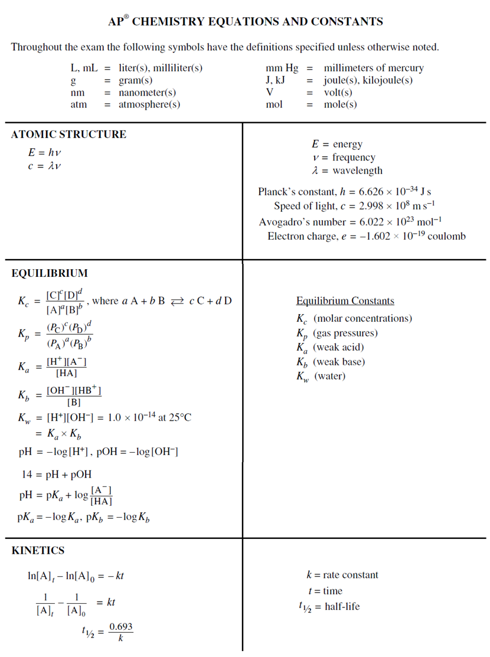

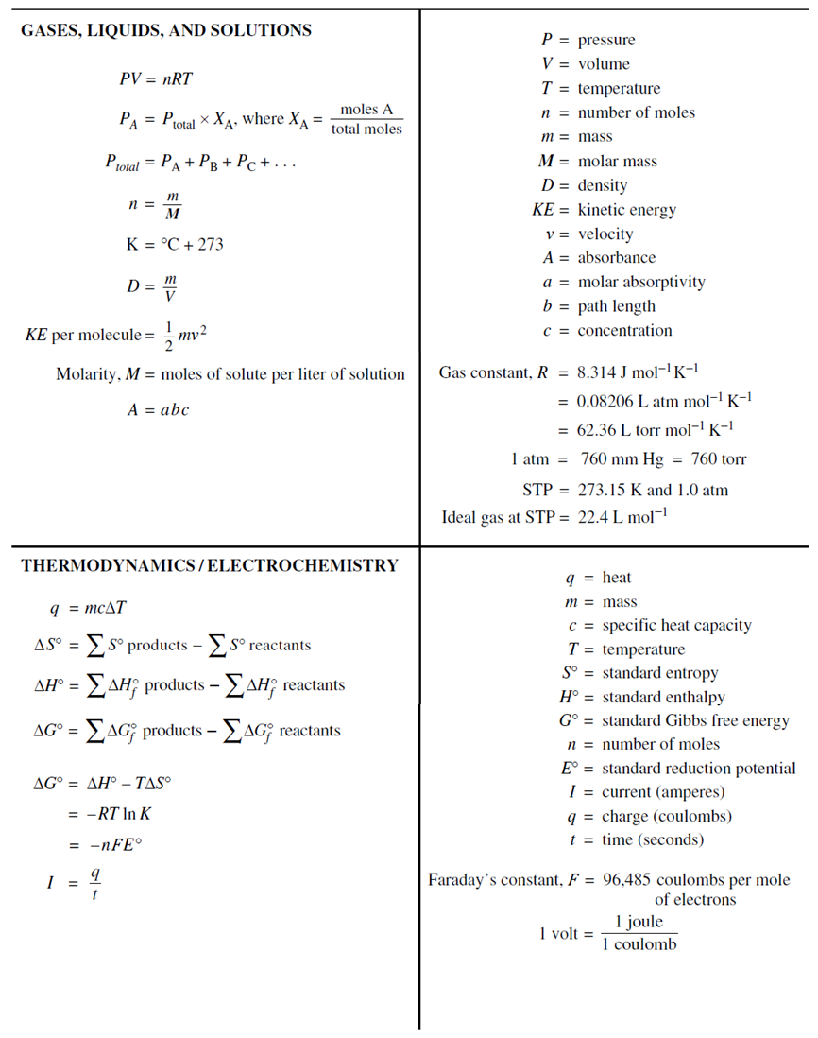

**CHEMISTRY**

**Section II**

**7 Questions**

**Time – 1 hour and 45 minutes**

**YOU MAY USE YOUR CALCULATOR FOR THIS SECTION.**

**Directions:** Questions 1–3 are long free-response questions that require about 23 minutes each to answer and are worth 10 points each. Questions 4–7 are short free-response questions that require about 9 minutes each to answer

and are worth 4 points each.

Write your response in the space provided following each question. Examples and equations may be included in

your responses where appropriate. For calculations, clearly show the method used and the steps involved in arriving

at your answers. You must show your work to receive credit for your answer. Pay attention to significant figures.

INSERT QUESTION HERE

GO ON TO THE NEXT PAGE