**Read this paragraph and answer the questions below in English or Spanish if you want.**

[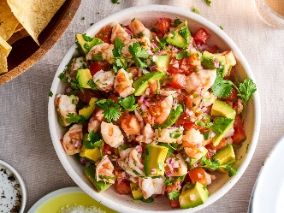](https://www.google.com/url?sa=i&url=https%3A%2F%2Fwww.thekitchn.com%2Fceviche-recipe-22902965&psig=AOvVaw2W0XihpE5wUwGwZw4lyfS8&ust=1589382335839000&source=images&cd=vfe&ved=0CAIQjRxqFwoTCIC4r-fMrukCFQAAAAAdAAAAABAD)**Ceviche para la cena**

Normalmente (*normally*) los peruanos cenan sobro (*about*) las nueve de la noche. La comida principal (*The main meal*) es a las dos de la tarde. El ceviche es ideal para una cena saludable.

1. What are the typical meal times in the United States?

2. Is this the same or different from the meal times in your part of Florida?