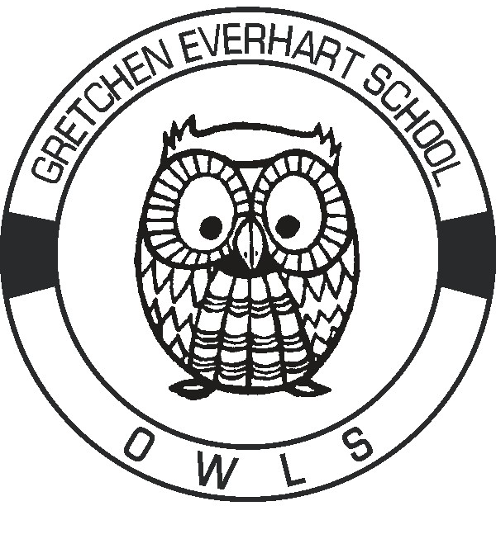

Videos from Everhart Staff to Students

Our “OWLMAZING” Judy Jecko, Art Teacher, put the following videos together for our students so we can continue to connect with them while we are out of school. ENJOY!

We miss you videos for students from Everhart Staff:

Elementary / Pre-K Students

Link to video: <https://animoto.com/play/F6uIoTStUF1ewMR1z6zNxA>

Middle School / ISC Students

Link to video:<https://animoto.com/play/PsJPx8V0sDqyAi7M9PlwQA>

High School / Post-Secondary Students

Link to video:   <https://animoto.com/play/wfNnX4twlrt61KRr2X7NXA>