1. 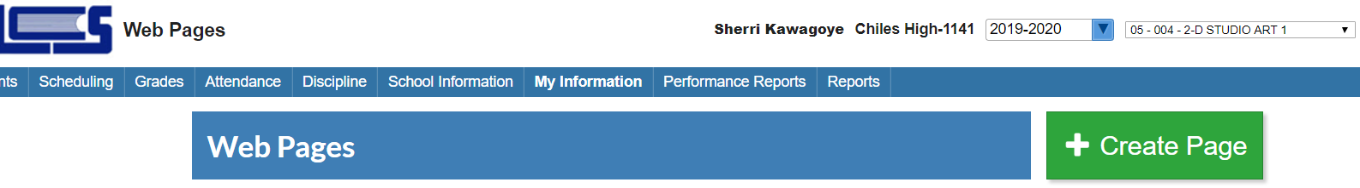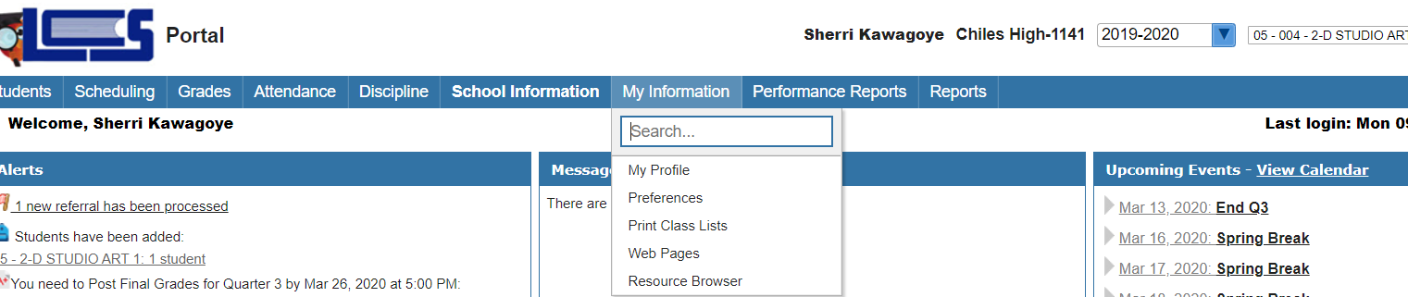START with **My Information Section-Select Web Pages**

FOCUS DIRECTIONS ---- STARTING A TEACHER WEBPAGE FOR REMOTE LEARNING

1. 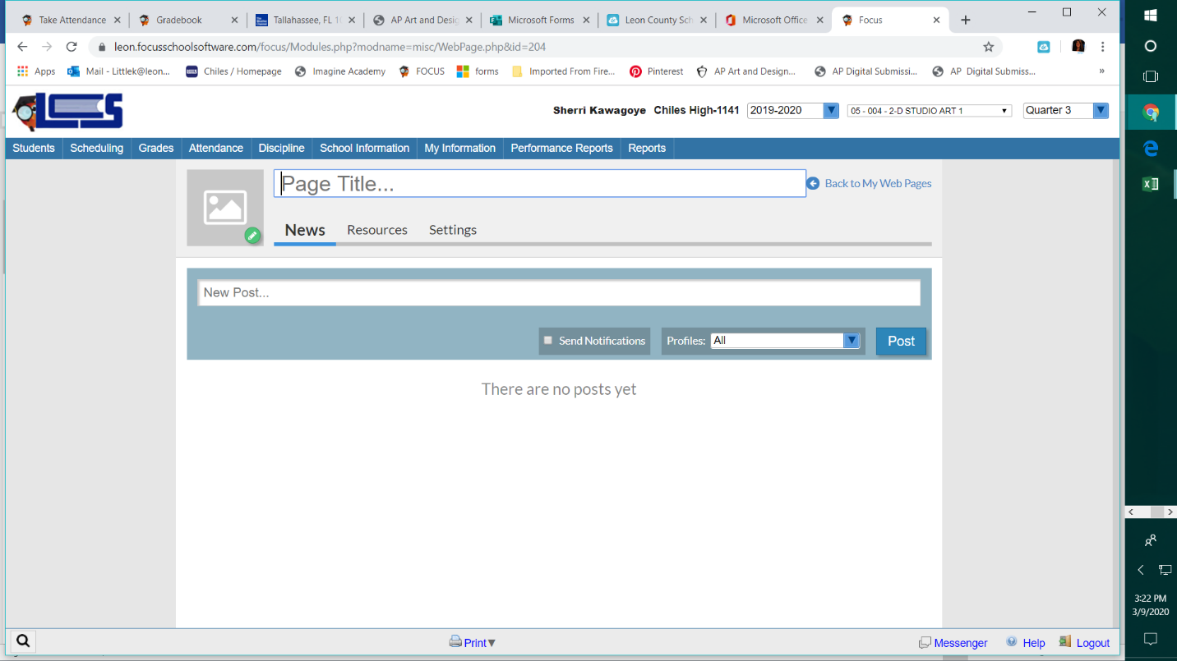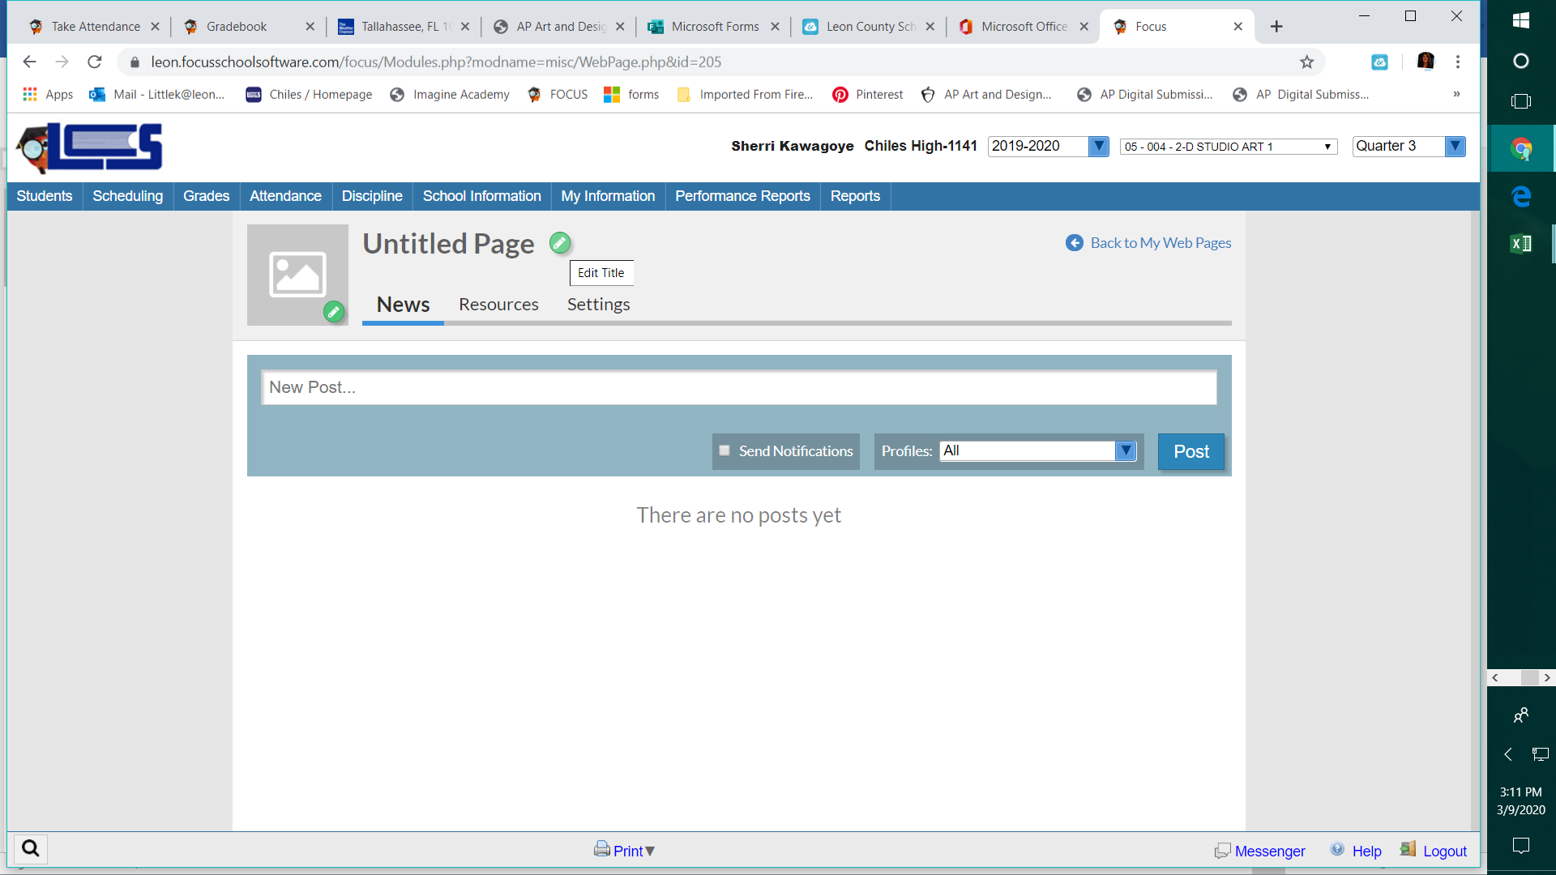Create Page- One for each Class/Level Group ***Click green pencil to name pages/add icons***
2. Once Page Groups are Titled, you simply have two active communication tabs and settings.
3. **News** is the announcement page and notice the alerts setting below the message field:

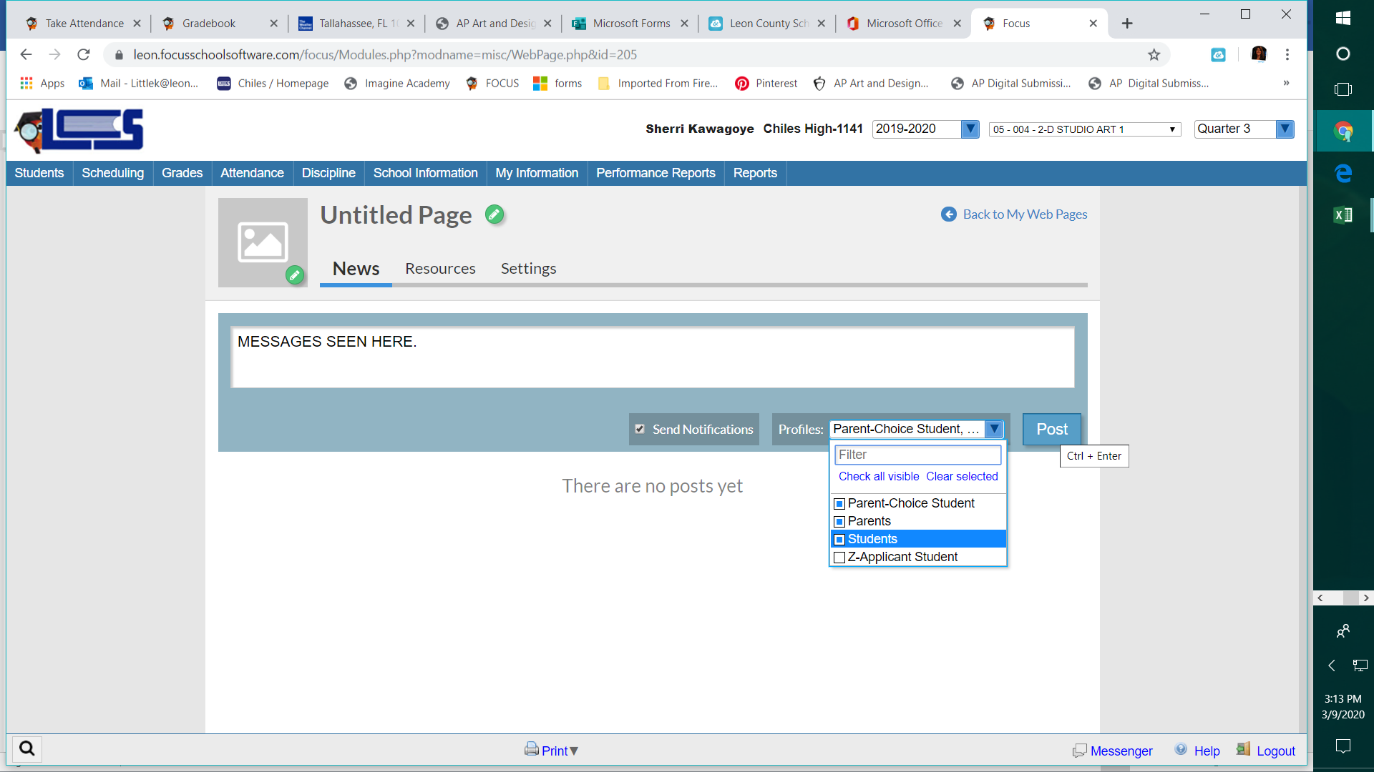

1. **Resources** is thelocation for shared files, and you can create folders there also to stay organized.

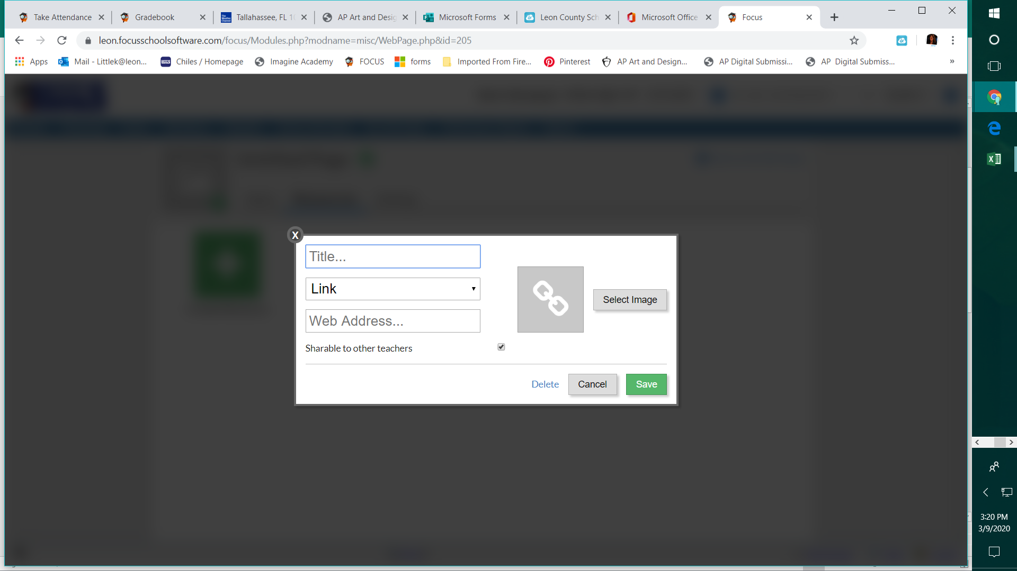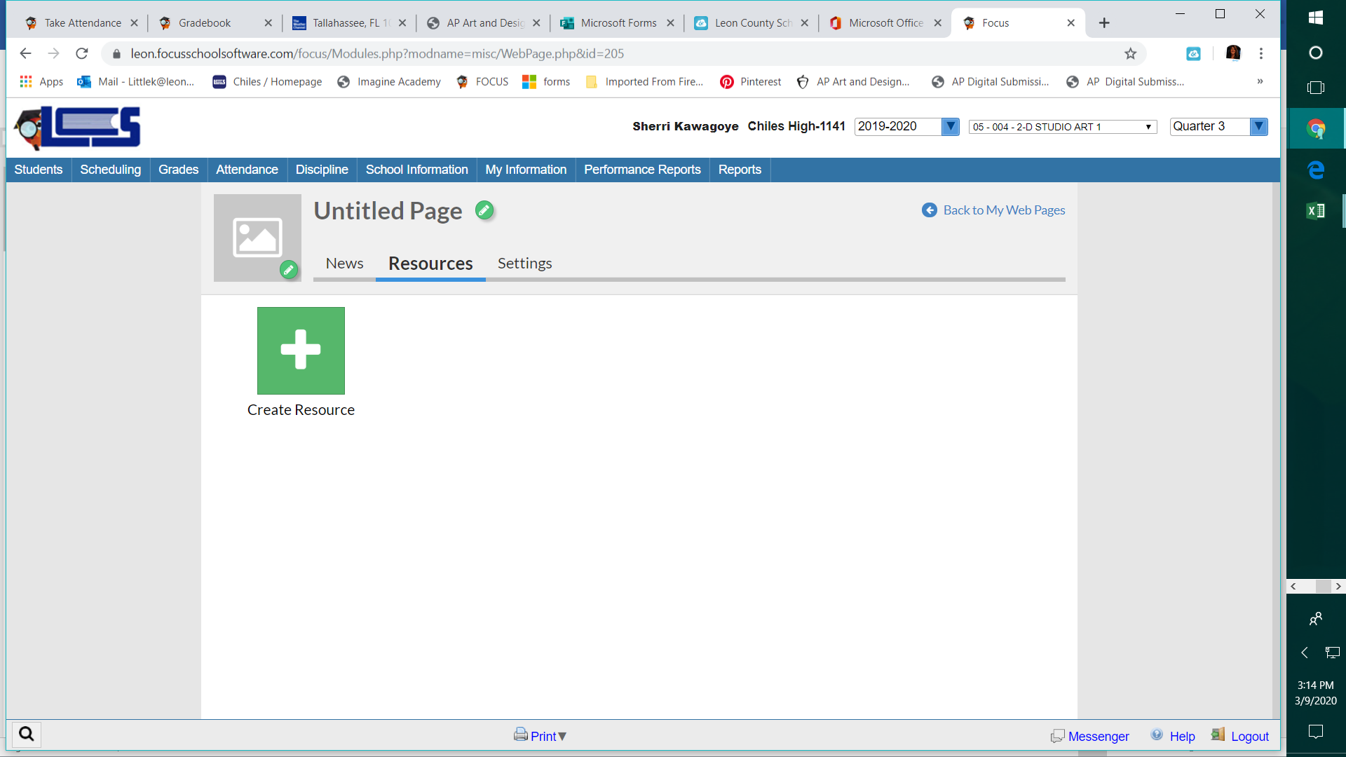

1. Click **CREATE RESOURCE**
   1. **Title** your resource
   2. paste WEB LINK, FOLDER, or FILE
   3. An image icon can be added also.

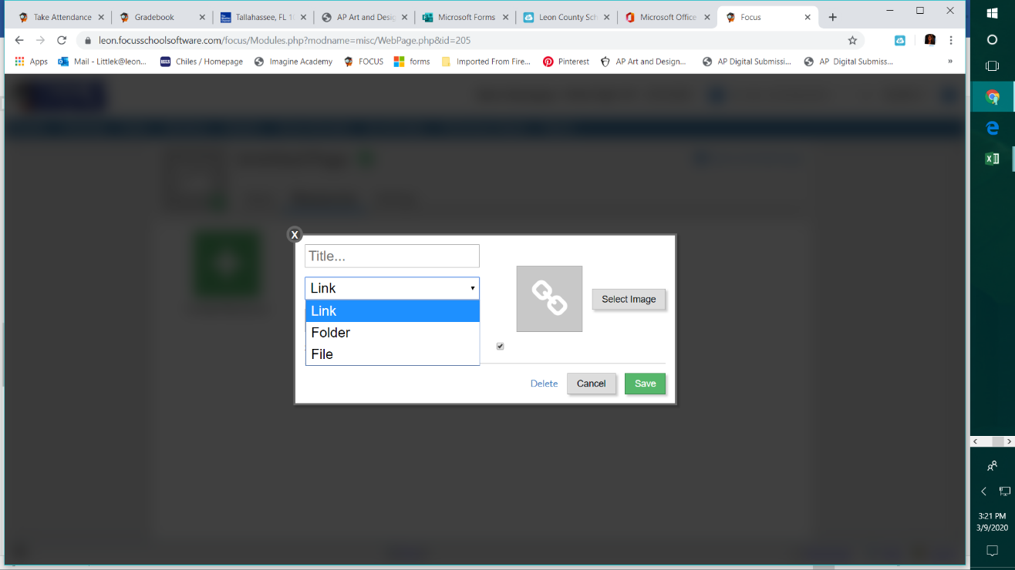

EXAMPLES

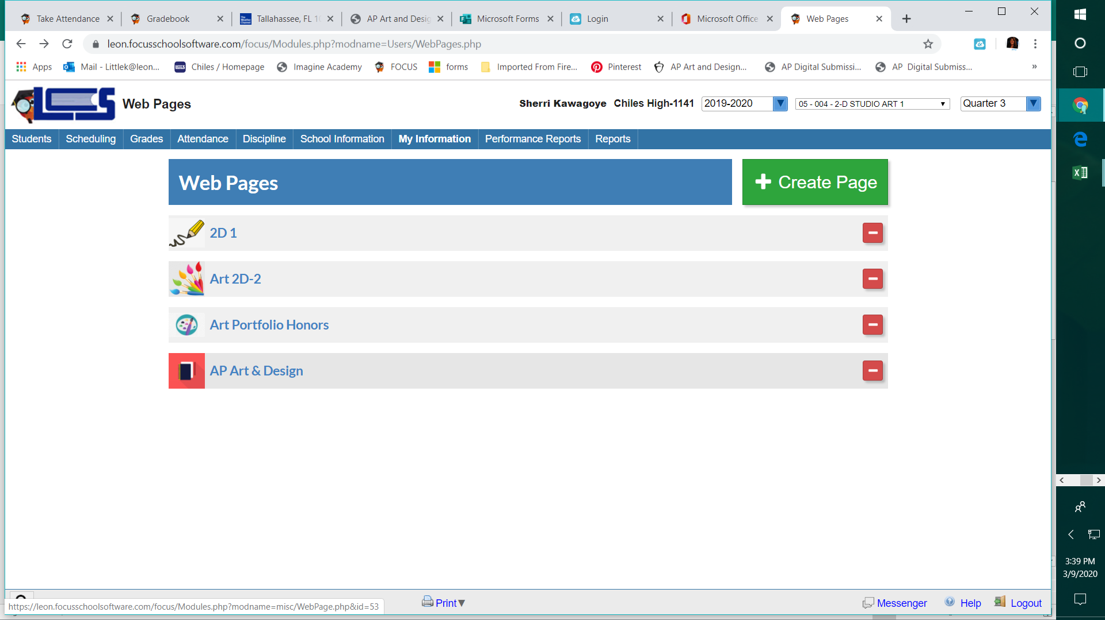

Resources

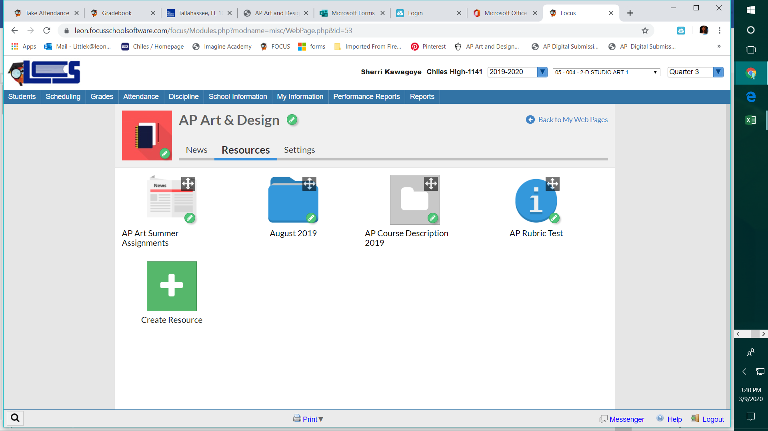

SEE NEXT PAGE FOR STUDENT SUBMISSION TO GRADEBOOK TIPS

STUDENT SUBMISSION TO GRADEBOOK TIPS

GO to GRADEBOOK Screen

When ADDING ASSIGNMENT—Make sure you check the box- ALLOW STUDENT UPLOADS

Also, you can set a

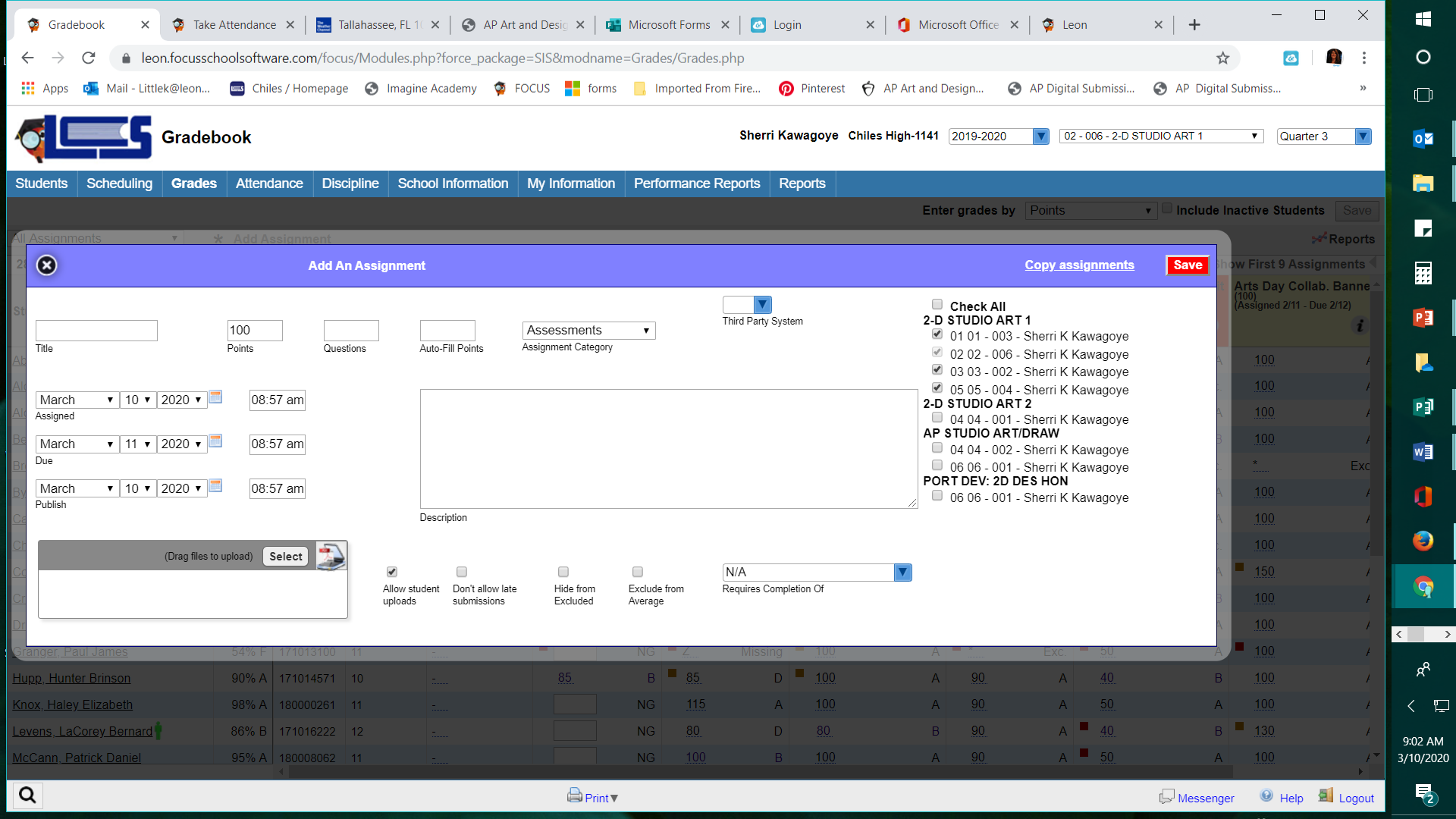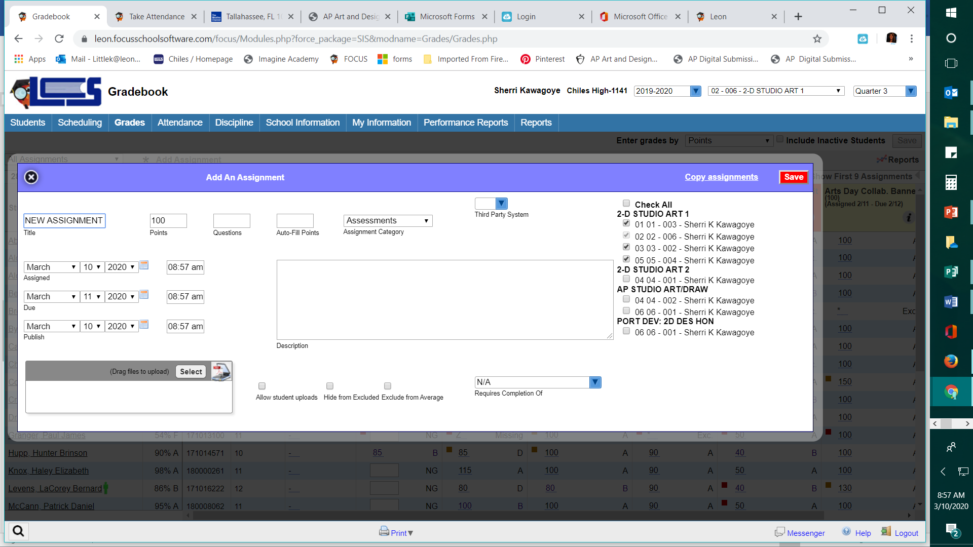After Box is checked for student file upload- NOTE that the box appears –DO NOT ALLOW LATE SUBMISSIONS.

**FILES that can be uploaded: TEACHERS AND STUDENTS**

**WORD, PDF, POWERPOINT, EXCEL, and .JPG IMAGES**

**Teacher can open files within the gradebook !**

**Click the pencil icon to see file.**

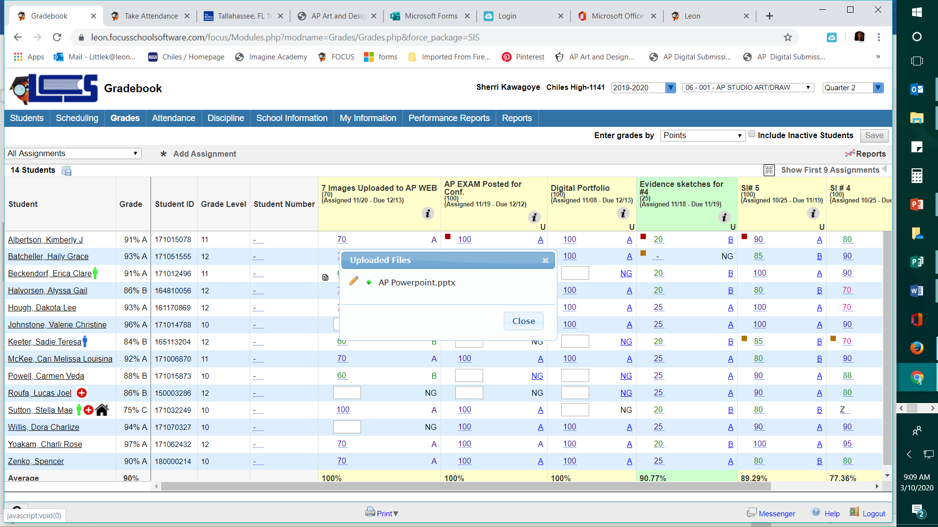

**When adding a new assignment: Teachers can attach directions/ resources also.**

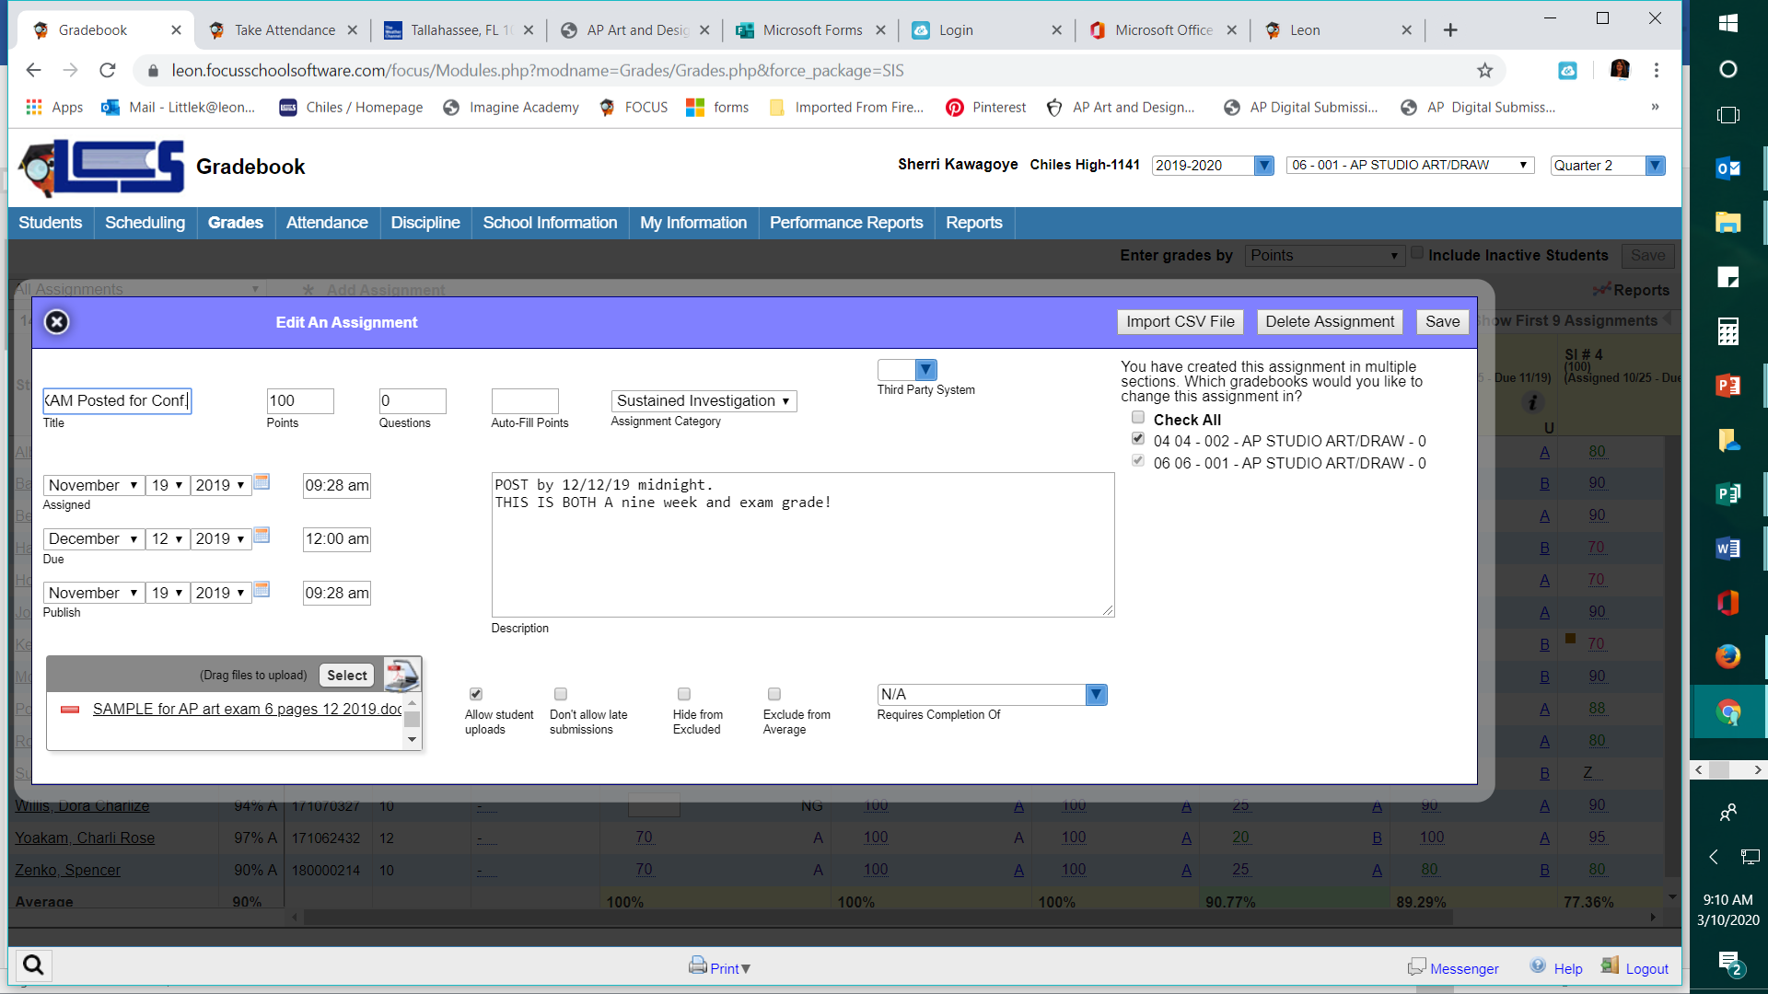

**FOR MORE HELP:**

<https://www.leonschools.net/Page/35557> HOW- TO DOCS

**Focus Helpdesk Hours 7am - 5pm** 850-487-7524 [**FocusHelp@leonschools.net**](mailto:FocusHelp@leonschools.net)