**Read the paragraph below about Frida Kahlo, and then answer the questions after the paragraph. You can answer the questions in English.**

**Frida Kahlo**

[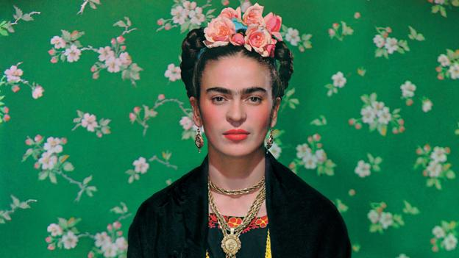](https://www.google.com/url?sa=i&url=http%3A%2F%2Fwww.bbc.com%2Fculture%2Fstory%2F20180615-unlocking-the-hidden-life-of-frida-kahlo&psig=AOvVaw0i1BDNasZfozGChtDXKN1e&ust=1589312693706000&source=images&cd=vfe&ved=0CAIQjRxqFwoTCIDa87DJrOkCFQAAAAAdAAAAABAJ)**La pintora mexicana (*the Mexican painter*) Frida Kahlo es una figura importante en la historia de arte. Sus cuadros (paintings) son autorretratos (*self-portraits*) y temas del arte popular de México.**

1. What American artists do you know?

2. Are their depictions realistic or unrealistic?