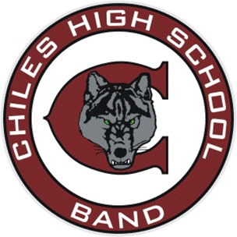 

Example of

Standard College Ready Credit Requirements for Diploma

for Band Students

Four-Year Program based on a Six-Period day 2024-25

**24 Credits needed for graduation including 19 college prep academic credits**

# Freshman Year Sophomore Year Junior Year Senior Year

+ English I + English II + English III + English (AP, etc.)

+ Mathematics + Mathematics + Mathematics * **Mathematics (AP, etc.)**

+ Science + Science + Science **\* Elective**

+ HOPE (Take online summer) +World History + American History + Economics/Amer. Gov’t

+ Foreign Language + Foreign Language **\* Elective** AP Music Theory **\* Elective** AP Music Theory

**\***  Band 1(Meets Fine Arts Requirement + Band 2 + Band 3 or (Honors 5) + Band 4 or (Honors 6)

**\*** Beginning Band **\*** Beginning Band **\*** Beginning Band **\*** Beginning Band

+ Required

**\* Elective Classes**

7th Period Elective Jazz Band (Must be a member of the Concert class for most instruments.

Taking online classes like Hope PE and Personal Finance over the summer though Leon County Virtual School or FLVS to free up elective choices.