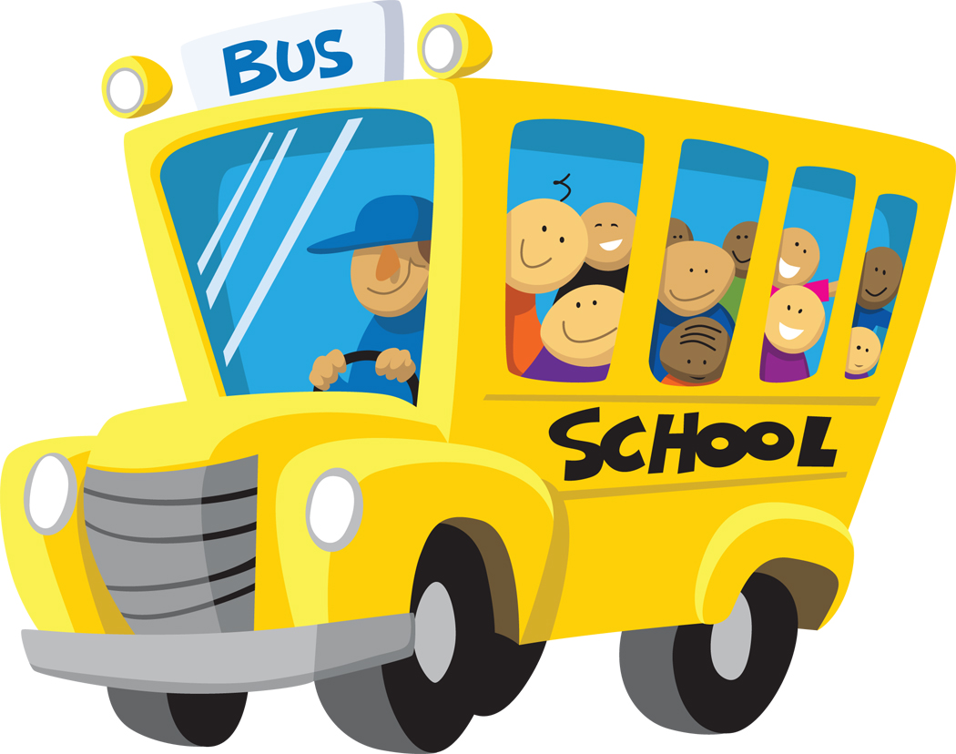Kindergarten Special Activities

**Spring Field Trip/Cost of Bus**:

\***TBA**

**Scholastic Weekly Readers:**

*These Monthly magazines are engaging, instructional, and help teach social studies/science standards!

**Kindergarten T-Shirts:**

*Class t-shirts will be used for field trips and on-campus special events

**Craft Supplies/EOY Activities:**

*Craft parties and end of the year student activities and gifts

The Kindergarten Activities fee is **$40.00** per child. This fee will include our Spring Field Trip/Bus, cost of Scholastic Weekly Readers, t-shirts, craft supplies and end-of-the-year activities/gifts. You will be able to pay this fee through E-Funds until Friday, September 27th**.**

**\*Note:** To create your E-Funds account, go to the Hawks Rise homepage and click the **E-Funds** under the **Easy Links** section. You will need your child’s student number.

Thank you!

The Kindergarten Team 😊