**Energy Pyramids BrainPOP Video Notes**

1. What is an energy pyramid?____________________________________________
2. Primary consumers eat ___________________.
3. Herbivores eat ________________.
4. Secondary consumers eat ______________.
5. Carnivores eat ____________________.
6. Decomposers _____________________________________________________.
7. A food web is made of ___________________________________________________________.
8. Animals eat to ______________________________.
9. Producers produce ______________________________________________________________.
10. Through the process of _____________________producers make ___________.
11. Glucose is ___________________________________________.
12. Where does all energy in an ecosystem come from? _________________
13. Generally are there more producers or top predators in an ecosystem? Why? ____________________

________________________________________________________________________________________________________________________________________________________________________

1. 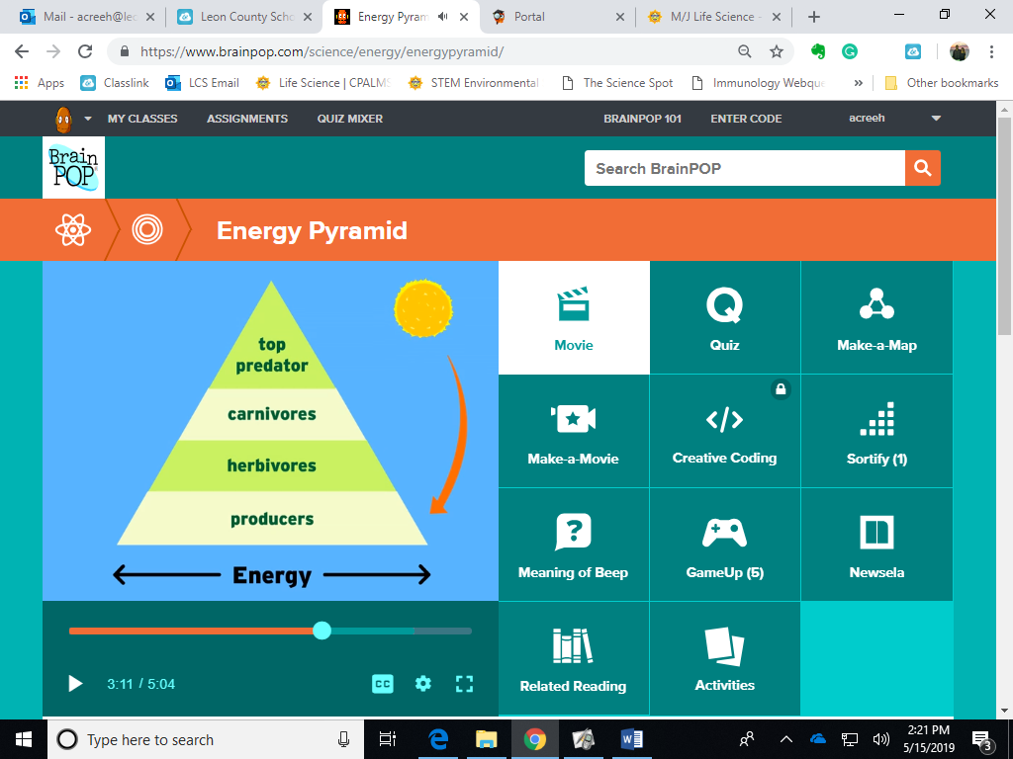Fill in the blanks of this energy pyramid.
2. Describe where the energy that we get from eating plants and producers comes from.

________________________________________________________________________________________________________________________________________________________________________