Occupational Therapy Activity of the Week

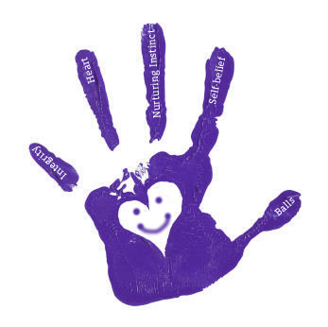

In- Hand Manipulation Part 2

Last week we started working on in-hand manipulation skills, the ability to move objects around in your hand, using only 1 hand. Here are some more fun activities that work on these skills! Turn them into a game for added fun!

* 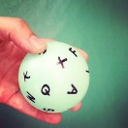 Write letters all over a tennis-sized ball or smaller. Hold it with the fingertips of one hand and move your thumb to each letter in your name- using only one hand to move the ball. Make it more challenging by having a race to spell words.
* Practice screwing/unscrewing a small water or soda bottle cap. Hold the bottle still with one hand and unscrew the cap using only the fingertips of the other hand. Make it more challenging by having a race with a partner to get a cap from across the room, racing back to the bottle to put it on, and going back for another one until all your bottles have caps.
* Lace beads, shifting the string in your hand as you push it through the bead.
* 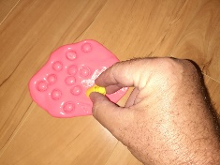 Spread out some putty or Playdoh on the table. Take the cap of a marker in your fingers, push it into the dough and twist the cap to cut out “cookies.”

* Cap Mix-up: Remove all the marker caps and put them back on so they do not match. See how fast you can put them back on the correct markers.
* 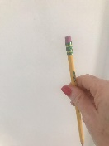 Marker Climb: Hold a marker or pencil vertically. Using only 1 hand, “climb up and down” the marker or pencil.
* 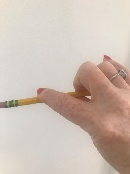 Marker Twirl: Hold a marker or pencil horizontally and twirl with your thumb, index, and middle fingers without dropping the marker.
* Pencil flip: Hold a pencil as if writing. Walk your fingers up to the eraser, and flip the pencil around in your hand so that you are now holding the eraser end. Make it easier by using a short pencil, marker, or crayon.
* If that’s not enough of a challenge: Can you uncap a pen and put the cap on the end of the pen without dropping either the cap or the pen?