**Instructions to Complete**

**Position Control Form in Liquid Office**

The Position Control Form is now located in Liquid Office so that the submission and approval can be tracked. The process to complete a PCF has not changed, only the use of technology to submit the form.

1. **Log on to the District’s main web page (**[**www.leonschools.net**](http://www.leonschools.net)**). Click on LCS Employees.**

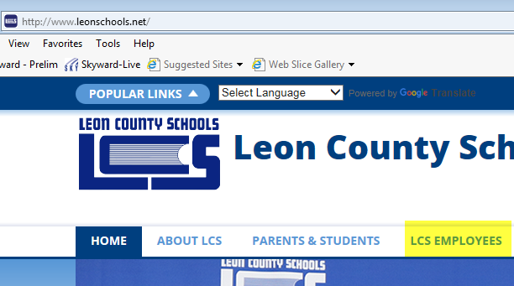

2. **Scroll down under “Employee Quick Links” and click on Liquid Office.**

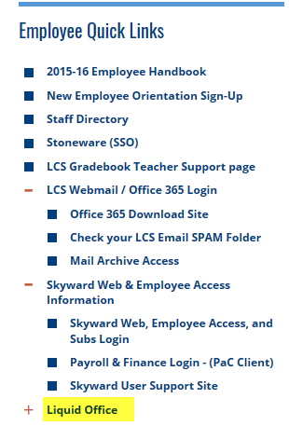

3. **Sign on with your computer username and password.**

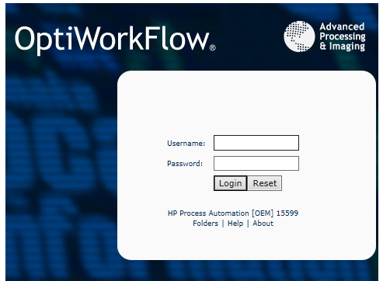

4. **Click on the “Folders” tab on the top, left-hand side of the screen. Click on “Personnel.”**

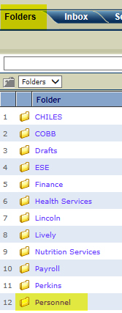

5. **Click on PCF-Skyward**

6. **The electronic PCF is identical to what you have been using in paper form or Excel format from the Human Resources web page. This is a two-page document.**

**The date will automatically pre-fill**. All other areas will be completed as normal.

**When you choose your Building/Cost Center Center number from the pull-down menu and then hit your ‘tab’ key, the site name will pre-fill.**

**There are still formulas to calculate your percentages based on the hours you enter for each line of coding needed.**

**“NEW” indicates this is what you want the line of coding(s) to be now.**

**“CURRENT” indicates what is currently showing in Skyward.**

**“COMMENTS” will be used as usual (i.e, name of person (if altering funding), etc.)**

7. **When completed, scroll to the bottom and leave the choice as “submit” and click “go.”**

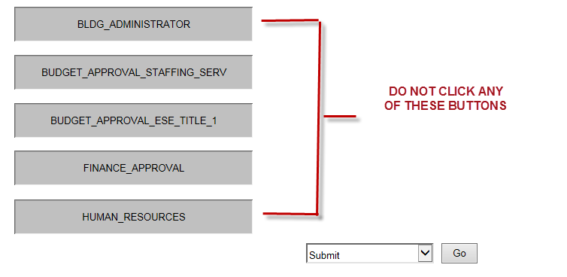

8. **ALWAYS leave the “USER” button marked. DO NOT click “routing completed.”**

**If your site administrator’s name does not appear in the box, click ‘search’**

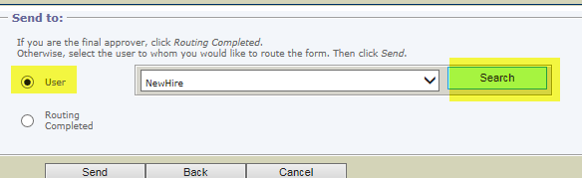

**Type in the last name of your site administrator and click “search.” After you locate his/her name, click the button to the left of their name and click “OK.”**

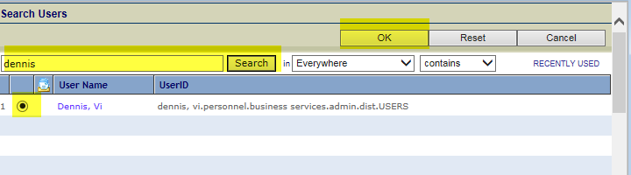

9. **In the “NOTES” section, type a note to remind your site administrator to forward Staffing_Services_Secondary_Special OR Staffing_Services_New_Hire_Elementary, depending on site then click “Send.”**

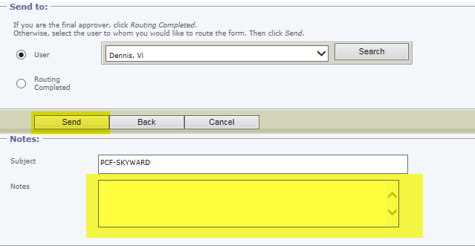

10. **Your site administrator will receive the PCF in their Liquid Office “In Box.”**

11. **Site Administrator must open the PCF, click on “Bldg Administrator,” leave the choice as “approve” and click “go.”**

11. **ALWAYS leave the “USER” button marked. DO NOT click “routing completed.”**

**If Staffing Services’ name does not appear in the box, click ‘search’**



**Type in Staffing Services and click “search.” After you locate the appropriate Staffing Services name (Elementary or Secondary), click the button to the left and click “OK.”**

**Click “send.”**

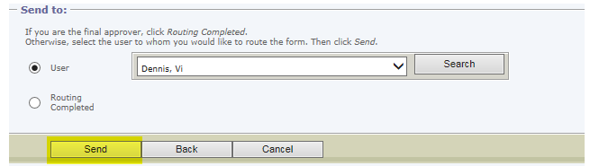

**Any questions regarding PCFs, please contact Vicki Morrison in Human Resources at 487-7127 or** [**morrisonv@leonschools.net**](mailto:morrisonv@leonschools.net)**.**