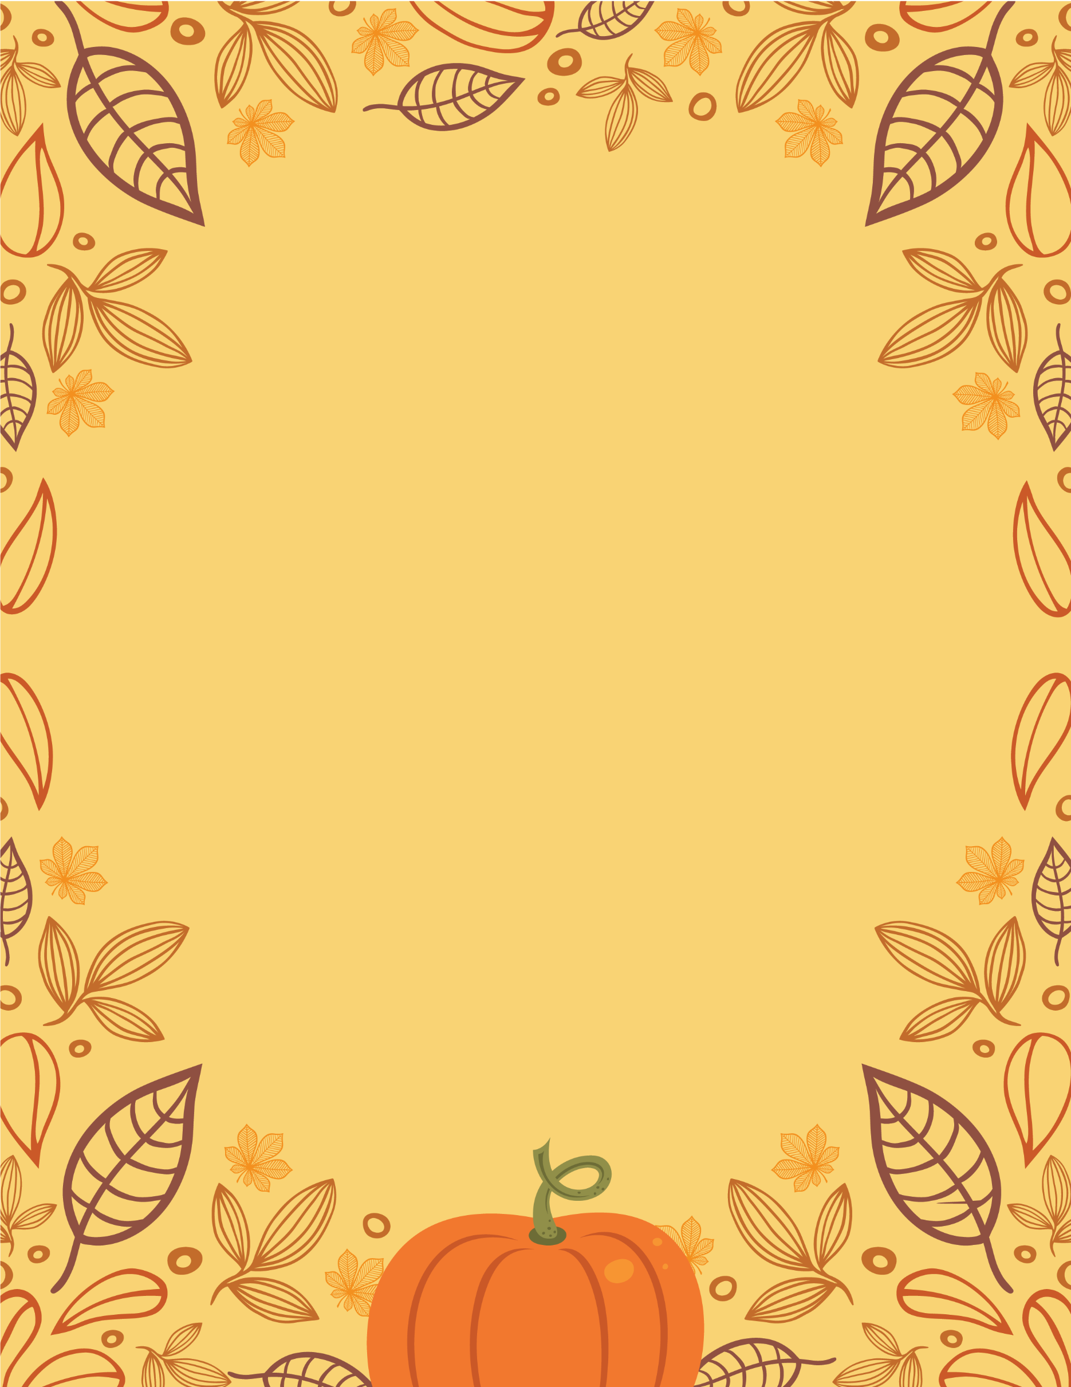

**ATTENTION SENIORS**

**Below are dates of some colleges that are visiting Chiles this Fall. Please be sure to stop by and visit with the recruiters as they are on our campus.**

college visit days

CELEBRATION

**Tabling @ Chiles Auditorium**

* 9/6 – Stanford University
* 9/17 – Wake Forest University
* 9/24 – Troy University
* 9/26 – Vanderbilt University

**LCS College & Career Fair @ TSC**

* 9/30 Leon County Schools **2024 College & Career Fair Location: Tallahassee State College 5:00-6:30 PM**

**Group Presentations**

* 10/2 – FSU – Seniors Only sign-up in Guidance
* 10/2 – UF – Seniors Only – Sign-up in Guidance

November 26, 20xx at 7 PM

Join us in celebrating   
the fall harvest with friends,   
food, and more!

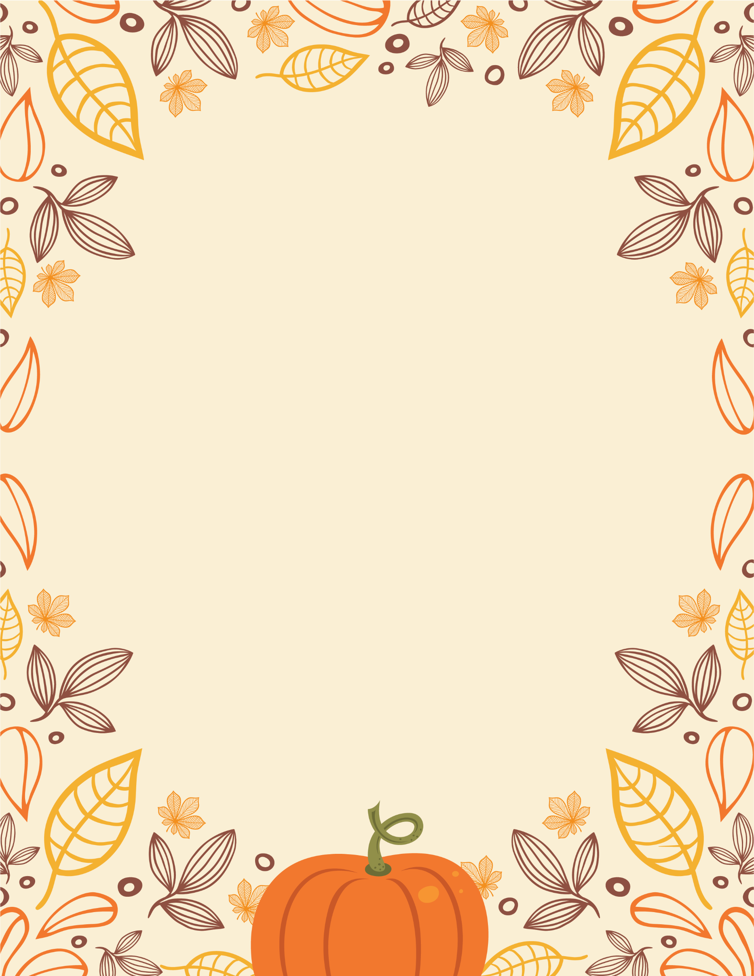

Get ready for a

FALL HARVEST

CELEBRATION

November 26, 2024 at 7 PM

Join us in celebrating   
the fall harvest with friends,   
food, and more!