**NAME** __________________________________________________ **DATE** _____________ **PERIOD** ____

**WS 10-3 a Equations of Circles**

**Write the equation of each circle.**

1. center at (0, 0), radius 2
2. center at origin, radius 6
3. center at (2, -4), radius 1
4. center at (5, -3), diameter 26
5. center at (12, 2), diameter 13
6. center at (9, 3), radius 1
7. center at (2, -4), diameter 9
8. center at (-3, 7), radius 

**Write the equation of each circle.**

**Find the center and radius of each circle.**

**11.** *x*2 + *y*2 = 36 1**2.** (*x* − 2)2 + (*y* − 7)2 = 49

**13.** (*x* + 1)2 + (*y* + 6)2 = 16 1**4.** (*x* + 3)2 + (*y* − 11)2 = 12

Write the standard equation of each circle.

**15.** center (0, 0); *r* = 7 1**6.** center (4, 3); *r* = 8 1**7.** center (5, 3); *r* = 2

**18.** center (−5, 4); *r* =  1**9.** center (−2, −5); *r* =  **20.** center (−1, 6); *r* = 

**Write the standard equation of each circle**

|  |  |  |
| --- | --- | --- |
| **21.** | **22.** | **23.** |
| **24.** | **25.** | **26.** |

**Find the center and radius of each circle. Then graph the circle.**

**27.** *x*2 + *y*2 = 25 **28.** (*x* − 3)2 + (*y* − 5)2 = 9

**29.** (*x* + 2)2 + (*y* + 4)2 = 16 **30.** (*x* + 1)2 + (*y* − 1)2 = 36

**Write the standard equation of the circle with the given center that passes through the given point.**

**31.** center (0, 0); point (3, 4) **32.** center (5, 9); point (2, 9)

**33.** center (−4, −3); point (2, 2) **34.** center (7, −2); point (−1, −6)

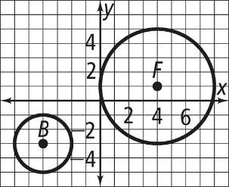**Write the standard equation of each circle in the diagram at the right**.

**35.** *B*

**36.** *F*

**Write an equation of a circle with diameter *.***

**37.** *A*(0, 0), *B*(−6, 8) **38.** *A*(0, −1), *B*(2, 1) **39.** *A*(7, 5), *B*(−1, −1)