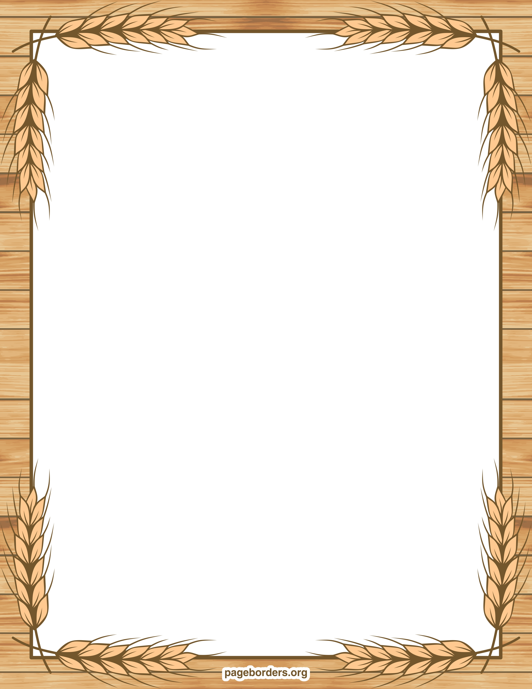

Important Dates:

5/3 First Friday

5/6 Last Day for sight words and reading packets homework

5/22 All Media Center books are due

5/27 Memorial Day- No School

5/29 Water Day- Early Release Day

5/30 Fun Fitness- Early Release Day

5/31 Last Day of School- Early Release Day

*On Early Release Days, school ends at 12:20

**Week Topic:**

Our Natural Resources

**Essential Question:**

How can things in nature be used to make new things?

**Morning Centers:**

Long O activities

Poetry book

Story Sequence of Events

Clay Creations

Leveled Readers

Dirt Cups

Your Turn Book

**Afternoon Centers:**

Mother’s/Father’s Day gift

Earth Day

Earth Day Magazine

**Wonders**

Sight words: look, where

Long O

Informational text

**Math**

Chapter 11- Measurement: comparing lengths, heights, and weights

**Science/ Social Studies**

Taking care of our Earth/ Plants parts and how they grow

Mrs. Smiley and Miss Brannon’s News

April 26, 2019

We are roaring into Spring!!

