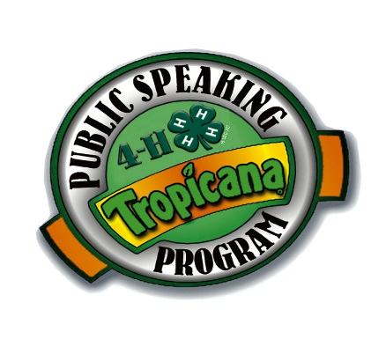 Tuesday, October 10, 2017

Dear Parents/Guardians:

Congratulations! Your child is about to embark upon the exciting and challenging world of public speaking.

Your child’s school will be participating in the 4-H/Tropicana Public Speaking Program. This educational program, designed to introduce fourth, fifth, and sixth grade children to the concept of public speaking, is administered by your local 4-H Cooperative Extension Office and sponsored by Tropicana.

Students throughout Florida will compete in classroom and school-wide speaking contests with winners going on to a county competition.

To prepare your child for this educational opportunity, your child’s teacher has been provided with a series of instructional materials introducing the 4-H/Tropicana Public Speaking Program. Throughout the next few weeks, your child will learn how to research, organize, and deliver a speech on a topic of their choice. Your child will need your support at home…from the selection of a topic to the preparation of the final speech.

Speeches:

* must be original and student written.

* must be a different topic each year of participation.

* must be between 2 and 3 minutes.

* may **NOT** utilize visual aids (no costumes, posters, props, etc.)

**Note Cards are not considered visual aids.**

Classroom winners will advance to a school contest and school winners will advance to a county contest. The county contest (for school winners) will be held Saturday, January 27, 2018 at the Perry Paige Auditorium on Florida A&M University campus. If you would like additional information about this important program, please don't hesitate to call your child's teacher or the Leon County 4-H Office at 606-5204.



and your local

4-H County Extension Office