Spanish 1
Extra Credit Project: Due by lunes, 10 de diciembre

Create a Power Point with one sentence and one picture illustrating the sentence you wrote. Here is what you will need to include:

Paso 1: Write 20 sentences using the verb ser with the following vocabulary:
10 sentences need to tell about physical characteristics of a person.
10 sentences need to tell about personality traits of a person.
Incorporate your vocabulary of people and family to help create these sentences. You will need two sentences for each of the following conjugations: (*Hint: there are 10 conjugations so one sentence needs to have the physical characteristics and the other needs to have the personality traits)
Yo, tú, él, ella, usted, nosotros, vosotros, ellos, ellas, ustedes
You must write the sentence in both English and Spanish and do not repeat attributes!!!
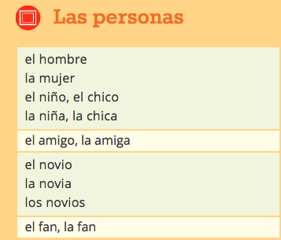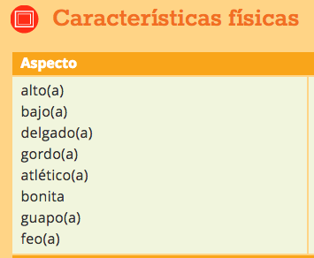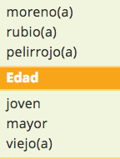

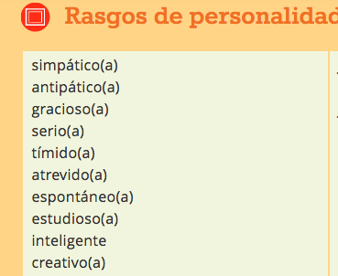

Paso 2: Now you will write 10 sentences using the same conjugations as before but this time you will need to use your verb estar.

Incorporate your emotions vocabulary and do not repeat any. As well as write the sentences in both Spanish and English.
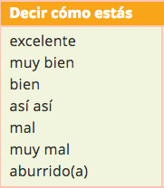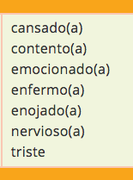

Paso 3: Finally, incorporate your 5 sensation phrases with the verb tener. Look back in your vocabulary and notes to find these. Use one sentence for each of the following conjugations: yo, tú, él, nosotros, ellos. Illustrate these as well and write your sentences in both Spanish and English.

Grading:
Incorporated all criteria (has 35 sentences): 35 pts
Conjugated the verbs correctly and used them correctly: 10pts
Included pictures for each sentence: 5 pts.
Creativity: 5pts.
Has a title slide with your name and an ending slide: 5pts

Total points: 60 points

