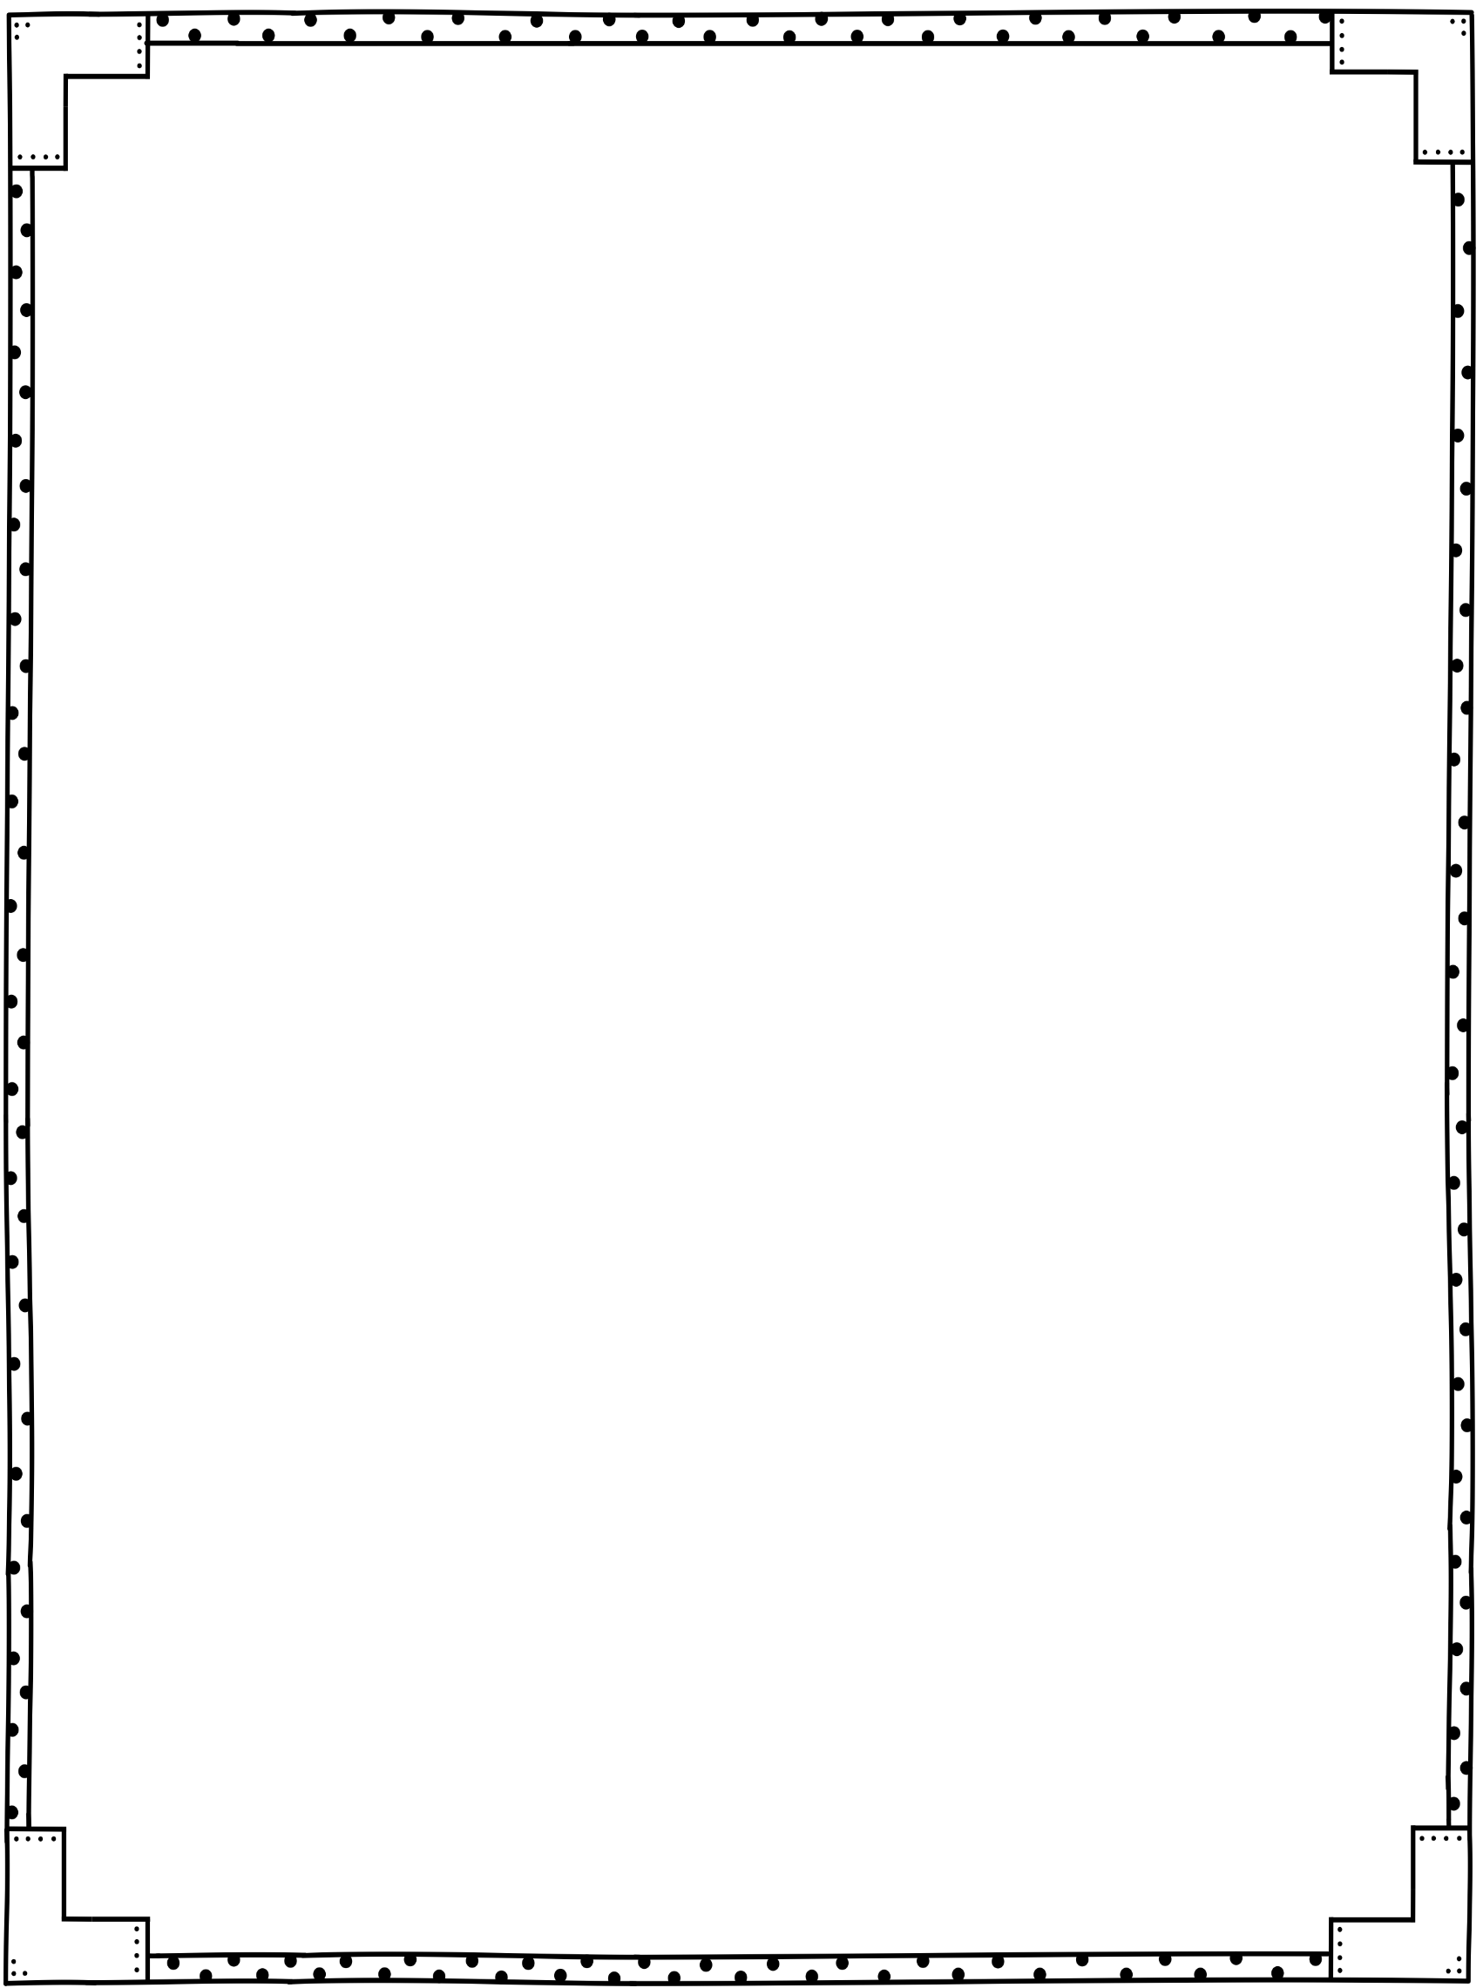



August 8, 2024

Dear Parents,

Welcome to third grade! I am so excited to meet everyone. I can’t wait to learn a little more about each and every one of you! It is going to be an awesome year in third grade and I can’t wait to get started. Here are just a few things you will need to know for Monday morning.

**ARRIVAL**: The first bell rings at 8:25, school supervision begins at 7:45 a.m. Students are to report to the cafeteria, and will be released at 8:00 a.m. For the first two days of school, the students will come directly to my classroom. I am located downstairs in room 16-111. Monday, August 12th -13th students will report directly to classrooms. Starting Wednesday August 14th, students will go to the cafeteria, but after 8:00 a.m., they will go directly to the intermediate playground (the basketball court) for supervision until the bell rings. They may NOT wait at the classroom door before the bell. Backpacks are placed in a specific area on the playground for each class.

**ATTENDANCE**: Making sure your child arrives on time and ready to learn each day is essential to their success in third grade. Please make sure you make every effort to have your child at school unless they are out sick.

**SUPPLIES**: It would be helpful if your child could bring the following items in the first day or two of school. These items do not have to be brand new, just in usable condition. If you ordered the PTO Supply Kit, your child’s supplies should have been shipped already.

Please do not label any supplies, we will take care of this in class.

* 4 folders with pockets and fasteners for inserting notebook paper

(1 red, 1 green, 1 blue, and 1 yellow)

* 1 wide rule composition notebook

*earbuds to use with Chromebook

* 2 yellow highlighters * 6” sharp tip scissors for kids * 6 glue sticks

* colored pencils, #2 pencils (12 pk sharpened), * dry erase markers (2ct), crayons (24ct)

**BELONGINGS**: It is best to label ALL of your child's personal items, especially jackets, lunch boxes and backpacks. Please do not allow your child to bring anything that is or might be considered a toy.

**LUNCH:** Our lunch time is from 10:35 – 11:00. The cafeteria will be providing hot lunches this year. Breakfast and Lunch are free to all students this year. Sodas and candy are not allowed for lunch; so please refrain from sending these items in. [www.schoolcafe.com](http://www.schoolcafe.com) has information regarding school menus etc. Please see our FOCUS emails for more information about visiting your child for lunch bunch.

Mrs. Vinson’s Homeroom



**SNACK**: We will have a short snack time each day.  Please send in healthy, simple,**non-messy** snacks. If you send in a water bottle, please make sure it is labeled with your child’s name and has a re-closable top to prevent spills.  If you would like to send in a birthday treat for your child’s special day, please let me know in advance. At this time, we can only accept items that are store bought and pre-packaged or sealed.

**SPECIAL AREA:** Our Special Area time is from 12:00 – 12:45. We will have PE, Art, Music, Media/Guidance. Students must wear sneakers for PE, and I recommend that they wear sneakers daily because we do lots of walking and have recess every day.

**DISMISSAL**: Please note that car pick-up is located in the back of the school. We will also dismiss students from the third-grade gate (next to our third-grade building) at 2:50 for parents who wish to pick up there. This year we will be utilizing the pikmykid app for all students, please download the app prior to August 12th. You will utilize this app to notify the school of any dismissal changes.

**MEDICINE**: If your child needs to take ANY medicine at school, it MUST be handled by the clinic. You will need to complete a medication form in the front office when you bring in medication. Do not send any medication, including cough drops, in your child's lunchbox or backpack. **If your child is sick please keep them home. Your child must be fever-free for 48 hours without the aid of medication prior to returning to school.**

**PARENT INFORMATION:** The most efficient way to get school information is to make sure that your parent contact information is current and updated in FOCUS. All school emails will be sent to email addresses on file in FOCUS.

**COMMUNICATION**: Anytime you have a concern or question please e-mail [vinsons@leonschools.net](mailto:vinsons@leonschools.net) or send in a note with your child. Our class webpage (www.leonschools.net/grauerm) can be accessed directly or from the school’s home page. The Parent Portal allows you to view your child’s grades (FOCUS) and current average as each nine-week progresses. I will be communicating with you weekly through your child's Friday Folder. This is an important tool that allows you to monitor your child's progress, both academically and socially. Please sign your child’s folder each week. Monthly newsletters will be sent to keep you informed about our class studies and scheduled events. The e-newsletter will include important information so please be sure I have your most current email address.

Looking forward to an

amazing year in third grade!

Mrs. Vinson