**ALGEBRA 2 WS 10.4 A ELLIPSES**

**Match the equation with the graphs labeled I-IV.**

1. 
2. 
3. 
4. 

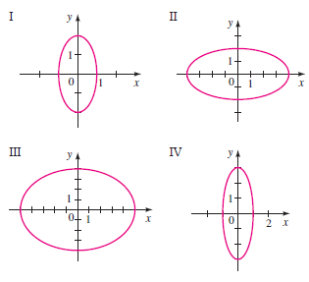

**Find the vertices, foci, and eccentricity of the ellipse. Determine the lengths of the major and minor axes.**

1. 
2. 
3. 
4. 

**Find the vertices, foci, and eccentricity of the ellipse. Determine the lengths of the major and minor axes.**

1. 
2. 

**Find an equation for the ellipse that satisfies the given conditions.**

1. Foci , vertices 
2. Foci , co-vertices 
3. Length of major axis 4, length of minor axis 2, foci on the y-axis.
4. Endpoints of major axis , distance between foci 6

**Determine the eccentricity and explain.**

1. 

**Write an equation for the ellipse:**

1. 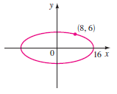
2. 