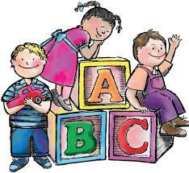PRE-K

Sealey Elementary School

**Preschool Supply List**

● Backpack *** Label with child’s name visible on the outside (No wheels)

● Complete change of clothes labeled with your child’s name in a large Ziploc bag.

● Non-breakable water bottle

● Pencil box (able to fit set of markers and crayons)

● 1 box of Kleenex

● 1 Solid color folder to keep in backpack

● 1 box gallon size Ziploc bags and 1 box sandwich size Ziploc bags

● 1 large box or bagged snack (crackers, fruit snacks, cereal, goldfish, cheez-it, capri-sun)

● 2 box Crayola markers, basic colors

● 2 box 24 count crayons

● 1 Watercolor Paint set

● 1 bottle Elmer’s Liquid Glue

● 4 glue sticks

● 1-Clorox Wipes

