**PRE CALC WS 12.1 Name:**

**Complete the table of values and use the table to estimate the value of:**

1.  x = 8.9, 8.99, 8.999, 9.001, 9.01, 9.1



1.  x = -0.1, -0.01, -0.001, 0.001, 0.01, 0.1

3. State the value of the given quantity using the picture:





1. State the value of the given quantity using the picture:





a.

b.

c.

d.

e.

f.



**Graph and find the given information:**

1. 
2. 
3. 
4. 
5. 
6. Find the 

**PRE CALC WS 12.2 Name:**

**Evaluate each limit by showing all your steps – the LONG WAY!!**

1.  13. 

**Use direct substitution, if possible, to evaluate each limit. If not possible, explain why.**

1. 
2. 
3. 
4. 

**Evaluate each limit.**

18.  19. 

20.  21. 

22.  23. 

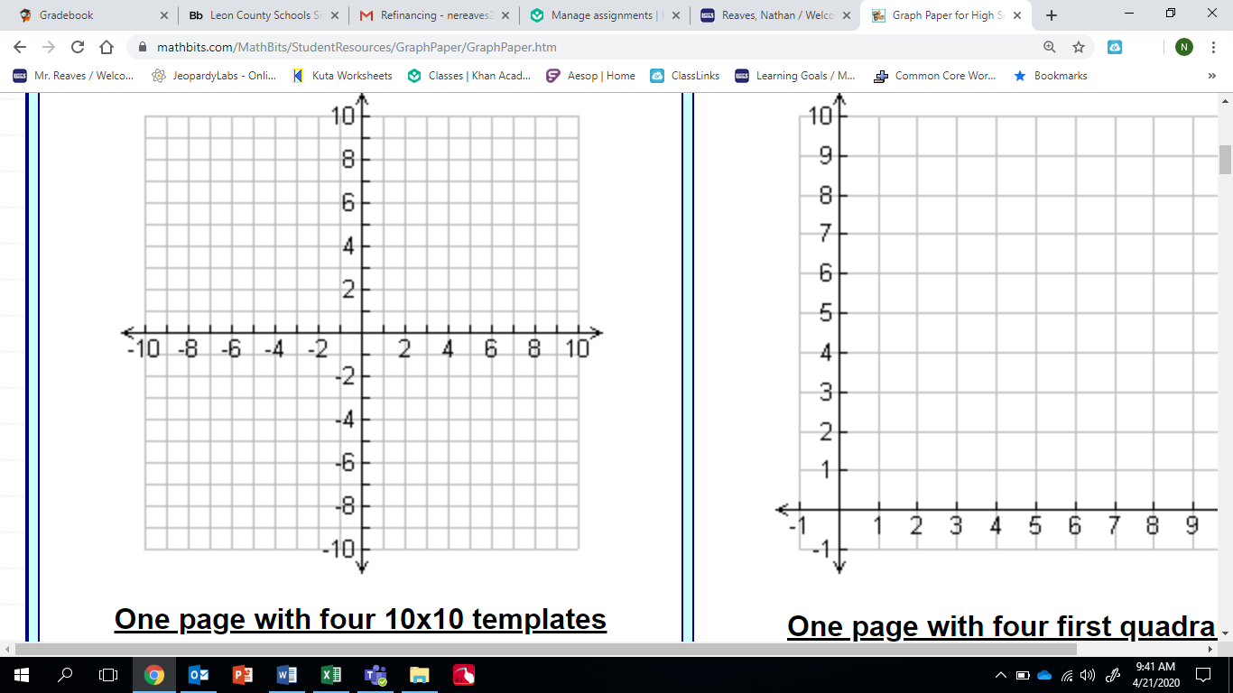**24. Graph and find the following values, if they exist. **



**25. State the value of the limit, if it exists from the given graph.**



