**Animal Match**

**Copy the Spanish name under each picture.**

**OSO RANA CABALLO VACA**

[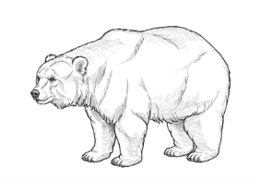](https://www.google.com/url?sa=i&url=https%3A%2F%2Fdesign.tutsplus.com%2Ftutorials%2Fhow-to-draw-a-bear--cms-30310&psig=AOvVaw3g7axCPhAH3tlmYQ7DAorF&ust=1588003159189000&source=images&cd=vfe&ved=0CAIQjRxqFwoTCJDx8aS7hukCFQAAAAAdAAAAABAD)[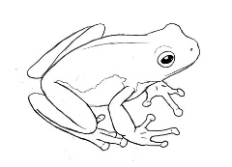](https://www.google.com/url?sa=i&url=https%3A%2F%2Fwww.pinterest.com%2Fpin%2F514536326155900122%2F&psig=AOvVaw1jdK8yVnJWtI1H9OcmIi8a&ust=1588003307414000&source=images&cd=vfe&ved=0CAIQjRxqFwoTCJDP0sC7hukCFQAAAAAdAAAAABAD)[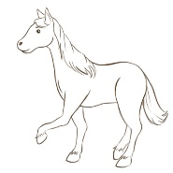](https://www.google.com/url?sa=i&url=http%3A%2F%2Fclipart-library.com%2Fhorse-drawing-easy.html&psig=AOvVaw0yt_aGpW2ZdxE7gmffJYfp&ust=1588003399429000&source=images&cd=vfe&ved=0CAIQjRxqFwoTCMiC2oC8hukCFQAAAAAdAAAAABAD)[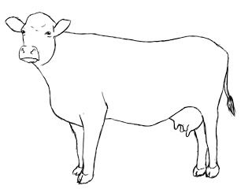](https://www.google.com/url?sa=i&url=https%3A%2F%2Fwww.pinterest.com%2Fpin%2F26740191512737588%2F&psig=AOvVaw1EBEL_WuMjmd9CJPY4wzXj&ust=1588003510107000&source=images&cd=vfe&ved=0CAIQjRxqFwoTCNDu2qK8hukCFQAAAAAdAAAAABAD)

**____________ ____________ ____________ ____________**

**ELEFANTE OVEJA PUERCO GALLINA**

[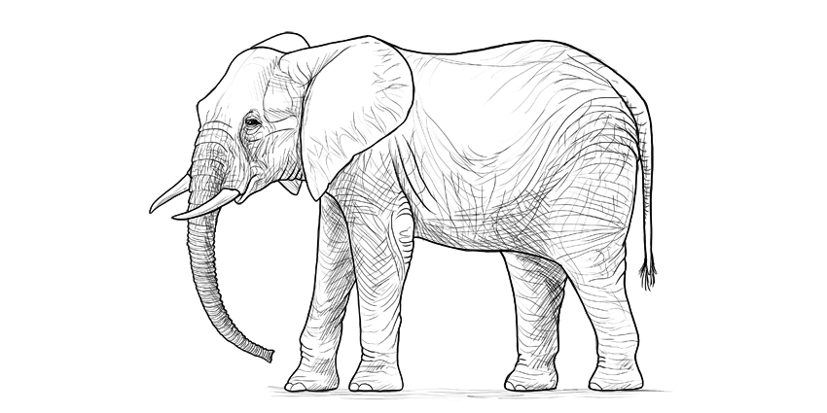](https://www.google.com/url?sa=i&url=https%3A%2F%2Fdesign.tutsplus.com%2Ftutorials%2Fhow-to-draw-an-elephant-step-by-step--cms-29550&psig=AOvVaw2JeTL9ks_drwEqtNnJ1Hnu&ust=1588003677914000&source=images&cd=vfe&ved=0CAIQjRxqFwoTCKCWtv-8hukCFQAAAAAdAAAAABAD)[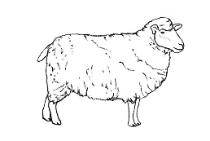](https://www.google.com/url?sa=i&url=https%3A%2F%2Fwww.pinterest.com%2Fpin%2F425449496030380532%2F&psig=AOvVaw29ZvJ4d2EieA06mg9mV-LI&ust=1588003864530000&source=images&cd=vfe&ved=0CAIQjRxqFwoTCJC1gcq9hukCFQAAAAAdAAAAABAD)[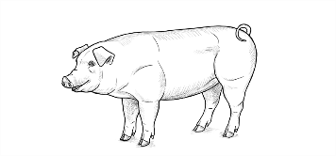](https://www.google.com/url?sa=i&url=https%3A%2F%2Fdesign.tutsplus.com%2Ftutorials%2Fhow-to-draw-a-pig--cms-30794&psig=AOvVaw3gQWJ73ZkwqMOV_RNIo2V0&ust=1588003935113000&source=images&cd=vfe&ved=0CAIQjRxqFwoTCPDty-29hukCFQAAAAAdAAAAABAD)[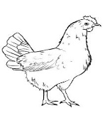](https://www.google.com/url?sa=i&url=https%3A%2F%2Fwww.pinterest.com%2Fpin%2F269371621434983617%2F&psig=AOvVaw3sF3YMiS8-DMm8zgVdl2ia&ust=1588003997172000&source=images&cd=vfe&ved=0CAIQjRxqFwoTCLin2om-hukCFQAAAAAdAAAAABAD)

**____________ ____________ ____________ ____________**

**GATO TORTUGA MARIPOSA DINOSAURIO**

[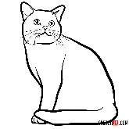](https://www.google.com/url?sa=i&url=https%3A%2F%2Fsketchok.com%2Fanimals%2Fcats%2Fhow-to-draw-the-american-shorthair-cat&psig=AOvVaw0o3E6xZrGg6te3igbF4b63&ust=1588004127272000&source=images&cd=vfe&ved=0CAIQjRxqFwoTCOiHzMe-hukCFQAAAAAdAAAAABAD)[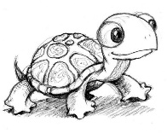](https://www.google.com/url?sa=i&url=https%3A%2F%2Fwww.pinterest.com%2Fpin%2F295408056779742627%2F&psig=AOvVaw0ks5BBlixx8fY-WmxkBlGM&ust=1588004180917000&source=images&cd=vfe&ved=0CAIQjRxqFwoTCKic4u6-hukCFQAAAAAdAAAAABAJ)[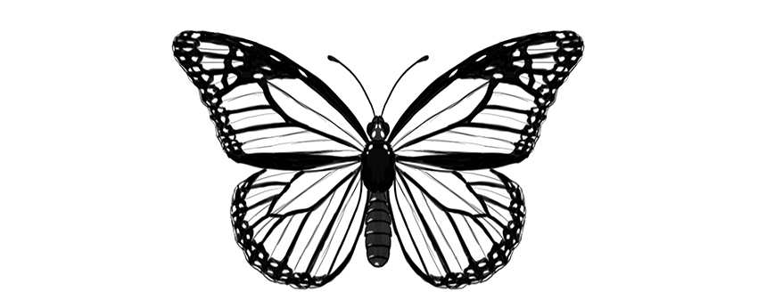](https://www.google.com/url?sa=i&url=https%3A%2F%2Fdesign.tutsplus.com%2Ftutorials%2Fhow-to-draw-a-butterfly-step-by-step--cms-28682&psig=AOvVaw3GBXF2QNUkHE3h0KZN_XnJ&ust=1588004289571000&source=images&cd=vfe&ved=0CAIQjRxqFwoTCPDon5W_hukCFQAAAAAdAAAAABAD)[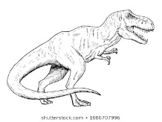](https://www.google.com/url?sa=i&url=https%3A%2F%2Fwww.shutterstock.com%2Fsearch%2Fdinosaur%2Bdrawing&psig=AOvVaw19_2Lzq8OcVmV2S5kdG9nv&ust=1588004367547000&source=images&cd=vfe&ved=0CAIQjRxqFwoTCKD0nry_hukCFQAAAAAdAAAAABAD)

**____________ ____________ ____________ ____________**

**Write the Spanish word for each animal name.**

1. butterfly ____________________________ 7. cow ____________________________

2. sheep ____________________________ 8. bear ____________________________

3. cat ____________________________ 9. elephant ____________________________

4. dinosaur ____________________________ 10. horse ____________________________

5. chicken ____________________________ 11. turtle ____________________________

6. pig ____________________________ 12. frog ____________________________