**PRE CALC WS CIRCLES & ELLIPSES**

**Write each equation in standard form and find the center, foci, length of the major and minor axis, vertices, & co-vertices.**

1. x2 + y2 – 12x + 10y + 12 = 0
2. x2 + 4y2 – 6x – 7 = 0
3. 4x2 + 4y2 – 24x + 32y + 36 = 0
4. 4x2 + 3y2 + 36y + 60 = 0

**Write an equation of an ellipse with each set of characteristics.**

1. Major axis from (-6, 2) to (-6, -8) and minor axis from (-3, -3) to (-9, -3)
2. Vertices at (-4, 4) and (6, 4); foci at (-2, 4) and (4, 4)
3. Foci at (19, 3) and (-7, 3); length of major axis equals 30
4. Vertices at (-2, -4) and (-2, 8); length of minor axis equals 10
5. Vertices at (-10, 0) and (10, 0) and eccentricity *e* is 
6. Center at (2, -4), one focus at  and eccentricity *e* is 

**Determine the eccentricity and explain.**

1. 

**Write an equation of a circle with each set of characteristics.**

1. Center at (-4, -3); tangent to y = 3
2. Center at (2, 0), endpoints of diameter at (-5, 0) and (9, 0)

**Write an equation for the ellipse:**

1. 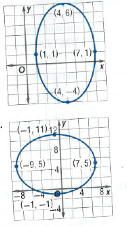
2. 