A title page is not required in a standard MLA report. The title and other information go on the first page of your report.

[](http://0.tqn.com/d/homeworktips/1/0/4/7/-/-/pagewithtitle.JPG)*Grace Fleming*

Begin typing on the top left of your paper. Use 12 point Times New Roman font.

1. Place four-digit number, your teacher's name, your class, and the date. Double space between each item.

2. Next, double space down and type your title. Center the title.

3. Double space below your title and begin typing your report. Indent with a tab. Note: MLA standard format for the title of a book has changed from underline to italics.

4. Your 4 digits or last name and page number will go in a header at the top right corner of the page. You can insert this information after you type your paper. To do so in Microsoft Word, go to **insert** and select **page number** from the list. Choose **Top of Page** and the **3rd one down**. The page number should appear. Simply type your 4 digits/last name before the page number and put a space between the two.

A standard MLA paper requires a works cited list. This is the list of sources you used in your research. It is similar to a bibliography.

[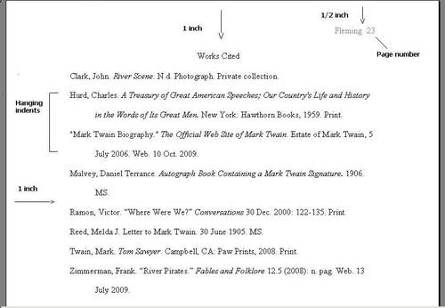](http://0.tqn.com/d/homeworktips/1/0/2/7/-/-/mlabib.JPG)

MLA Bibliography

*Grace Fleming*

1. Type "Works Cited" one inch from the top of your page. This measurement is pretty standard for a word processor, so you shouldn't have to make any page set-up adjustments--just start typing.

2. Type in the information for each source, double spacing the entire page. Alphabetize the works by author. If there is no author or editor mentioned, use the title.

3. Once you have a complete list, you will format so that you have [hanging indents](http://homeworktips.about.com/b/2008/12/09/writing-a-paper-with-microsoft-word.htm). To do this: highlight the entries, then go to FORMAT and PARAGRAPH. Somewhere in the menu (normally under SPECIAL), find the term HANGING and select it.

4. To [insert page numbers](http://homeworktips.about.com/od/computertips/ss/pagenumbers.htm), place your cursor on the first page of your text, or the page where you want your page numbers to begin. Go to Insert and select Header and Footer. A box will appear at the top and the bottom of your page. Type your last name in the top header box before the page numbers and right justify.