**Meiosis, Pedigrees, and the Reproductive System Study Guide**

The qui z on these topics will be held on Thursday May 9th. You should be able to answer the following questions or do the following tasks. This study guide is due completed on May 9th.

1. Name the stages of Meiosis and describe what happens in each stage.
2. Describe how much DNA is in a cell before meiosis and after meiosis.
3. What is the name of a cell before it goes through meiosis? After?
4. How many cells present after meiosis? ______________
5. Diploid cells have _____________ DNA, haploid cells have _________________________ DNA.
6. Compare and contrast meiosis and mitosis.
7. What is the purpose of reproduction?
8. 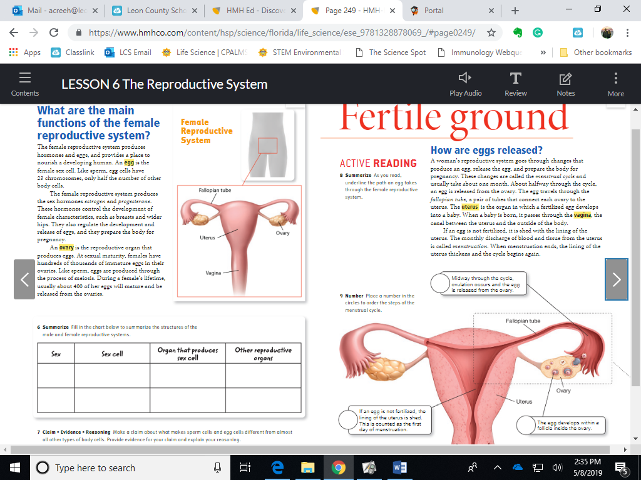Name and label the parts of the female reproductive system.
9. Name and label the parts of the male reproductive system.

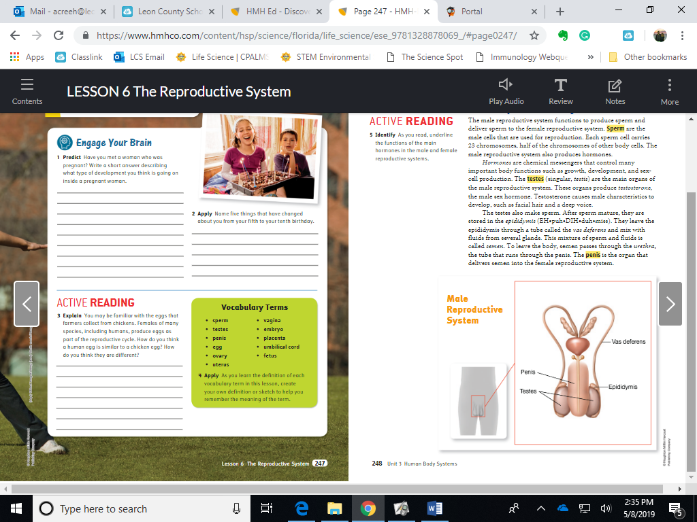

1. Describe what must happen to a sperm and an egg in order to become a new organisms.
2. Where are sperm produced and by what process?
3. Where are eggs produced and by what process?
4. Be able to interpret a pedigree. Be able to create a pedigree given traits of members of a family. Use the Pedigrees Practice page to practice, know everything on the Pedigree Video Notes.