**3rd Grade Summer Reading Assignment**

**Due: Friday, August 30, 2019**

Welcome to Sealey 3rd Grade, where we love reading! We want you to enjoy your summer with a good book. We would like for you to select **one** book from the list of Accelerated Reading Books below. Then complete the reading assignment before returning to school in August. The assignment includes a brief book report and a poster about your selected book. Be sure to include all the necessary information and use your neatest 3rd grade handwriting. Your poster and book report will be due during the first two weeks of school. Please be prepared to present your poster and convince the class to read your book. We hope you have an adventurous, reading-filled summer, and we look forward to seeing you in August!

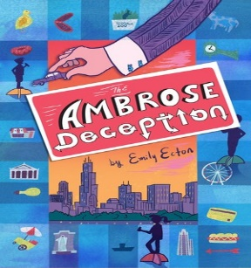

Selected Books:

* *The Ambrose Deception* by Emily Ecton

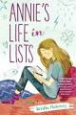

* *Annie’s Life in Lists* by Kristin Mahoney

**Book Report**

* Neatly written or typed
* 1 page
* Includes: Title, Author, Illustrator, important characters, brief story summary, your personal opinion of the book
* Any other important details you decide to include

**Poster**

* Colorful, attractive, and neatly put together and ready for display
* Includes: Title and Author
* Think of it as an “ad” for your book-you want to try to sell other people on reading the book