**Read this paragraph and answer the questions below in English or Spanish if you want.**

**Central Park**

[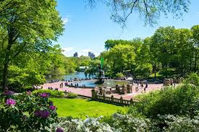](https://www.google.com/url?sa=i&url=https%3A%2F%2Fwww.facebook.com%2Fcentralparknyc%2F&psig=AOvVaw2vBqSxNIodxTz5BBvuC_Oj&ust=1587576607078000&source=images&cd=vfe&ved=0CAIQjRxqFwoTCIC9roOG-ugCFQAAAAAdAAAAABAD)Central Park es un famoso parque de Nueva York. Ofrece (*it offers*) muchas actividades para jóvenes y mayores. Visitantes (*visitors*) de todo el mundo (*whole world*) pasan tiempo allí (*spend time there*), porque pueden caminar, ver animales, assistir al teatro o a conciertos (*attend the theater or concerts*). Central Park es un oasis en medio (*in the middle*) de la ciudad.

1. Do you have something like Central Park where you live?

2. Where do people in your community go for outdoor activities?

3. Do visitors from other countries ever go there?