2009 Revised AP Euro DBQ- Causes of Expansion

- Using the documents and your knowledge of world history, analyze at least two causes of European expansion in Africa from 1861 to 1910.

Document 1
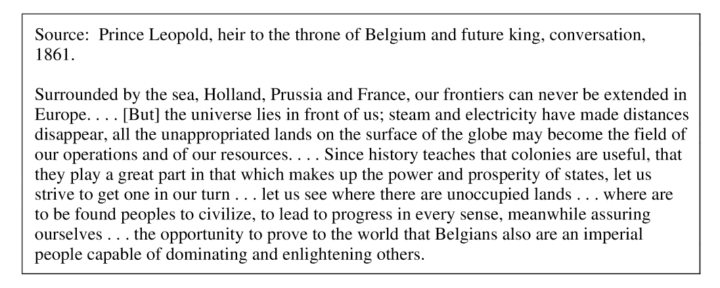

Document 2
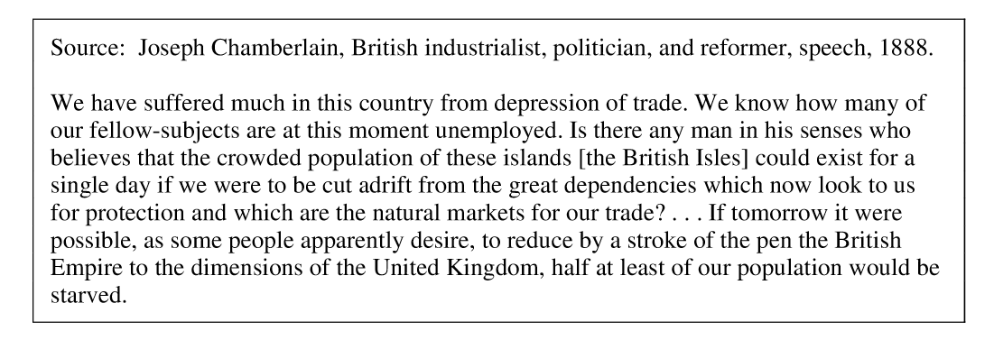
Document 3
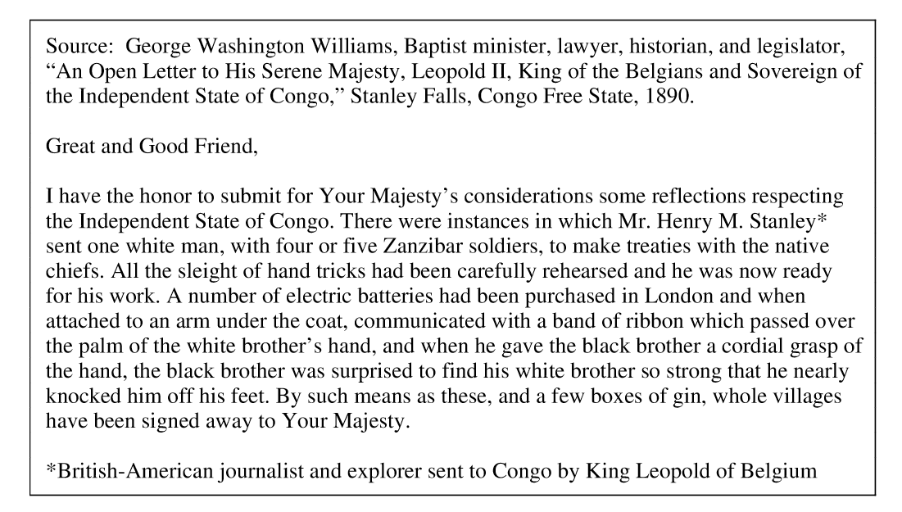
Document 4
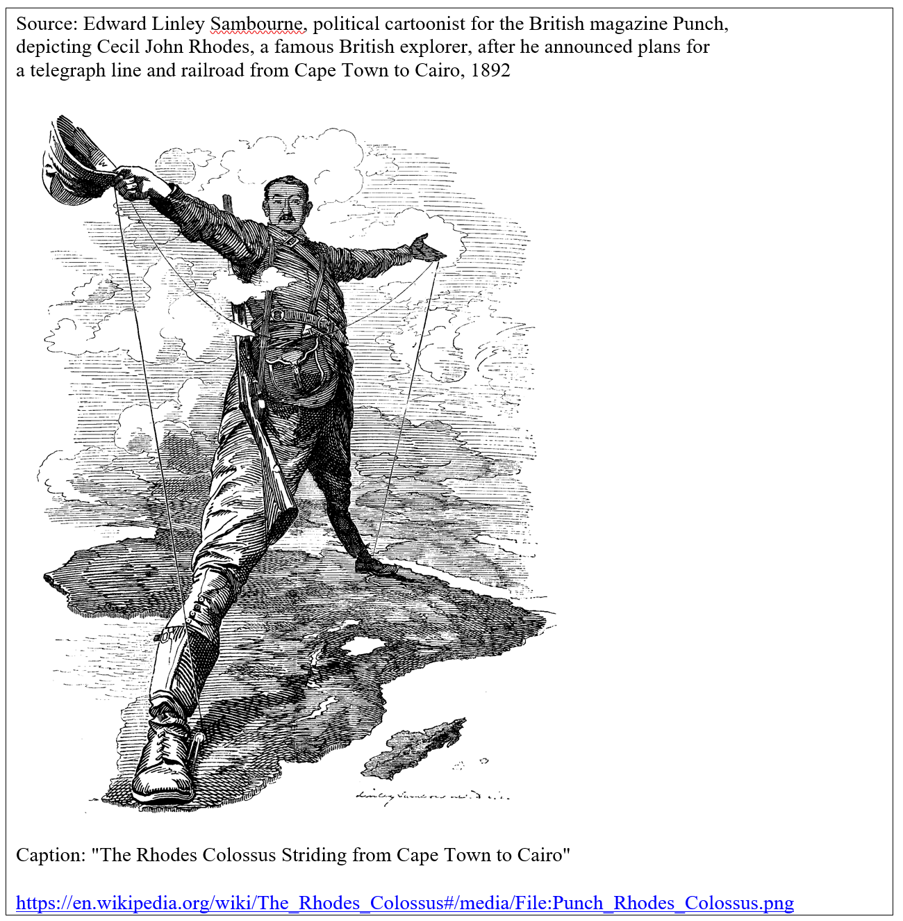

Document 5
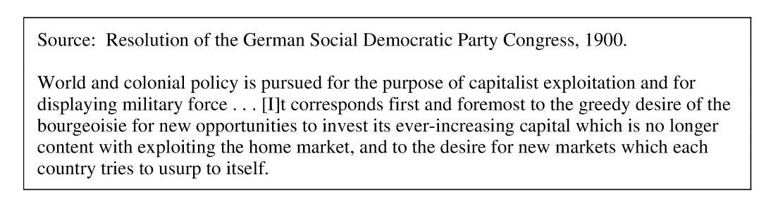

Document 6
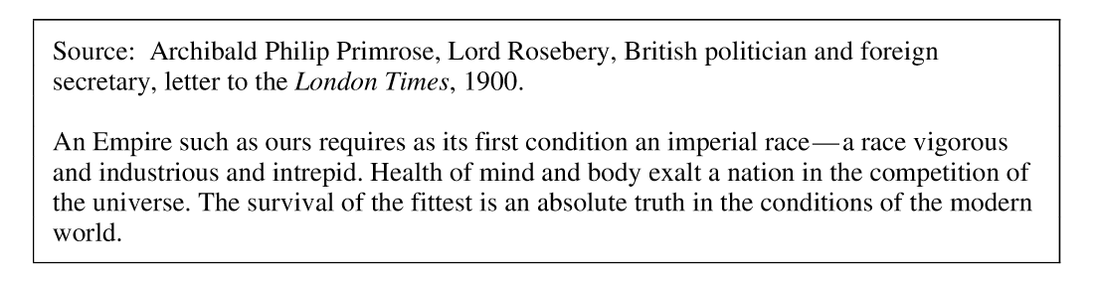

Document 7
