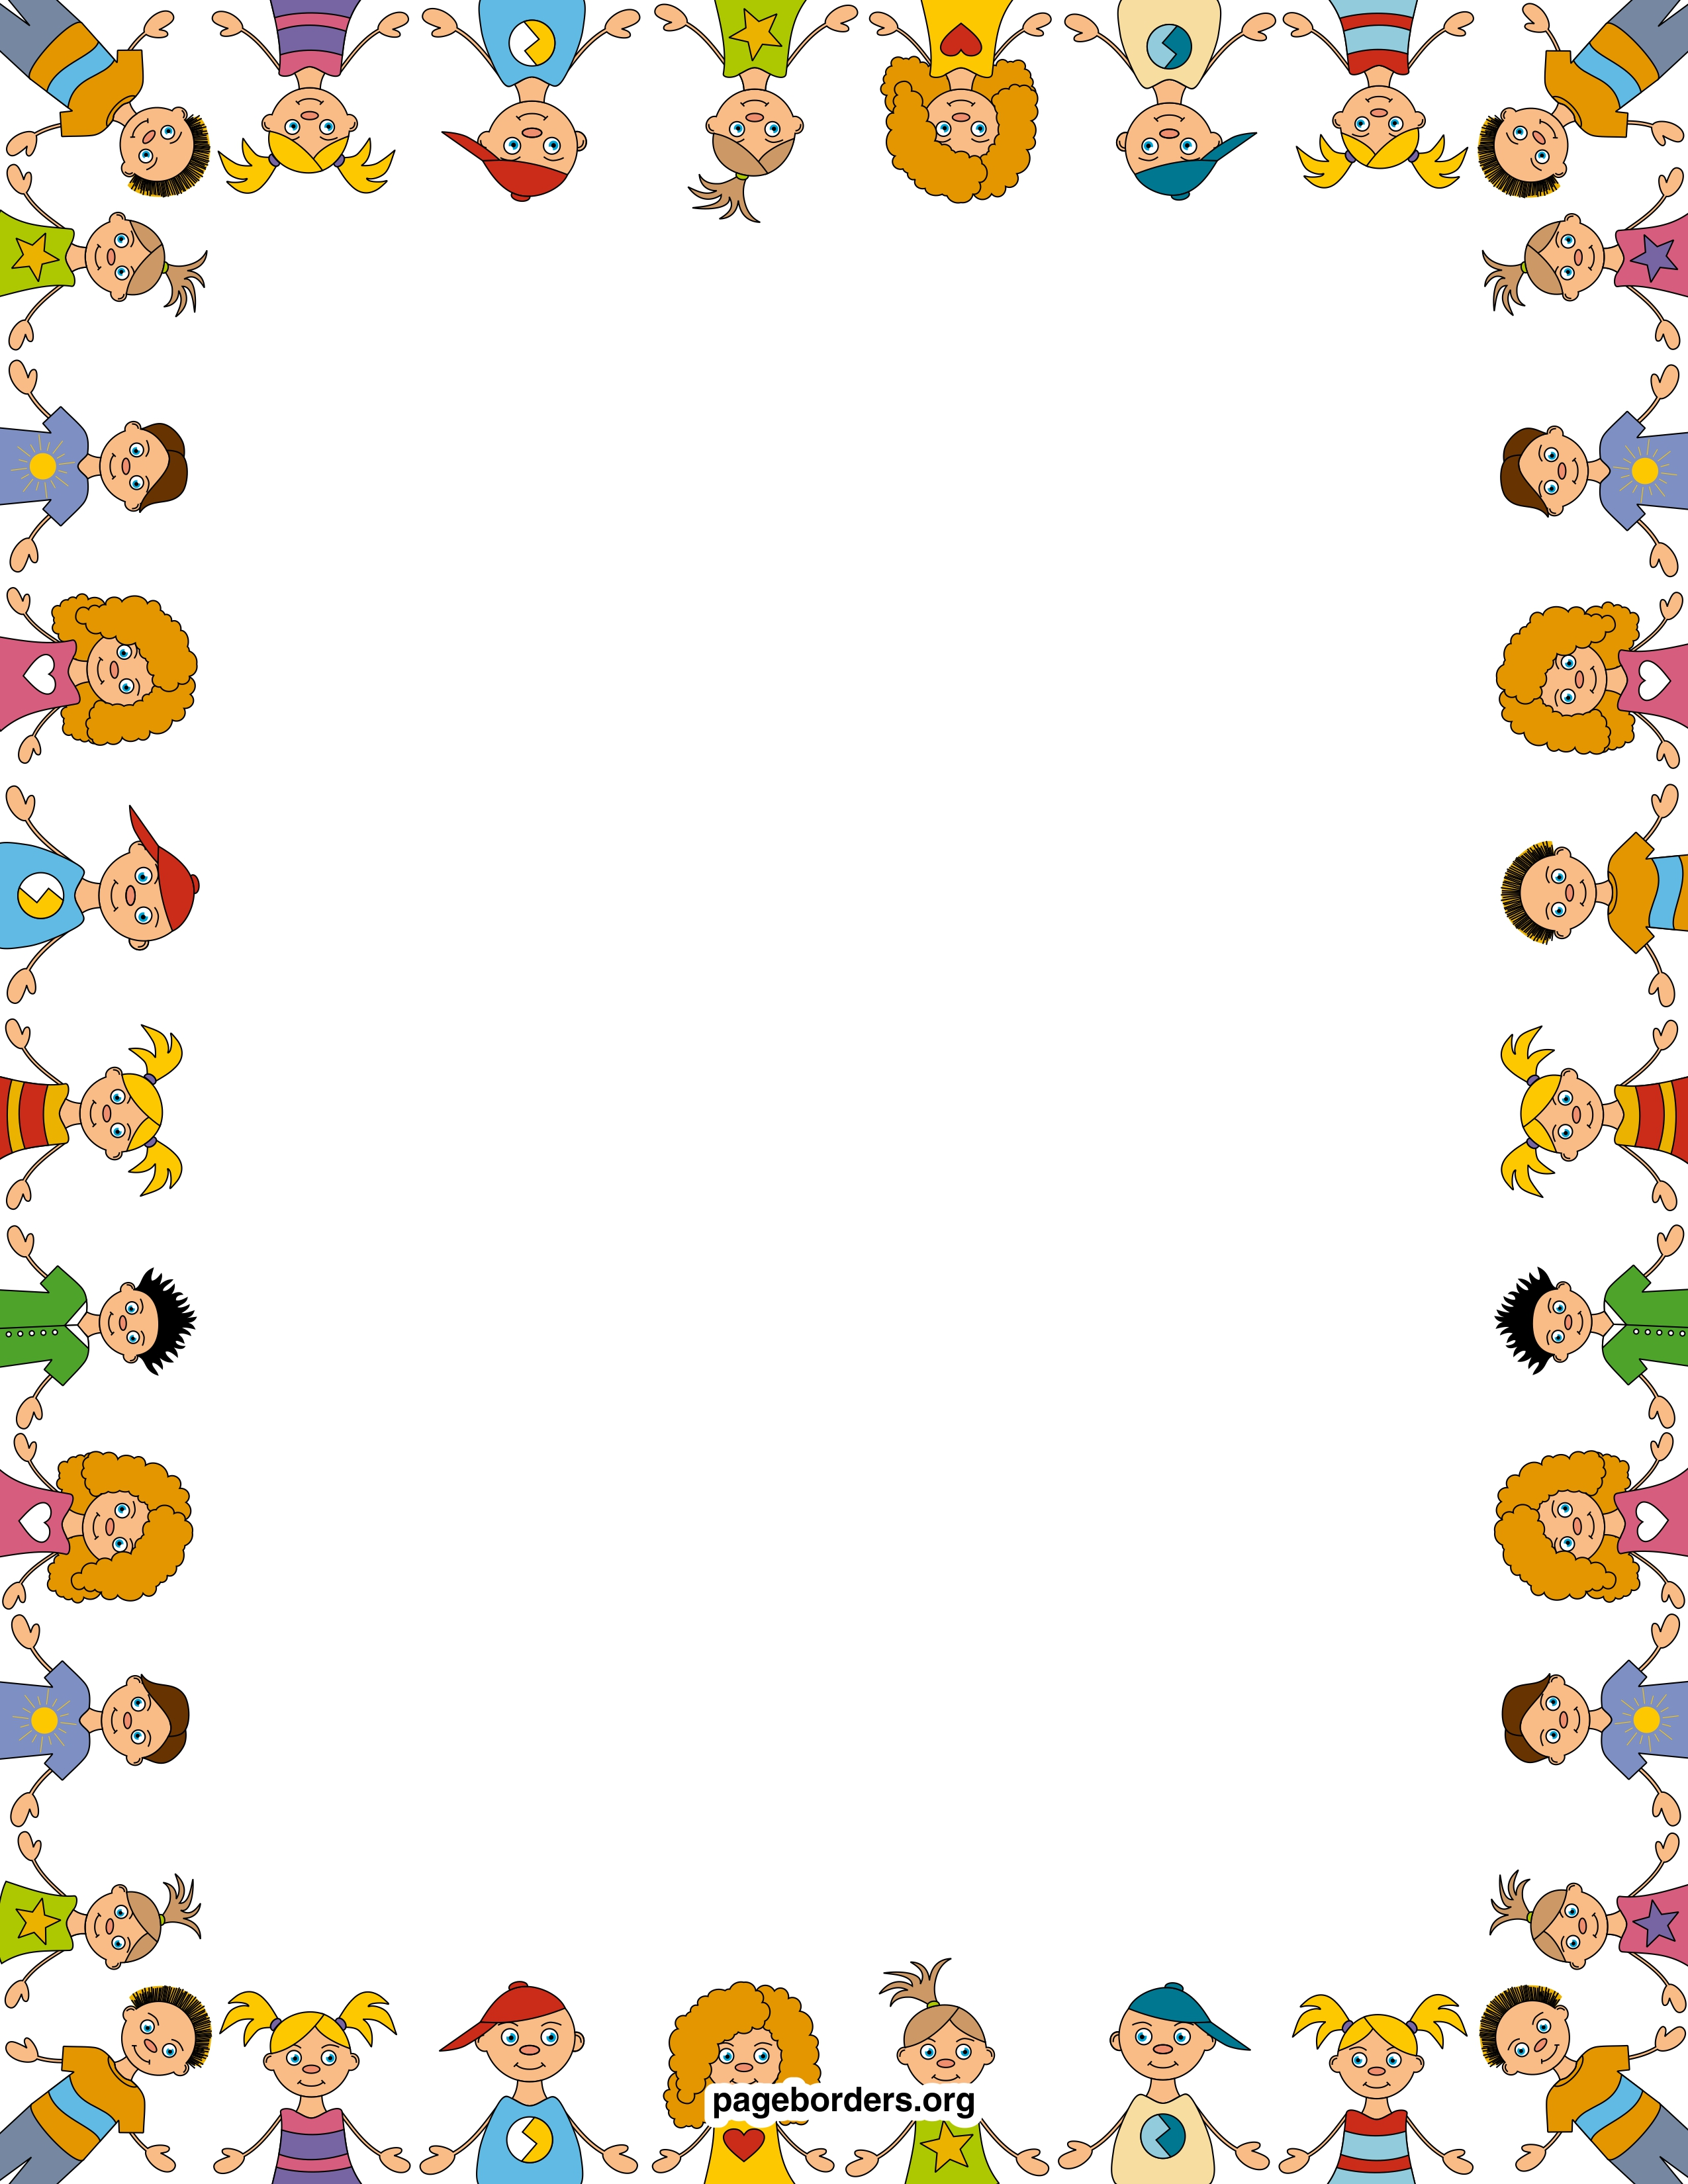

**Week Topic:**

Sort It Out

**Essential Question:**

What Ideas Can You Suggest to protect The Environment?

**Morning Centers:**

Word Families

Opinion Writing

Sorting Recycling

Sight Word Game

Leveled Readers

Long Vowels

Comprehension Check

Journals

**Afternoon Centers**

Butterflies

Frog poem

**Important Dates:**

**5/27 No School**

**5/29-31-Early Release**

**5/29-Water Day**

**5/30-Fun Fitness**

**5/31 Last Day**

**Wonders**

Sight words: come, does, good, who, look, where, has, play too help

Long A, E, I, O, U

Listening for those long vowels

Reading words with those long vowels

Pronouns

Informational genre

Opinion Writing

**Math**

Chapter 12- Classifying & Sorting Data

**Mrs. Smiley’s News**

**May 17, 2019**