Monetary and Fiscal Policy and

The Five Most Common Graphs

**The Expansionary/Contractionary Chart**

The following things can make GDP grow or shrink. Remember, if you memorize half of this chart, you know the other half because it is the exact opposite.

**Expansionary ( AD)** **Contractionary ( AD)**

|  |  |
| --- | --- |
| G  T | G  T |
|  |  |
| OMO- Buy Bonds | OMO- Sell Bonds |
| Reserve Ratio | Reserve Ratio |
| Discount Rate | Discount Rate |
| Federal Funds Rate | Federal Funds Rate |

**Fiscal**

**Policy**

**Monetary**

**Policy**

OMO- Open Market Operations

G- Government Purchases

T- Taxes

**FISCAL NOTE**:

1. If the problem is unemployment or recession then Congress uses Expansionary fiscal policy. Increase government spending and/or lower taxes.

**If** problem is **Unemloyment ↑ Inflation ↑**

**Then** Congress uses . . . .

|  |  |  |
| --- | --- | --- |
| Tools | **Expansionary** | **Contractionary** |
| **Taxes=T** | Decrease | Increase |
| Subsidies | Increase | Decrease |
| Spending=G | Increase | Decrease |

1. If the problem is inflation, then the government uses contractionary fiscal policy. Decrease government spending

**MONETARY POLICY NOTE**:

1. If the problem is unemployment or recession then the Fed will use “Easy money” or Expansionary polices: Buy Bonds, Lower discount rate, lower the reserve ratio, lower the federal funds rate.
2. If the problem is inflation then the Fed will use “Tight Money” or Contractionary policies: Sell Bonds, Raise the discount rate, raise the reserve ratio, raise the federal funds rate.

**5 Most Common Graphs**

**The Below graphs are the most commonly used and referenced graphs on the AP Macroeconomics Exam. Understanding how Fiscal and Monetary Policies impacts these graphs, the additional determinants of these graphs, and how they interact with each other is crucial to your success on the test. ALWAYS REMEMBER – PROPER LABELS!**

**Graph 1: Aggregate Supply/Aggregate Demand.**

It is imperative that you understand how changes in monetary and fiscal policies create changes on this graph and subsequently how they impact employment levels, output (Real GDP), and price levels (inflation).

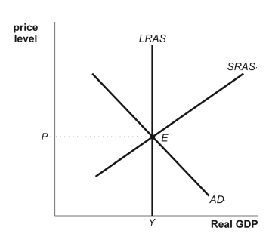

**Graph 2: Money Market**

It is important to understand how changes in monetary policy impact this graph and how changes in this graph can impact AS/AD and the loanable funds market.

•What shifts the Supply curve? Monetary Policies (Changes in the money supply, use your Expansionary/Contractionary Chart Monetary Policy tools)

•What shifts the demand curve? The demand for money is found by adding the Transaction Demand for Money and the Asset Demand for money.

Transaction Demand- this amount is based solely on whatever the GDP is. Anything that makes people consume more impacts this.

Asset Demand- this amount is based on what people want to save or invest

Summary- The demand for money will shift if something makes people want to consume or save more

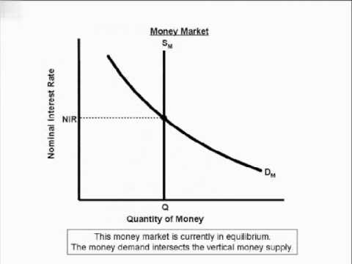

**Graph 3: Loanable Funds Market**

It is important to understand how changes in the Money Market impact this graph and how the changes in the real interest rate (represented by the Loanable Funds Graph) will impact AS/AD, Investment, and FOREX market.

•What Shifts the supply curve? Any changes in the money supply (Monetary Policy Changes – most common one on the AP), Changes in any of the following: disposable income, wealth, expected future income, Federal Budget Surplus.

•What shifts the demand Curve? Federal Government Deficit Spending (most common one on the AP - crowding out effect), Change in expected future profits, phases of the business cycle, technology.

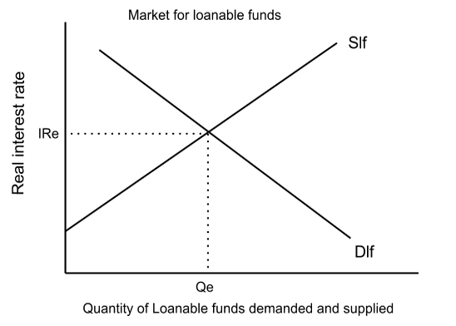

**Graph 4: Foreign Exchange Market (FOREX)**

It is important to understand how the value of currencies appreciate and depreciate and how to show these changes in currency graphically. Also, how do changes in the value of currencies impact Net Exports and as such Real GDP (AS/AD graph).

**Determinants: (5 total)**

•Three most common on AP: Changes in relative Price Levels, Changes in relative Interest Rate, Changes in relative Income. Two others: Changes in consumer tastes, speculation

***ALWAYS REMEMBER: Any time one currency’s demand shifts, the other currency’s supply curve shifts IN THE SAME DIRECTION.



**Graph 5: Phillips Curve**

The Phillips Curve is a graph that shows the inverse relationship between inflation and unemployment. It is a mirror image of the aggregate supply curves.

•Movement Along the Short-Run Phillips Curve: A Change in Aggregate Demand (Shifting the AD curve), causes a movement along the Short-Run Phillips Curve (SRPC).

•Shifting the Short-Run Phillips Curve: A change in Aggregate Supply (Shifting the SRAS curve), causes a shift in the Short-Run Phillips Curve (SRPC).

Below are side-by-side graphs of the AS/AD model and Phillips Curve. It shows the movement that occurs on the Phillips graph when there is a shift in SRAS.

