**UNIT THREE EXTRA CREDIT REVIEW (Chapters 13-21)**

**Directions:** On a **separate piece of paper**, answer the questions or terms below.You may use the Bentley textbook, the AMSCO book, or online resources to answer the questions. All responses must be complete sentences and should be your **OWN WORK.**

**Identify-** Explain the significance of each term.

1. Stirrup
2. Camel
3. Camel saddle
4. Mecca
5. Ka’ba
6. Ishmael
7. Muhammad
8. Caliphate
9. Quran
10. Ghana
11. Charlemagne
12. Byzantine Empire
13. Cyrillic alphabet
14. Manorial system
15. Feudalism
16. Investiture controversy
17. Pope Urban II
18. Grand Canal
19. Tributary System
20. Movable type
21. Flying money
22. Foot binding
23. Hongwu
24. Yongle
25. Zheng He
26. Shamanism
27. Champa rice
28. Chinampas
29. Quetzalcoatl
30. Cahokia
31. Quipus
32. Marco Polo
33. Bubonic plague
34. Ivan III
35. Forbidden City
36. Ming porcelain
37. Ibn Battuta
38. Swahili States
39. Kilwa
40. Malacca
41. Hanseatic League
42. Guild
43. Medici family
44. Printing press
45. Thomas Aquinas
46. Johann Gutenberg
47. Da Vinci
48. Michelangelo
49. Magna Carta

**Short Answer-** Answer each question using complete sentences.

1. What lands were originally linked by the Silk Road?
2. What was the role of the nomad along the early Silk Road?
3. What areas were linked by the Indian Ocean Maritime System?
4. Compare travel in the Mediterranean to travel in the Indian Ocean.
5. What items were traded along Indian Ocean trade routes?
6. What were the effects of the Bantu migrations?
7. How did trade affect religion?
8. What are The Five Pillars of Islam?
9. Explain the Shi’ite/Sunni split of Islam.
10. What areas were conquered by the Arabs and the Islamic caliphate?
11. Describe the Abbasid Caliphate/Dynasty.
12. What led to the fall of the Abbasid?
13. Who/what influenced Muslim scholars?
14. What was the role of monasteries in medieval Europe?
15. What was Vladimir I’s impact on Kievan Russia?
16. What types of technology appeared in Europe between 1000-1200? What were the impacts?
17. What effect did the Crusades have on Europe?
18. What was the importance of the Sui Dynasty?
19. Describe the Tang relationship with Buddhism.
20. Describe Song China’s technological innovations.
21. How did movable type impact society?
22. What was China’s influence on Japan?
23. Compare and contrast the Tang tribute system and the Aztec tribute system.
24. How were the Mongols able to conquer large numbers of people even though they were outnumbered by their enemies?
25. How could the Mongols be considered barbarians?
26. How could the Mongols NOT be considered barbarians?
27. What ended the Byzantine Empire?
28. Describe the social hierarchy under the Yuan Empire.
29. What areas of Asia escaped Mongol conquest? How?
30. Who were Sundiata and Mansa Musa?
31. Discuss the spread of Islam in Africa.
32. Discuss/describe the slave trade in Africa between 1200-1500.
33. How did the Three Field System impact farming in Europe between 1200-1500?
34. What was the Black Death? What effect did it have on Europe?
35. How were Jews affected by the Black Death?
36. What were the positive and negative effects of industry during the European revival?
37. What was the importance of Flemish textiles?
38. What was the status of cities during the Renaissance?
39. What is scholasticism?
40. Who were Chaucer, Dante, and Boccaccio? Why are they important?
41. What was the Great Western Schism? (Causes, effects, etc)
42. What was the Hundred Years War? Causes, effects, etc)

**Images-**

For 92-94, Identify each of the following images. Give the significance of each.

1. 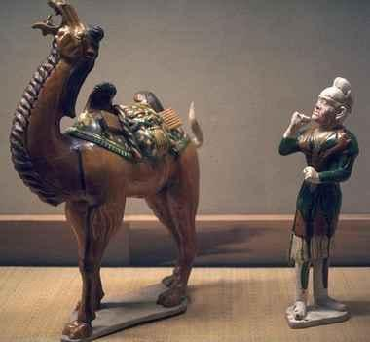
2. 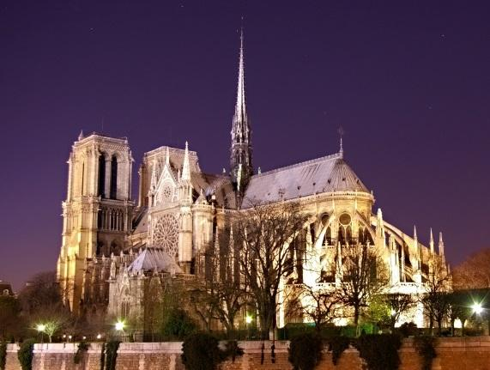
3. 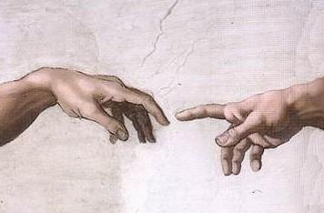

For 95- 100, Tell which empire is associated with each of the following images. Give the significance if applicable.

1. 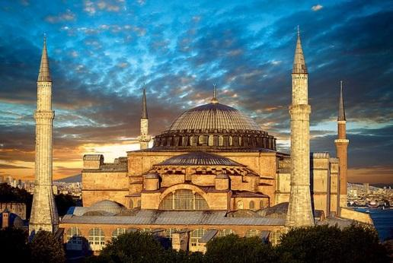
2. 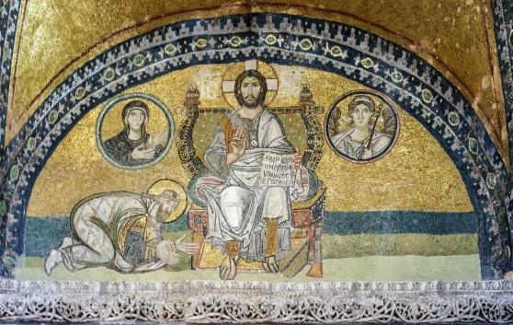
3. 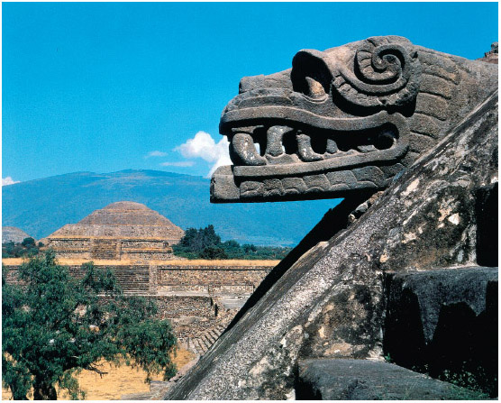
4. 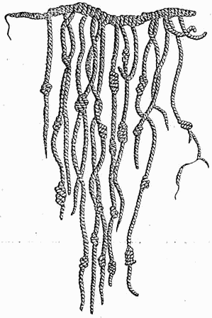
5. 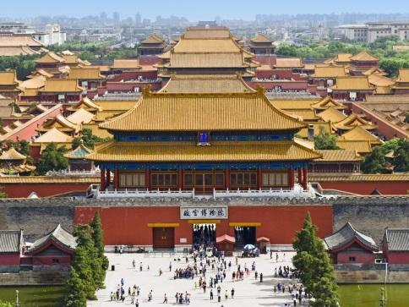
6. 