**EOC Review#1 Algebra Name _________________________________**

**A#______ Date __________________ Period _________**

1. Solve by graphing. y = -x + 5 : y = 2x - 4

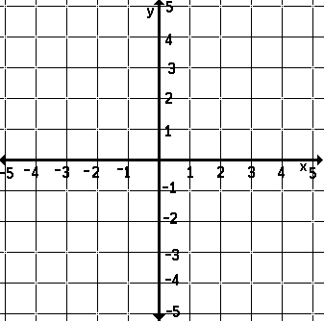

2. Solve by graphing. y > 5x + 1 : y ≤ -x + 3



3. Solve the system using elimination. 6x - 18y = 60 : 9x + 2y = 32

4. Write a system of equations to model each situation. Solve by any method. Lisa charges $25 for private tutoring and $18 for group tutoring. In one day, Lisa earned $265 from 12 students. How many students of each type did she tutor?

5. Write a system of equations to model the following situation. Solve by any method. A collection of quarters and nickels is worth $1.25. There are 13 coins in all. How many of each coin are there?

6. Model the rule f(x) = -1/2x + 3 with a table and a graph.

7. The table shows a school district’s enrollment for two successive years. Write a linear function using the data (with x representing the year number), and then use the model to predict the enrollment in Year 4.

|  |  |
| --- | --- |
| Year 1 | 8295 |
| Year 2 | 8072 |

8. Write an equation in point-slope form for the line through the point (2, -7) with slope m = -1/3 .

9. What is the range of the function ƒ(x) = x2 + 1, when the domain is {-6, 4, 8}?

10. Write a function rule to describe the statement. The amount of change c(x) from a $20 bill if you buy x pounds of pears for $0.79/lb

11. Find the next three terms of the arithmetic sequence. 9, 12, 15, …

12. Find the next three terms of the arithmetic sequence. 288, 252, 216, …

13. Write the equation in slope-intercept form. -8y = 5x + 3

14. Find the x- and y-intercepts of the line 3x + 2y = 12.

15. The cost to rent a scooter is $10 plus $8 each for each hour of use. If the cost were to be modeled with a linear equation and graphed, what would be the slope?

16. Graph y = |x| - 2 by translating y = |x|.



17. Use the graph to find the slope and write the equation of the line.



18. Are the lines y = -4/3x + 3 and 4x + 3y = 1 parallel, perpendicular, or neither?

19. Is (3, 10) a solution of y ≥ 5x - 8? Explain why or why not.

20. Describe the difference between the function f(x) = x2 and the function shown by the table.

|  |  |  |  |  |
| --- | --- | --- | --- | --- |
| x | 0 | 1 | 2 | 3 |
| y | 1 | 2 | 5 | 10 |

21. The parents club compiled a cookbook. One company charges $750 to make a master copy and $25 for each additional copy. The total selling price depends on how many copies are ordered. Write a function rule and create a table of values for the rule. How much will you save per book by ordering 400 books instead of 100 books?