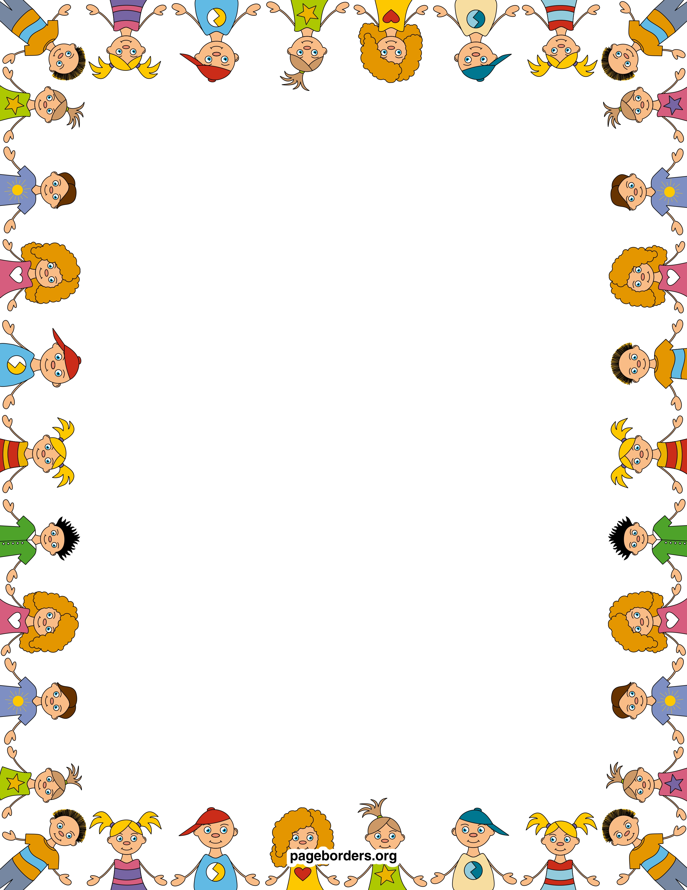

Important Dates:

5/3 First Friday

5/6 Last Day for sight words and reading packets homework

5/22 All Media Center books are due

5/27 Memorial Day- No School

5/29 Water Day- Early Release Day

5/30 Fun Fitness- Early Release Day

5/31 Last Day of School- Early Release Day

*On Early Release Days, school ends at 12:20

**Wonders**

Sight words: who, good

Long U

Fiction genre

Writing using dialogue

**Math**

Chapter 11- Measurement

Introduced Chapter 12- Classifying & Sorting Data

**Week Topic:**

Problem Solvers

**Essential Question:**

What can happen when we work together?

**Morning Centers:**

Solve the Puzzle

Writing a sequenced story

Forming long U words

Writing dialogue

Leveled Readers

Journals

**Afternoon Centers**

Scholastic Magazine

Parent gifts

**Mrs. Smiley and Miss Brannon’s News**

**May 3, 2019**