Here are the steps for logging into your online textbook:

- Go to Fort Braden’s website: www.leonschools.net/ftbraden
- In the top right corner of Fort Braden’s website there should be an icon for ClassLinks. Click on the icon. Here is what it looks like:



- Students will be asked to log into ClassLink. Their username will be their student email and their password should be their lunch number. If students have any problems logging in, please contact me.

The student email will be their 9-digit student ID followed by @edu.leonschools.net

- When students log in, their ClassLink launchpad will look something like this:

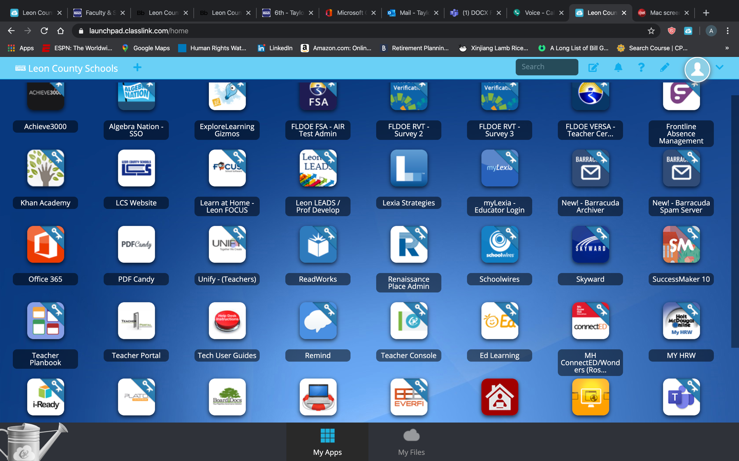

- From the launchpad, students should locate the icon for the online textbook. It is entitled “MH ConnectEd/Wonders”. It looks like this:

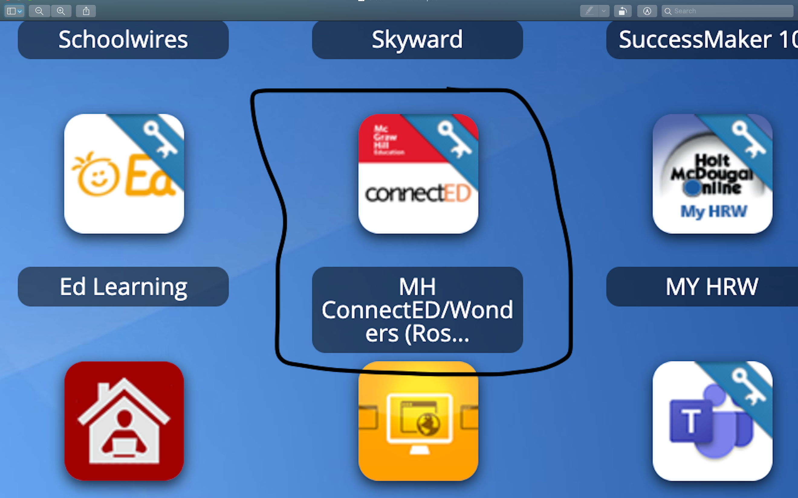

- Students should click the icon to access the textbook. As soon as students click, they will be taken to a page with a button that says “launch”. Students should click the “launch” button.

- After students click launch they will be taken to a page that looks like this:

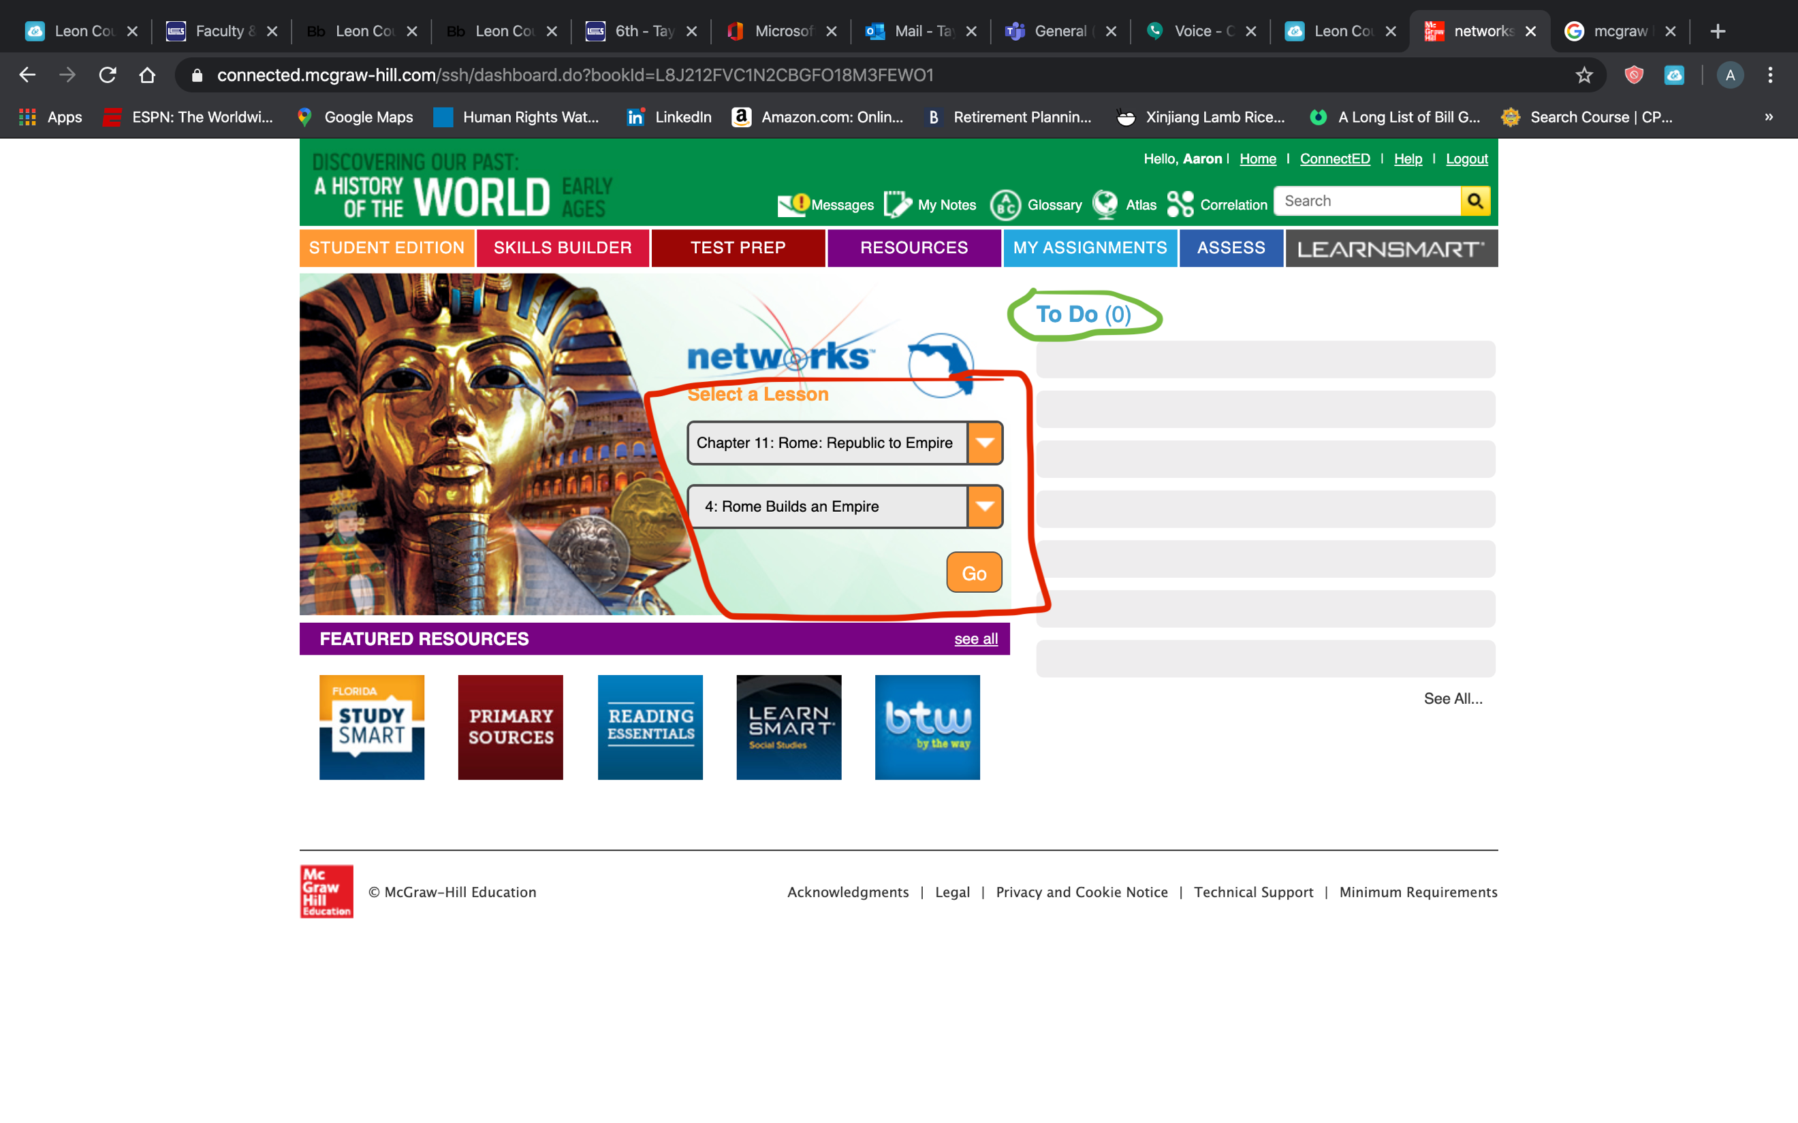
- Student assignments will be list under the “To Do” list. Students will be able to access different parts of the textbook using the drop-down menus under “Select a Lesson”. Image below:

- When students click an assignment under the “To Do” list there will be instructions they need to follow in the assignment page. Any important resources students need will be under “Attach Resources and Content” When students complete the assignment, they need to click the yellow “Submit” button in the bottom right corner of this page. Assignment page image below:

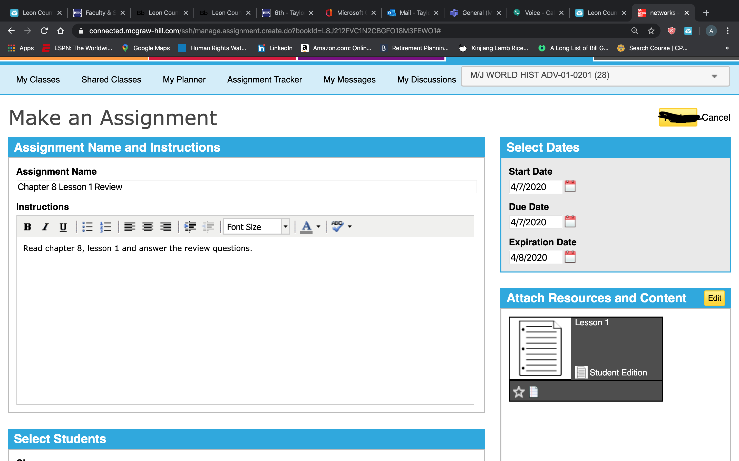

Note: student page will not say “make an assignment”.

