Occupational Therapy Activity of the Week:

Fine Motor Skills Using a Deck of Cards

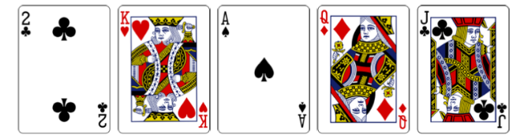

A large part of a child’s day at school requires fine motor skills- cutting, gluing, writing, manipulating fasteners, opening packages and containers, folding paper, putting items in folders and backpacks…the list goes on. Working on improving a child’s fine motor skills is important! But it doesn’t have to be “work”! It’s easy to make it fun! Below is a list of activity suggestions using something that many of us have in the house….a deck of cards! These activities improve pincer grasp, development of the arches of the hand, hand strength, in-hand manipulation, motor planning, bilateral coordination, and more! There are ideas for children with a whole range of abilities. Pick an idea and give it a try!

* Clip clothespins or place paperclips onto cards to match the # on the card.
* Place a rubberband around the deck. Pull out 1 card at a time as fast as you can, flipping it over onto the table. To make it more challenging, make it a race with a partner.
* Place a row of cards face down on the table. Flip them over 1 at a time. To make it more challenging, make it a race with a partner.
* Sort cards by color or suit. See additional attachment for visuals. How many can you sort in a minute? Or make it a race with a partner.
* Work on mixing/shuffling the deck with 2 hands.
* 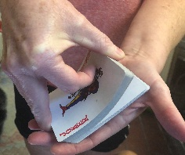 Try riffling the deck like this for thumb strengthening.
* Use with playdough. Roll small balls of playdough and stick the corners of cards into them to make a house or other structure.
* Pinch a card between thumb and pointer finger and toss it into a basket. How many can you get in the basket in a minute?
* Play traditional card games (Uno, Go Fish). Work on holding the cards, fanned out, in one hand.
* Play War: Each player holds the deck face down in one hand, flipping over 1 card at a time with the other hand. Who has the highest value card? That player keeps both cards. The player with the most cards at the end of the game wins.
* A different kind of “Go Fish” game to sneak in handwriting practice: Write a letter, number, or word on the back of the card. Place a paperclip on the card. Make a “fishing pole” with a pencil, string, and magnet. “Catch” a fish and write the letter/number/word on paper. That player gets the number of points on the card. The player with the most points at the end wins!
* To add a math challenge, try this “Total of 10” game. <https://www.youtube.com/watch?v=SD028NO-ZGc>