**Unit 4 Test Review (Chapters 22-27)**

1. How did the global trade network after 1500 CE affect the pre-existing regional trade networks? (Indian Ocean, Mediterranean, trans-Saharan, Silk Routes)
2. What technical developments made transoceanic European travel & trade possible, and where did they originate?
3. What were the major notable transoceanic voyages between 1450-1750 CE?
4. Where did Zheng He and the Chinese Treasure Fleets travel?
5. Why did Portugal begin longer maritime voyages ca. 1430 CE?
6. What effect did Columbus’ travels have on Europeans?
7. What originally motivated Europeans to travel across the northern Atlantic?
8. How did the new global connections affect the peoples of Oceania and Polynesia?
9. What new financial and monetary means made new scale(s) of trade possible?
10. What previously established scale(s) of trade continued?
11. Describe European merchants overall trade role c. 1450-1750.
12. What role did silver play in facilitating a truly global scale of trade?
13. What new mercantilist financial means developed to facilitate global trade?
14. What were the economic and social effects of the Atlantic trading system?
15. What were the unintentional biological effects of the Columbian Exchange?
16. What foods were transferred to new geographic regions as part of the Columbian Exchange, and what were labor systems made this transfer possible?
17. What plants/animals were deliberately transferred across the Atlantic as part of the Columbian Exchange?
18. What effects did American food crops have on the diet of Afro-Eurasians?
19. How did settlers’ action affect the Americas environmentally?
20. How did the Columbian Exchange affect the spread of religions?
21. Where did the “universal” religions of Buddhism, Christianity & Islam spread?
22. How did the Columbian Exchange affect religion(s)?
23. How did the arts fare during this period?
24. How did public literacy as well as literary and artistic forms of expression develop during this period?
25. How did agriculture’s role change between 1450 -1750? What pre-requisite conditions made these changes possible?
26. How did labor systems develop between 1450 -1750?
27. How was peasant labor affected between 1450 -1750?
28. How did slavery within Africa compare to the pre-1450 era?
29. How did the Atlantic slave trade affect both African societies and the economy of the Americas?
30. How did labor systems develop in the colonial Americas?
31. How did the post-1450 economic order affect the social, economic, and political elites?
32. How did pre-existing political and economic elites react to these changes?
33. How were gender and family structures affected to these changes?
34. How did societies in the Americas reflect the post-1450 economic order?
35. How did empires attempt to administer the new widespread nature of their territories?
36. How did the role of Africa, the Americas, Asia, and Europe develop in this new world-wide political order?
37. How did the people of various empires react to their government’s methods?
38. How did political rulers legitimize and consolidate their rule?
39. What role did religion play in legitimizing political rule?
40. How were ethnic and religious minorities treated in various empires?
41. How did rulers make sure that their governmental were well run?
42. How did rulers finance their territorial expansion?
43. What was the relationship between imperialism and military technology?
44. How did Europeans go about creating new global empires and trade networks?
45. How did pre-existing land-based empires and new empires during this era compare to previous era’s empires?
46. What obstacles to empire-building did empires confront, and how did they respond to these challenges?

**Must Know People**

1. Vasco de Gama:
2. Bartolmeu Dias:
3. Christopher Columbus:
4. Ferdinand Magellan:
5. Hernan Cortes:
6. Francisco Pizarro:
7. Emperor Atahualpa:
8. Emperor Moctezuma II:
9. Emperor Akbar:
10. Emperor Shah Jan:
11. Emperor Aurangzeb:
12. Tokugawa Ieyasu:
13. Emperor Kangxi:
14. Queen Elizabeth I:
15. King Louis XIV:
16. Emperor Peter the Great:
17. Sultan Suleiman the Magnificent:
18. King Nzinga/Afonso I:
19. Shah Ismaii:

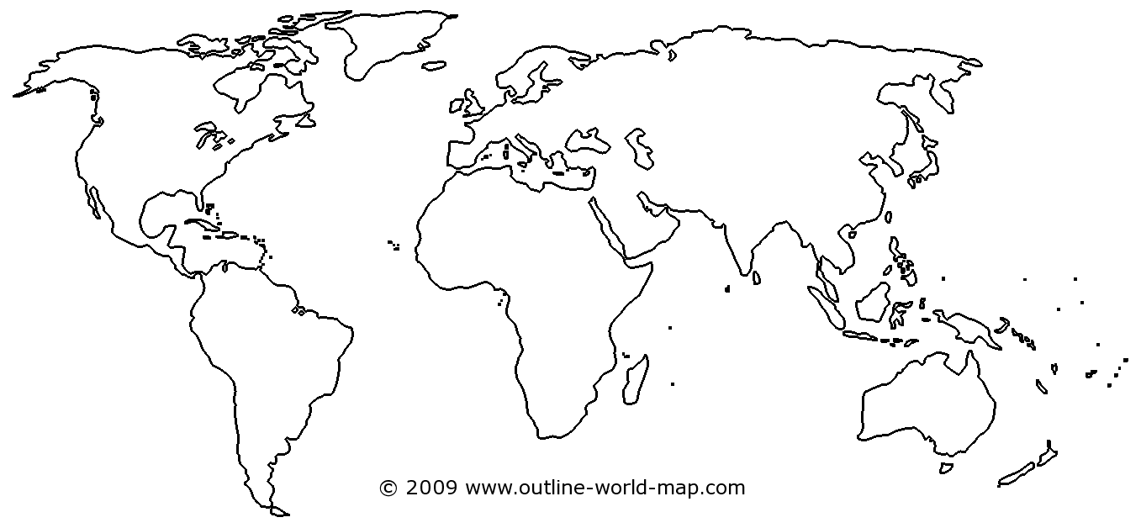

**Directions: Fill in the boxes with major events, trends, patterns, or ideas from this period. Think about the connections! Draw a line from the box to the region.**

S/E/C Africa

S/SE Asia

South/Latin America

Middle East

North America/Mesoamerica

Europe/ Mediterranean

N/C/W Asia

East Asia

N/W Africa

South/Latin America