Ch. 12 Services and Settlements
Key Issue 2 Where are Consumer Services Distributed?
Rubenstein, p.434-441

- In what ways do consumer and business services differ?

I. CENTRAL PLACE THEORY

- Identify and take notes on Walter Christaller’s Central Place Theory:

- Purpose:
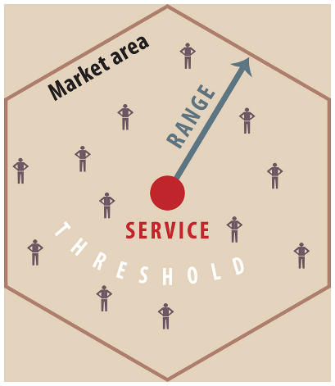
- Central place:

- Market area/hinterland:

  - Why the use of the hexagon shape for this model?

  - The extent of a market area is based on

    - Range:

    - Threshold:

II. HIERARCHY OF CONSUMER SERVICE

- Describe settlements in MDCs.

- Using geography terms, explain why there is not a Target or Sam’s Club in Frankfort, Ky.

- Define rank-size rule:

Ex.:

What does following the rank-size rule show about a country overall?

- Define the primate city rule:

Ex.

What does following the rank-size rule show about a country overall?

- Search for “most populous cities in _____________” for the countries below. Tell if the country follows the rank-size rule or the primate city rule.

      - Germany
      - Peru

      - Zimbabwe
      - France

III. MARKET AREA ANALYSIS

- Take notes on the gravity model:

IV. PERIODIC MARKETS

- Take notes on periodic markets:

- Give examples of how periodic markets vary by culture.

Flip over to the second half of 12.4 (starting on p.452) for the remaining questions.
V. PERCENT URBAN

- What are the two dimensions of urbanization?

- Louis Wirth published a book in 1938 entitled Urbanism as a Way of Life in which he observed that cities have three characteristics. Identify, and take notes as necessary, the three characteristics.

- Give the percent of the world population that lived in urban settlements in:
- 1800 –

- 1850 –
- 1900 –

- 1950 –
- 2000 –

- 2008 –

- a. How does the percent of population living in urban areas differ between MDCs and LDCs?

b. Is this gap increasing or decreasing?

c. Identify factors that have led to urbanization.

VI. SIZE OF URBAN SETTLEMENTS

- Contrast the size of urban areas in LDCs v. MDCs.

- ___________________ is the largest city in the world.

- What factors are fueling the growth of cities in LDCs?

**Megacity –

