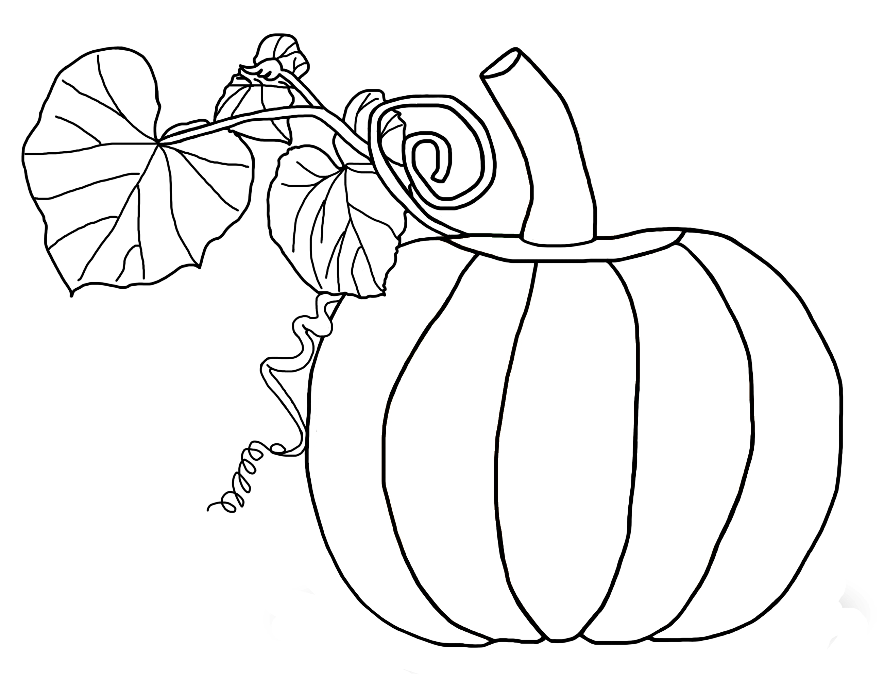
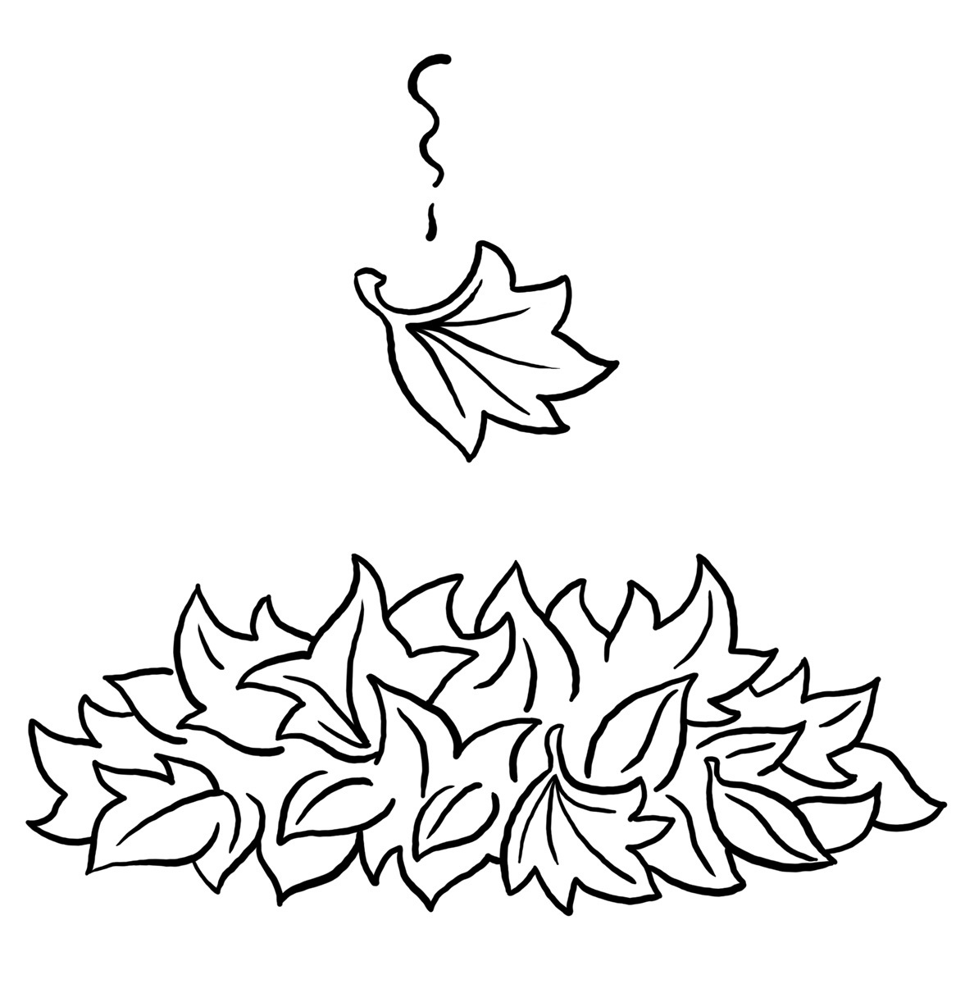

The Kindergarten Connection
November 2024

SAVVAS Reading Themes

Unit 2 – Living Together: What Do Living Things Need?

Do We Need This?; How do we know what we need?

Open Wide!; How do different animals eat their food?

Run, Jump, and Swim; Why is exercise important?

Unit 3 – Tell Me A Story: Why do we like stories?

How Anansi Got His Stories?; What can we learn from stories?

UFLI for Phonological Awareness/Word Work

VC/CVC Word Building and Blending, Generating Letter Sounds with Proper Mouth Placement
Language Arts
Genres: Informational Text, Fiction
Animal Names
Parts of a Book
Letters: short E, B,
plural S, S /z/, K, H, R
Writing: Write 1-2 sentences.
Sight word recognition:
A, I, the, and, is, as, said, of, see, he, be, me
Math
Chapter 5: Count and Represent Numbers Through 10
Chapter 6: Order and Compare Numbers Through 10
Science
Unit 6: Energy (sound, light, heat),
Unit 7: Motion
Social Studies
Hawks Rise Character Traits, Veterans Day, Thanksgiving (Long Ago & Today)

Important Dates

11/1 First Friday Friendship Lunch

11/5 Kids Voting

11/7 Health Screenings

11/11 Veterans Day No School

11/12 Turkey in Disguise Family Project Due (more details to come)

11/13 Fall Picture Retake

11/21 PTO at 7:00 p.m.

11/25-29 Thanksgiving Holiday – No School

Reminders

Please send a seasonal change of clothing labeled with your child’s name along with daily snack and water thermos/bottle

The Kindergarten Teachers,

Mrs. Campbell, Mrs. Deason, Ms. Hammond, Mrs. Lindsey, Ms. Lindquist,

Mrs. Ramos, Ms. Randall, Mrs. Rockwood

