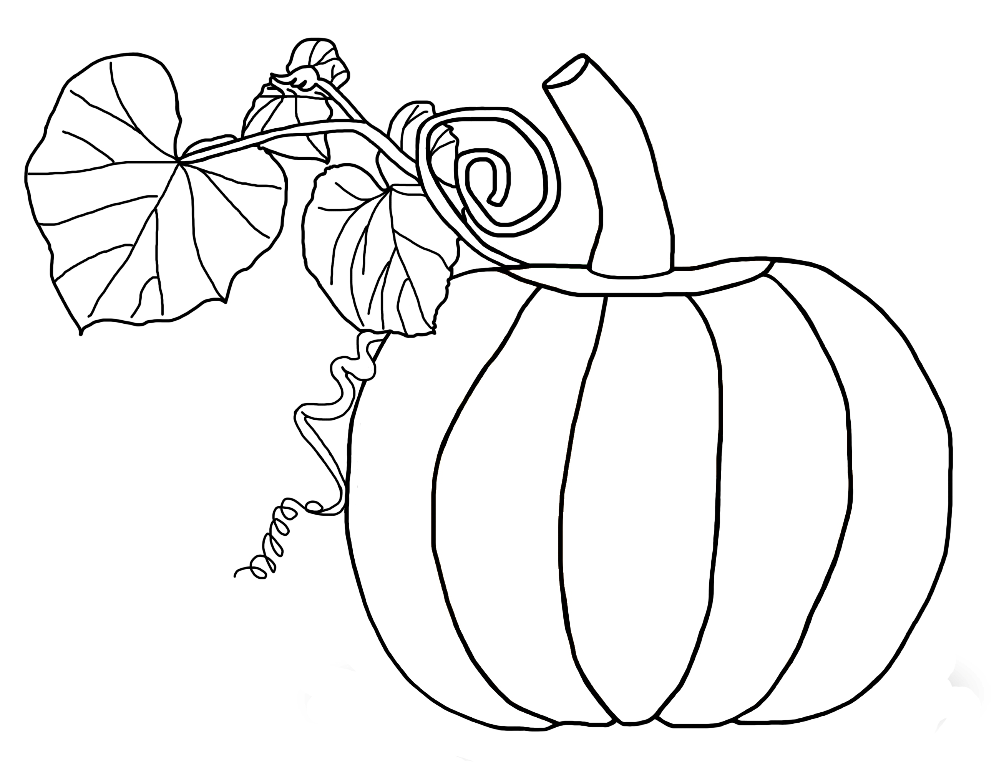
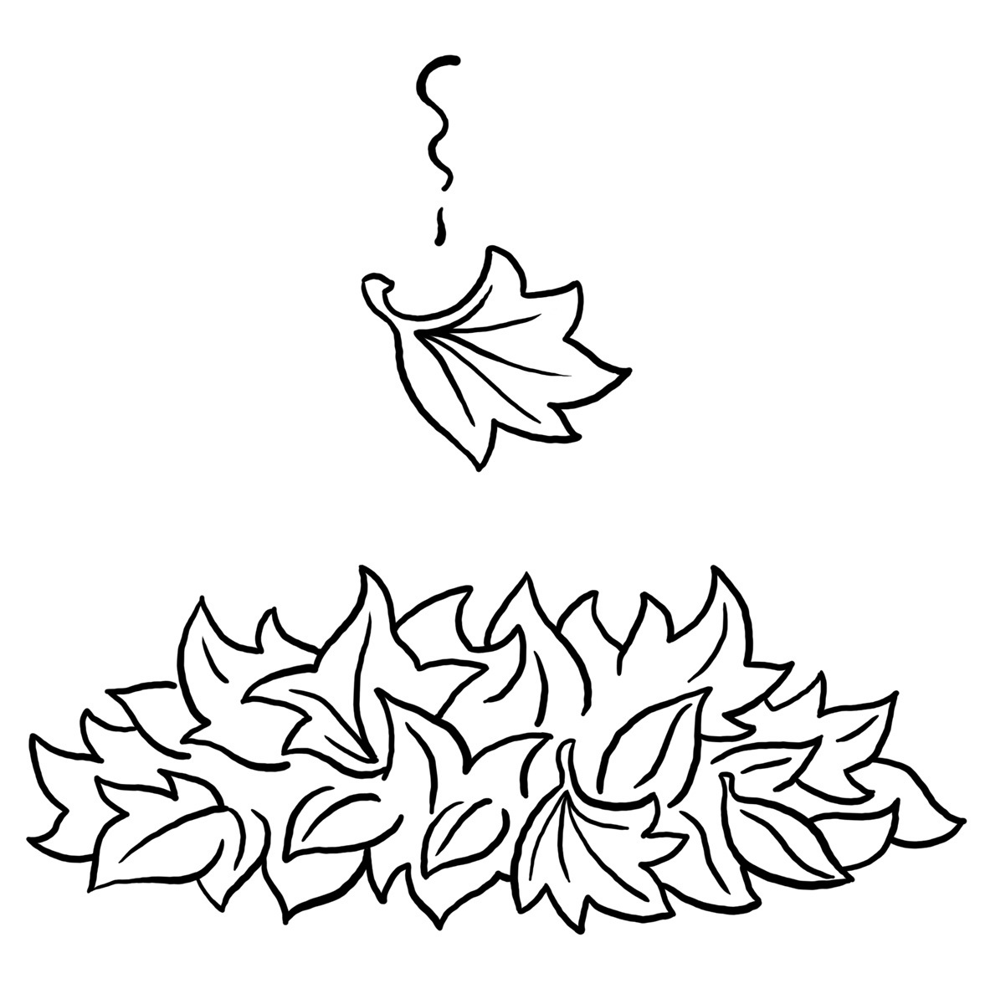

The Kindergarten Connection
October 2023

SAVVAS Reading Themes

Unit 1 – Going Places!

How Can We Describe Special Places?

Project-Based Learning: Let’s Go!

Unit 2 – Living Together: What Do Living Things Need?

Animals on the Move-Why do some animals move from place to place?

From Nectar to Honey-How do some living things make what they need?

UFLI for Phonological Awareness/Word Work

VC/CVC Word Building and Blending, Generating Letter Sounds with Proper Mouth Placement

*Please Note: Mrs. Lindsey is the Kindergarten “Typo Queen” and would like to correct the following errors: K will not use Waggle Math, we will use I-Ready Math instead. Also, our Winter Craft Party will be Friday 12/15!
Language Arts
Genres: Informational Text, Fiction
Animal Names
Parts of a Book
Letters: FF, Ii, Aa, Oo, Nn, Dd
Writing: Personal Narrative/Complete a sentence.
Sight word recognition:
A, I, the, and, is, as, said
Math
Compare Numbers Through 5
Count and Represent Numbers Through 8
Science
Making Observations, Physical Science,
States of Matter
Social Studies
Hawks Rise Character Traits, Hispanic Heritage, Bully Prevention, Red-Ribbon Week

Important Dates

10/6 First Friday/NEST Lunch

10/9 Reading Rally Logs Due

10/12 Fall Picture Day

10/13 End of 1st 9 Weeks

10/16 NO SCHOOL – Teacher Planning Day

10/17 Beginning of 2nd 9 weeks Kindergarten grading begins

10/18 Pumpkin Family Projects DUE *More Info to Come*

10/23 Red Ribbon Week

10/27 Spirit Sprint Kick-Off

10/31 Fall Party/ Dress-Up Day wear black and orange or pumpkins

Reminders

Please send a seasonal change of clothing labeled with your child’s name along with daily snack and water thermos/bottle

The Kindergarten Teachers,

Mrs. Campbell, Mrs. Deason, Ms. Hammond, Mrs. Manuel, Mrs. Lindsey, Ms. Lindquist

Mrs. Ramos, Ms. Randall

