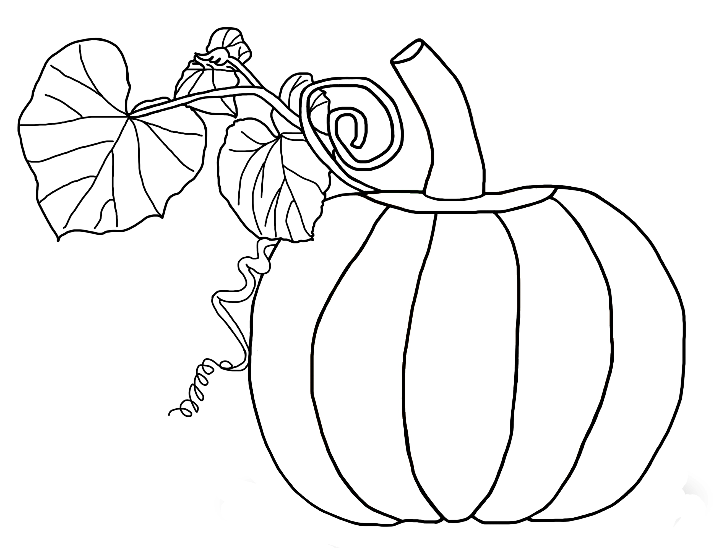
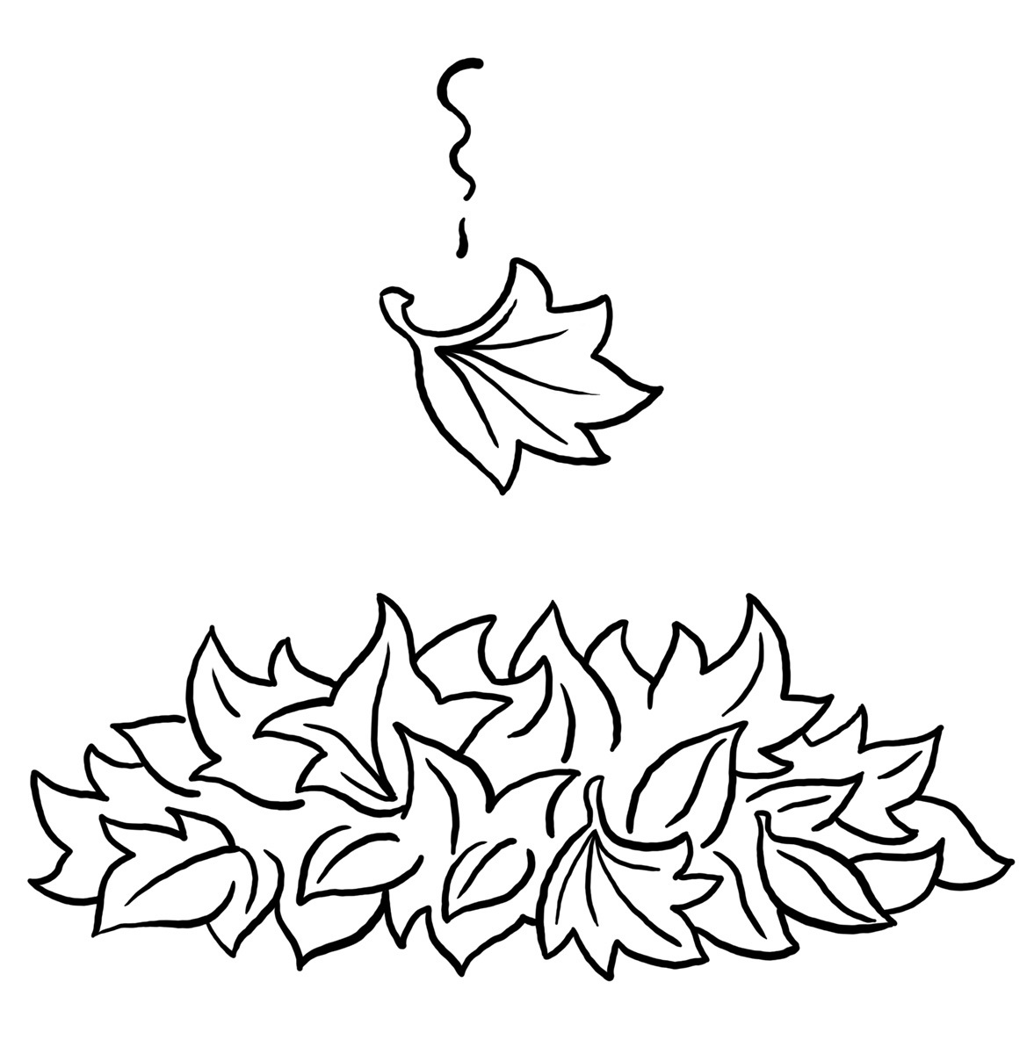

The Kindergarten Connection
November 2023

SAVVAS Reading Themes

Unit 2 – Living Together: What Do Living Things Need?

Do We Need This?; How do we know what we need?

Open Wide!; How do different animals eat their food?

Run, Jump, and Swim; Why is exercise important?

Unit 3 – Tell Me A Story: Why do we like stories?

How Anansi Got His Stories?; What can we learn from stories?

UFLI for Phonological Awareness/Word Work

VC/CVC Word Building and Blending, Generating Letter Sounds with Proper Mouth Placement
Language Arts
Genres: Informational Text, Fiction
Animal Names
Parts of a Book
Letters: Hh, Gg, short Ee, Bb, S /z/, Kk, Rr
Writing: Write 1-2 sentences.
Sight word recognition:
A, I, the, and, is, as, said, of, see, he, be, me
Math
Chapter 5: Count and Represent Numbers Through 10
Chapter 6: Order and Compare Numbers Through 10
Science
Unit 6: Energy (sound, light, heat),
Unit 7: Magnets and Positional Words (above/below)
Social Studies
Hawks Rise Character Traits, Veteran’s Day, Thanksgiving (Pilgrims/Native Americans)

Important Dates

11/3 First Friday Nest Lunch

11/9 Health Screenings

11/10 No School

11/13 Turkey in Disguise Family Project Due

11/16 PTO at 7:00 p.m.

11/20-24 Thanksgiving Holiday – No School

11/30 Fall Picture Retake

Reminders

Please send a seasonal change of clothing labeled with your child’s name along with daily snack and water thermos/bottle

The Kindergarten Teachers,

Mrs. Campbell, Mrs. Deason, Ms. Hammond, Mrs. Manuel, Mrs. Lindsey, Ms. Lindquist

Mrs. Ramos, Ms. Randall

